San Mateo County Community College District
3401 CSM Drive
San Mateo, California 94402
650.358.6880
Occupation Report
8 County SF Bay Area
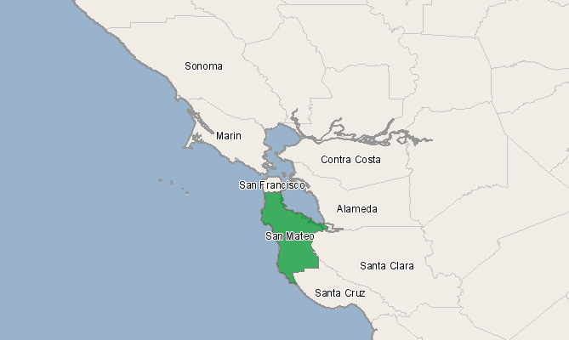

Region Info

Region: San Mateo, California (6081)
Selected Occupations

Occupation | Education Level
Registered nurses (SOC 29-1111) | Associate's degree

Executive Summary

Basic Information
2010 Occupational Jobs | 4,621
2017 Occupational Jobs | 5,155
Total Change | 534
Total % Change | 11.56%
Openings | 1,106
2011 Median Hourly Earnings | $48.49

Economic Indicators
2010 Location Quotient | 0.67
2017 Location Quotient | 0.65

Source: EMSI Complete Employment - 2011.4

Occupational Change Summary
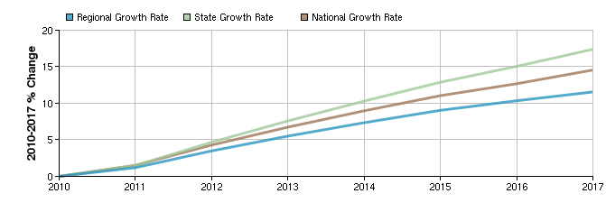
Region | 2010 Jobs | 2017 Jobs | Change | % Change | Openings | 2011 Median Hourly Earnings
Regional Total | 4,621 | 5,155 | 534 | 12% | 1,106 | $48.49
State Total | 231,350 | 271,577 | 40,227 | 17% | 69,139 | $39.48
National Total | 2,619,935 | 3,001,246 | 381,311 | 15% | 711,320 | $30.38

Source: EMSI Complete Employment - 2011.4

Top Industries for Selected Occupation
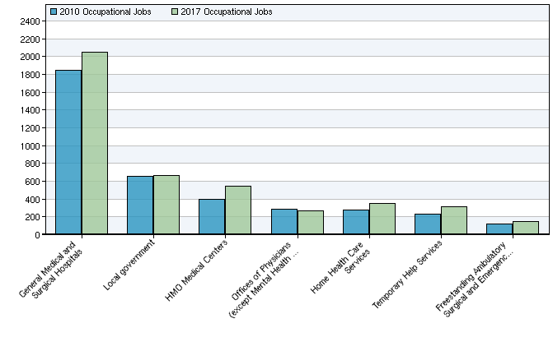
NAICS Code | Name | 2010 Jobs | 2017 Jobs | Change | % Change
622110 | General Medical and Surgical Hospitals | 1,850 | 2,051 | 201 | 11%
930000 | Local government | 654 | 664 | 10 | 2%
621491 | HMO Medical Centers | 401 | 546 | 145 | 36%
621111 | Offices of Physicians (except Mental Health Specialists) | 282 | 270 | -12 | -4%
621610 | Home Health Care Services | 274 | 350 | 76 | 28%
561320 | Temporary Help Services | 227 | 313 | 86 | 38%
621493 | Freestanding Ambulatory Surgical and Emergency Centers | 122 | 147 | 25 | 20%

Source: EMSI Complete Employment - 2011.4

Location Quotient Breakdown
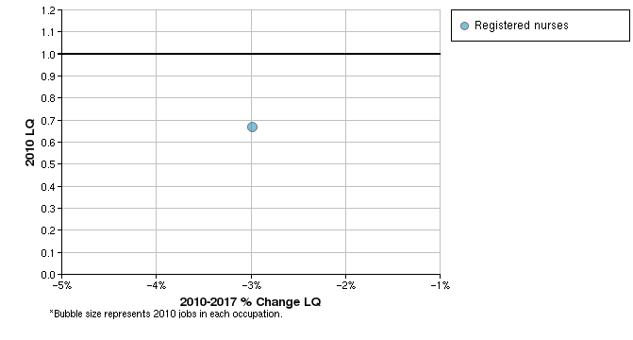
SOC Code | Description | 2010 Jobs | 2010 LQ | 2017 LQ
29-1111 | Registered nurses | 4,621 | 0.67 | 0.65
 | Total | 4,621 | 0.67 | 0.65

Source: EMSI Complete Employment - 2011.4

Data Sources and Calculations

Industry Data
In order to capture a complete picture of industry employment, EMSI basically combines covered employment data from Quarterly Census of Employment and Wages (QCEW) produced by the Department of Labor with total employment data in Regional Economic Information System (REIS) published by the Bureau of Economic Analysis (BEA), augmented with County Business Patterns (CBP) and Nonemployer Statistics (NES) published by the U.S. Census Bureau. Projections are based on the latest available EMSI industry data, 15-year past local trends in each industry, growth rates in statewide and (where available) sub-state area industry projections published by individual state agencies, and (in part) growth rates in national projections from the Bureau of Labor Statistics.
Location Quotient
Location quotient (LQ) is a way of quantifying how concentrated a particular industry, cluster, occupation, or demographic group is in a region as compared to the nation. It can reveal what makes a particular region unique in comparison to the national average.
State Data Sources
This report uses state data from the following agencies: California Labor Market Information Department.

