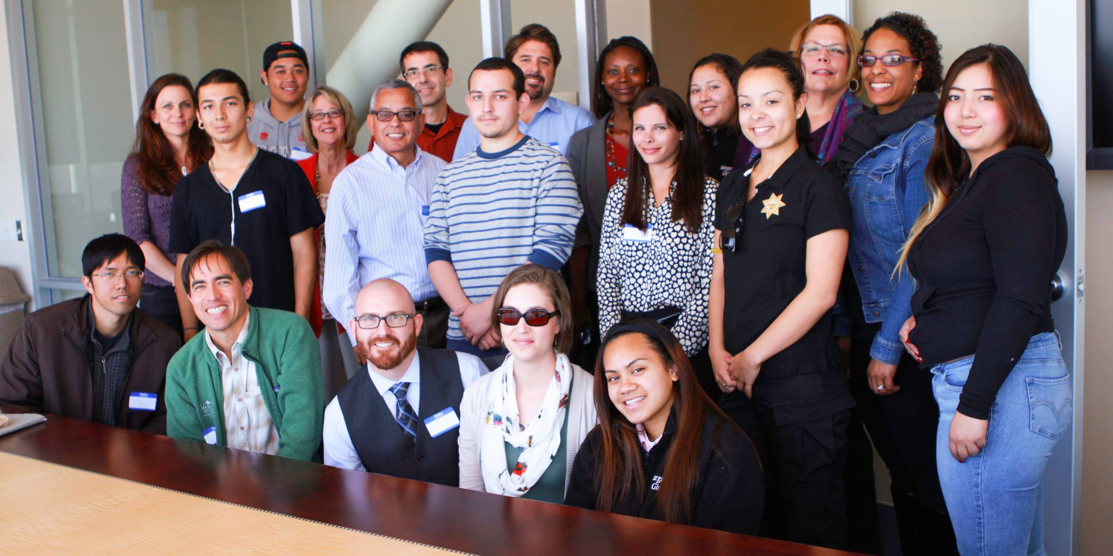
College of San Mateo Project Change Overview

Purpose
Project Change is a unique program providing comprehensive educational services and resources to serve students and the community in order to deliver opportunity for career and postsecondary attainment for court-involved youth. The project aims to assist some of the county’s most vulnerable population of students and help them access postsecondary education successfully at the College of San Mateo. The project is currently in its pilot year at the College of San Mateo, with an enrollment of ten students; the next stage of the project is to provide instruction on-site at the San Mateo County juvenile justice facilities. This is the first program of its kind in the state of California.

Design and Community Partnerships
The project utilizes resources and programs already in place on each college campus, such as summer bridge programs, Student Support Services, as well as cohort learning communities (Puente and Umoja), and provides students a clear pathway to resources on campus from which they benefit. Project Change provides a supportive network of volunteer faculty and staff mentors, as well as a project coordinator, to assist students navigating their first year in college. This program unites the College of San Mateo and San Mateo County community organizations together in a joint effort to help underrepresented populations of students make the transition to community college.

The San Mateo County community partners include: San Mateo County Youth Services Center; San Mateo County Probation Department; Superior Court of California, San Mateo County Branch, Juvenile Justice Judges; San Mateo Police Department; San Mateo County Office of Education; San Mateo Union High School District, Peninsula High School; Local Nonprofit Organizations: Each One Reach One and STEP; Court Appointed Committees: The Blue Ribbon Commission and Juvenile Justice Coordinating Council; and San Mateo County Behavioral Health and Rehabilitation Services.

The College of San Mateo faculty and staff participants in Project Change include: Katie Bliss, Project Change Coordinator; Administrator support: James Carranza, Dean of Language Arts; Jennifer Taylor-Mendoza, Dean of Academic Support and Learning Technologies; Jeramy Wallace, Assistant Professor, English; Autumn Newman, Assistant Professor, English; Joyce Luck, Assistant Professor, English; Rob Komas, Professor, Mathematics; Rosemary Nurre, Professor, Accounting; Estela Garcia, Community Relations and Marketing Staff; Cindy Erickson, Professor, Business; Sarah Negara, Instructor, Dance and Kinesiology; Cynthia James, Instructor, Cosmetology; Karen Powell, Director of Maintenance and Operations; Krystal Romero, Director of Student Support Services.

Mission
Project Change is aligned with the core values and mission of the College of San Mateo; this is a program serving students and the community. Project Change showcases the opportunity to provide higher education to underrepresented populations of students and to solidify the partnership between the San Mateo community and the College in an effort to exemplify the mission of California Community Colleges: access to higher education for all.

CSM’s Project Change is designed for students who:
- Are court-involved youth in San Mateo County
- Have or are attending any of the San Mateo Court and Community Schools
- Will enroll in pre-transfer level Math and/or English
- Are motivated to make the transition to college
- Are interested in having support and guidance while starting the first year in college

Current Updates: College of San Mateo Project Change Pilot
- 10 students, referred by community partners, are currently enrolled in the program
- Each student has met with their academic counselor and signed up for their fall classes
- Each student has participated in financial aid workshops and meetings with a financial aid officer and the Project Change coordinator.
- 4 students have completed the EOPS Summer Readiness Program, and three students have completed the summer pathway program (Pathway to College).
- Each student has a mentor for the academic year and regular check-ins have just started in September; students regularly check-in now and throughout the year with the Project Change Coordinator.
- 8 of the 10 students in Project Change will be participating in cohort learning communities for the fall: Puente and Umoja.
- All Project Change students are enrolled in courses with at least one, but typically two or more professors who are involved in Project Change and are there to provide the students support and guidance.

