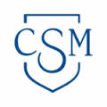

Project Change Next Phase

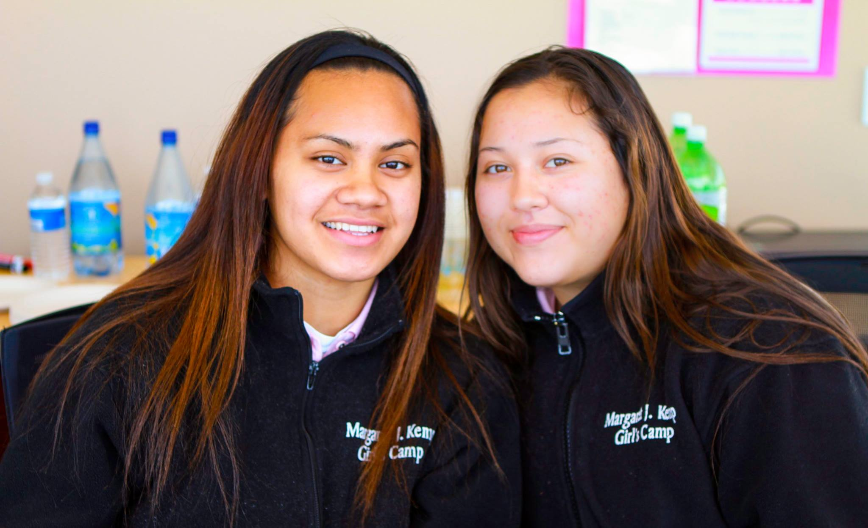

Population
There are 529 students who are being served by the five Court and Community Schools in San Mateo County. These schools serve the educational needs of incarcerated youth, many of whom would benefit from coursework in postsecondary education and are of the appropriate age and transition point to attend community college. There is additionally a large population where concurrent enrollment will be advantageous for postsecondary readiness. At present, administrators, faculty, and staff from the five Court and Community Schools refer students to Project Change at the College of San Mateo, and probation and administrators at Youth Services Center collaborate to refer and transition students to the college as well. There are ten students in the pilot program at the College of San Mateo for the 2014-15 academic year.

The 529 Youth served in the Court and Community Schools range from ages 12-18. At Gateway Community School, twenty students completed a high school diploma this academic year (2013/14). In Youth Services Center, 38 students completed their high school diploma, and 35 completed their GED. Project Change can serve students who have completed the educational requirements for a high school diploma or GED, but the program can additionally serve those students who are working towards completion. An emphasis on a college education and career availability through postsecondary academics can assist in fostering positive identity for students and help them to become more excited and motivated to finish their diploma or GED. For students to know that when they complete the milestone of graduating high school, that they have college awaiting them, can be a powerful motivating factor. In addition to serving graduating students, Project Change can provide concurrent-enrollment opportunities as well.

Overview
County Court and Community Schools:
- Project Change collaborates with the faculty, staff, and administrators at the five Court and Community schools, which currently provide 529 court-involved youth education in San Mateo County.
- The Court and Community Schools include: Hillcrest High School (located at Youth Services Center), Canyon Oaks Youth Center (located at Behavioral Health Services), the Boy’s Camp (Camp Glenwood), the Girl’s Camp (Camp Kemp), and Gateway Community School (the only post-release educational facility).
- Students typically attend these institutions for a minimum of one semester, but they are often enrolled for the full academic year.

Education for Court-Involved Youth
- Court-involved youth in San Mateo County are currently provided their educational needs by five Court and Community Schools.
- There are educational services provided on a year-round basis at three of the Court Schools: Hillcrest School (located at Youth Services Center), the Boy’s Camp (Camp Glenwood), and the Girl’s Camp (Camp Kemp).
- The non-residential Community School is Gateway and the residential is Canyon Oaks, where students are enrolled for an average of one semester, but they are often enrolled for the full academic year.

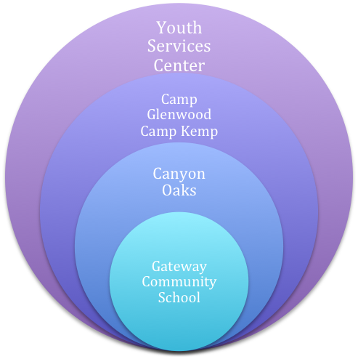

Figure 2: Court and Community School Partnership

Partnership Between College of San Mateo and Court and Community Schools
- Project Change will offer college courses and college readiness workshops at each of the five locations varying in length and focus dependent on the institutional needs of the facility.
- Four of the five programs serving court-involved youth (Gateway, Canyon Oaks, Camp Kemp, and Camp Glenwood) all have students for an average of one semester and up to a full academic year.
- This provides ample opportunity for students to receive credit bearing college courses on-site. Students who are more in-flux at Youth Services Center will participate in accelerated courses, online classes, and college readiness workshops.

Gateway Community School and Canyon Oaks Community School
- Gateway Community School is the non-residential community school serving court-involved youth.
- They had twenty seniors for the 2013/14 academic year in their Independent Study Program, which is housed on the College of San Mateo’s campus and aims to help students complete their high school diploma.
- The Independent Study Program is reserved for the most highly motivated seniors at Gateway, who are in-line to finish their credits to receive a high school diploma. Seven of those graduated seniors are currently enrolled in the College of San Mateo’s Project Change program.

Camp Glenwood and Camp Kemp
- San Mateo County Office of Education works alongside the probation department to provide education through three Court Schools, two of which are the Boy’s Camp, Camp Glenwood, and the Girl’s Camp, Camp Kemp.
- Camp Glenwood serves up to sixty youth and houses them in their facilities on average from four to nine months.
- Camp Kemp can serve up to thirty girls, and residents remain on average of four to nine months.
- As students are on-site for extended lengths of time, similar to Gateway, the ability to offer college courses by instructors from any of the three colleges at the camps is available. Workshops for college readiness and online classes are also ways for students to begin preparation for postsecondary education, as both camps have access to the Internet and technology.

Youth Services Center
- Youth Services Center serves as San Mateo County’s juvenile hall and is subdivided into multiple branches, which house youth according to age, offense, and gender.
- A target population for Project Change Program is the branch of Elm 7. This is a minimum-security boy’s unit, which serves about 60 students ages 15-18, and the students are detained for extended time periods of 6-9 months.
- The non-profit, Each One Reach One, which facilitates the GED program on-site, reported that 51 youth served in the GED program voluntarily in the 2013-14 academic year.
- 35 of these students completed their GED while detained.
- This unit houses the appropriate age group for students to be in a college transition program, and they are a motivated population who are interested in pursuing their educational goals, as evidenced by the large number of students in the GED prep program.
- As Hillcrest High School is housed in Youth Services Center, this is where Project Change will offer college and pre-college level courses in collaboration with the San Mateo County Office of Education and the College of San Mateo. Students can take accelerated English and math courses taught by community college instructors, which can help them with their preparation for college, while also helping them work on their skills for the CHASEE, GED, or completion of their diploma (if relevant).
Model
Project Change provides a three-phase model to offer students a clear trajectory with strong support focused on postsecondary readiness and success both on-site at the juvenile justice facilities and at the College of San Mateo:

Enriched Preparation
Phase 1
Phase 1
Project Change provides college services for preparation to transition to community college on-site at the juvenile justice facilities.
- College Readiness Workshops: study skills, financial aid literacy, information about college programs and majors, and an overview of pathways in the community college: certificate programs, associate degree, and transfer.
- College Courses: College courses taught by instructors from the College of San Mateo are provided to students for college credit at the juvenile justice facilities. This can include general education (pre transfer level English and Math), career and technical education, elective courses, and college readiness workshops.
Postsecondary Bridging
Phase 2
Project Change provides students a clear pathway and support network for success at the College of San Mateo. This can be done both on-site at the juvenile justice facilities and the community college campus:
- Pathway Process: placement testing, financial aid, academic counseling, and class registration.
- Summer Bridge Program: enrollment in summer program at the College of San Mateo. E.g. Pathway to College.
First-Year Support
Phase 3
First-year support begins on campus at the College of San Mateo.
- Mentoring: Students are matched with both peer and faculty mentors for the full academic year who provide guidance and support to help students be successful; mentors meet with the students bi-weekly and attend collaborative Project Change events monthly.
- Cohort Based Programs: Students will enroll in first-year cohort based programs when eligible such as Puente or Umoja.

San Mateo County Office of Education, Court and Community Schools (2013)“The Single Plan for Student Achievement:” School Year, 2013-14.
Each One Reach One Annual Report, 2014

