Students First
A Strategic Plan for the San Mateo County Community College District
The Strategic Planning Committees of the San Mateo Community College District
7/27/2015

DRAFT

This strategic plan serves as a guide for the San Mateo County Community College District (SMCCCD) through the year 2020.

INTRODUCTION 1
SAN MATEO COUNTY COMMUNITY COLLEGE DISTRICT MISSION STATEMENT 2
OVERARCHING THEMES 5
Students First: Student Success, Equity and Social Justice 5
Districtwide Strategies 5
STRATEGIC GOALS, METRICS AND STRATEGIES 6
Strategic Goal #1: Develop and strengthen educational offerings, interventions, and support programs that increase student access and success 6
Districtwide Strategies 7
Strategic Goal #2: Establish and expand relationships with school districts, 4-year college partners, and community-based organizations to increase higher education attainment In San Mateo County 7
Districtwide Strategies 7
Strategic Goal #3: Increase program delivery options, including the expanded use of instructional technology, to support student learning and success 8
Districtwide Strategies 8
Strategic Goal #4: Ensure necessary resources are available to implement this strategic plan through sound fiscal planning and management of allocations. Protect community-supported status and undertake the development of innovative sources of revenue that support educational programs beyond that which is available from community and state allocations. 9
Districtwide Strategies 9
STRENGTHS WEAKNESSES OPPORTUNITIES AND THREATS (SWOT) ANALYSIS 10
Strengths 10
Weaknesses 11
Opportunities 11
Threats 12
SUMMARY OF DATA TRENDS AND THEIR IMPLICATIONS FOR THE PLANNING PROCESS 13
Implications of Demographic Trends 14
Implications of Workforce Trends 14
Implications of Housing Trends 15
Implications of Community College Trends 16
Implications of State Education Policy Trends 17
Implications of K through 12 Trends 17
Implications of New Educational Paradigms 17
SMCCCD Strategic Plan Metrics Definitions 18
Appendix A: metrics 20
Metrics [Benchmarks and Targets To Be Determined] 20
Appendix B: External Trends and Their Implications for Strategic Planning 23
Demographic Trends 23
San Mateo County 23
Bay Area and the Peninsula 24
California 25
United States 26
Workforce Trends 27
San Mateo County 27
Bay Area and the Peninsula 28
California 29
United States 30
Housing Trends 31
Bay Area, the Peninsula, and San Mateo County 31
Community College Trends 32
Bay Area, the Peninsula, and San Mateo County 32
California 32
United States 34
Higher Education Policy 35
California 35
United States 36
K through 12 Trends 36
San Mateo County 36
California 37
United States 37
New Paradigms 37
Bay Area, the Peninsula, and San Mateo County 37
California 38
United States 38
Appendix C: Imperatives for Planning – Observations from the data prepared for the SMCCCD Strategic Plan 40
Demographics 40
Age and Forecasted Shifts 40
Race and Ethnicity 41
Income and Poverty 44
English Language Proficiency 45
Educational Attainment 45
Demographic Summary 47
Equity 47
Economics 47
Employment 47
Business Expansion 48
Housing 48
Community Supported Status 48
Enrollment and Student Demographics 49
Changes in Enrollment 49
Shifts in Student Demographics 51
Age Trends 51
Gender Trends 52
Ethnicity Trends 53
Financial Aid Trends 53
Secondary Schools and Penetration Rates 55
High School Student Enrollment 57
Connections to Labor Markets 58
Instructional Programs 59
Breadth of Offerings And Trends 59
Scheduled Class Times 61
Faculty Age Characteristics and Projections 62
Online Instruction 64
Competitor Analysis 65
Workforce Alignment 66
District Program Alignment with Labor Markets 67
Program Opportunities 68
Student Achievement and Success 68
Success Rates for Students in Coursework 68
Gatekeeper Classes 69
Retention Rates 69
Degree and Certificate Completion 69
Developmental Skills and Student Success 69
Degrees, Certificates, and Noncredit Awards 74
Transfer to the UC and CSU Systems 74
Appendix D: District Degrees and Certificates Awarded 77
Appendix E: Other Data Developed for the Strategic Plan 80
Sources for Environmental Trends 81

INTRODUCTION

This Strategic Plan signals a new era for the San Mateo County Community College District (SMCCCD) through the year 2020. It is a vehicle by which the District will embark on progressive goals to match changing times. It replaces the former SMCCCCD Strategic Plan covering the years 2008 to 2013. The plan consists of three overarching themes – student success, equity, and social justice; four strategic goals; and Districtwide strategies and metrics to be used to implement and measure the effectiveness of programs and activities in support of this plan. This document describes these components and the data used to inform its development.

Development of the District Strategic Plan was spearheaded by two committees: the District Strategic Plan Steering Committee, an executive-level team including members of the Board of Trustees, Chancellor, College Presidents, District Academic Senate, the Deputy and Executive Vice Chancellors of the District and the Director of Government and Community Relations; and the District Strategic Planning Task Force, consisting of the leadership mentioned above, less the Board members and including College Academic Senate leaders and district researchers. The Task Force served to review and inform output from the Steering Committee and manage dissemination of the information about the plan to their constituencies.

The plan’s development was data driven and collaborative. Internal and external data regarding trends in demographics, competitors, workforce needs, housing, k-12 and higher education were collected and considered. This plan is integrated with and draws from the District and College plans: Educational Master Plans, Facilities Master Plan, Equity Plans and Strategic Enrollment Plans. Four strategy sessions at each college – a total of 12 forums – provided the opportunity to collect information and insights from faculty, staff and students. The Board of Trustees discussed the plan at their Annual Retreat.

This Strategic Plan will help the District plan wisely for the future. It is tied to the Colleges’ Educational Master Plans and to resource allocation. The new resource allocation model includes annual funding for an Innovation Fund to support program development. Additionally, the new plan provides a way for the District to demonstrate its accountability to stakeholders, taxpayers, and students. District leaders will use continuous analysis of student persistence, completion, award of certificates and degrees and transfers in addition to assessing student goal attainment to make strategic decisions. Student performance and outcomes underlie accountability for the overarching District goals-student success and equity and social justice. In addition to the metrics included in Appendix A, the District will develop a District Scorecard that will track various performance measures. These metrics will provide visibility for the achievement of District goals outlined in this document.

This plan will be reviewed regularly and discussed at the Board’s Annual Retreat and at other times during the year. The metrics, some of which have yet to be developed, will change over time, as will the strategies as they are reviewed and refined annually

SAN MATEO COUNTY COMMUNITY COLLEGE DISTRICT MISSION STATEMENT
PREAMBLE
The Colleges of the San Mateo County Community College District, Cañada College, College of San Mateo, and Skyline College, recognizing each individual’s right to education, provide the occasions and settings, which enable students to develop their minds and their skills, engage their spirits, broaden their understanding of social responsibilities, increase their cultural awareness and realize their individual potential. The District actively participates in the economic, social, and cultural development of San Mateo County. In a richly diverse environment and with increasing awareness of its role in the global community, the District is dedicated to maintaining a climate of academic freedom in which a wide variety of viewpoints is cultivated and shared. The District actively participates in the continuing development of the California Community Colleges as an integral and effective component of the structure of public higher education the State.
MISSION
In an atmosphere of collegiality and shared responsibility, and with the objective of sustaining open access for students and being responsive to community needs, the Colleges of the San Mateo County Community College District will fulfill the following mission with excellence:
- Provide a breadth of educational opportunities and experiences which encourage students to develop their general understanding of human effort and achievement; and
- Provide lower division programs to enable students to transfer to baccalaureate institutions; and
- Provide career and technical education and training programs directed toward career development, in cooperation with business, industry, labor, and public service agencies; and
- Provide basic skills education in language and computational skills required for successful completion of educational goals; and
- Provide a range of student services to assist students in attaining their educational and career goals; and
- Provide self-supporting community education classes, contract education and training and related services tailored to the human and economic development of the community; and
- Provide leadership in aligning educational programs and services offered by all local educational institutions and community service organizations; and
- Celebrate the community’s rich cultural diversity, reflect this diversity in student enrollment, promote it in its staff, and maintain a campus climate that supports student success.
To fulfill this educational mission, the District is committed to effective institutional research that supports the evaluation and improvement of programs, services, and student outcomes. Shared governance is practiced through processes that are inclusive with regard to information sharing and decision-making, and that are respectful of all participants. The District plans, organizes and develops its resources to achieve maximum effectiveness, efficiency, equity and accountability.
The Mission is evaluated and revised on a regular basis.
The San Mateo County Community College District Board of Trustees commits itself to the following Core Values and Principles:
- Student-Centered Mission: The Board recognizes each individual's right to education and commits itself to providing the occasions and settings that will allow our students to develop their minds and skills, engage their spirits, broaden their understanding of social responsibilities, increase their cultural awareness and realize their individual potential. The Board recognizes that our core mission is to provide transfer education and career/technical training to as many students as possible. Basic skills classes which are focused on preparing our students for our core mission courses as noted above are also necessary and appropriate.
Lifelong learning classes which had long been an important part of the community college mission were necessarily curtailed during difficult budget years. The Board asserts that, given the District's financial outlook at this time, the College should consider restoring some of these programs - through contract education, not-for-credit programs, community education and hybrid community education/credit courses.
In order to insure that all programs and courses offered remain relevant, necessary and are serving student needs, the District’s programs and classes should be regularly examined and updated based upon student, employer and community need as determined through surveys, focus groups and other measurements.
Student support services and staff are also important and help ensure the success of our students in their pursuit of a postsecondary education. The Board is committed to providing a wide array of student services that are necessary and that support student success and that do not unnecessarily duplicate services offered in the community.
- Support for Innovation/Expanding Educational Opportunities: The Board believes that its long-standing support for innovation and creative approaches to serving the educational needs of the community has been essential to ensure that the Colleges are offering the appropriate balance of academic programs and in maintaining the academic excellence of these programs. With the changed financial status of the District, the Board encourages the Colleges to seek out underserved populations; evaluate their educational needs and provide courses and programs to serve them. Using the Business and Community Needs Assessment data, the Board also encourages the Colleges to provide new classes, certificate programs or AA/AS degrees that will meet those identified needs. The Colleges should also continue efforts to expand programs that extend access to new populations of students, many of whom cannot attend traditional college classes. Finally, the Board is interested in maintaining/expanding unique programs at the Colleges that serve broad community needs and draw that community to our campuses.
- Employment Philosophies: The Board subscribes to the principles of human resource management which promote: equal access; equal opportunity; equal treatment and fairness; staff development and training opportunities; competitive compensation that draws the best candidates to the District; and accountability. The Board reaffirms the long-standing District policy that it always seeks to employ the most qualified applicant for each job and does not make decisions about employment, retention, compensation, promotion, termination or other employment status which would discriminate on the basis of national origin, religion, age, gender identity, gender expression, race or ethnicity, color, medical condition, genetic information, ancestry, sexual orientation, marital status, physical or mental disability, pregnancy or because they are perceived to have one or more of the foregoing characteristics, or based on association with a person or group with one or more of these actual or perceived characteristics.
- Participatory Governance: The Board is deeply committed to the participatory governance process as it has been established in this District, and believes that this process can produce decisions that are comprehensive, fair and in the best interests of students, the community and employees. The Board encourages and expects the participation of all constituents in decision-making and governance and recognizes participatory governance as the means for having the voices and opinions of various constituencies heard.
- Final Decision-Making Authority: In this participatory governance environment, the Board, as the elected representatives of the people of San Mateo County, will ultimately make the final decision and sets policy on issues based upon what it believes is in the best interests of the District as a whole. In reaching its decisions, the Board acts independently, but considers the informed viewpoints of all participants and constituencies and relies on the research, advice, experience and expertise within the District.
The Board believes that adherence to these core values and operating principles will allow the District to be one of the most innovative and progressive in the State, and that these values and principles will continue to support the District and advance the interests of students, faculty, staff and the San Mateo County community.

OVERARCHING THEMES
This summary of the District Strategic Plan lays out the major components of the plan and a summary of the principles, themes and data used to establish its goals, strategies and metrics.

Students First: Student Success, Equity and Social Justice
Success, Equity and Social Justice for our students are longstanding goals of the San Mateo County Community College District and have been defined as the overarching themes of the District’s Strategic Plan. With this Plan, the District recognizes that there is nothing more important to the District’s future and to the future of San Mateo County than increasing student success rates. Providing equitable access to higher education is no longer sufficient. To fully meet the District’s obligation to increase equity and student success, it must close longstanding gaps in student attainment. Continuous use of the District’s data will be required to identify and close these gaps. While colleges are required to report success data to external agencies, these traditional measures of student completion and graduation do not fully capture the contributions of the District’s Colleges to the County. A more student-centric definition of student success is necessary. Accordingly, the District defines student success as occurring when students reach the individual goals they set for themselves.

This “students-first” philosophy is deeply grounded in the belief that diversity is a value added rather than something to be overcome or transcended and is a necessary starting point rather than the entire goal. In order to create an equitable and rigorous educational environment, the value of diversity must be embedded in policy and practice, be reflected throughout the District and its guiding plans, and must address equitable impact as well as intent.

To ensure that adequate resources are available to achieve the goals of this Strategic Plan, the District will, at all times, undertake sound fiscal planning and management of allocations. It will be essential for the District to protect its community-supported revenue status through advocacy, education and alliances with other similarly-funded colleges. In addition, the District will need to continue to support and expand entrepreneurial efforts that produce additional revenue that can be used to support student educational programs and services beyond that which is available from other state and local sources.

Districtwide Strategies
The following strategies will help inform the District and Colleges in developing policies, procedures and initiatives in support of the Overarching Themes of this Strategic Plan.
- Develop a robust and comprehensive research, planning and institutional effectiveness infrastructure Districtwide to produce actionable data for use in Districtwide decision-making.
- Measure the impact of new and existing College efforts to increase success and equity for all students. Close gaps that result in inequitable outcomes.
- Capture the real education goals that students want to achieve and use these goals to determine their subsequent success.
- Continually explore and implement interventions that benefit all students, with particular emphasis on students with high potential and limited resources.
- Provide clear and distinct pathways for all students, particularly those from underserved populations, to accelerate program completion and successful transitions to work or transfer.
- Support the Colleges by providing resources for teaching and support innovations that are designed to increase student success
- Review student placement assessment processes and incorporate multiple measures of assessing the preparedness of new students for college level work for students with the goal of decreasing time needed to achieve one’s goal.
- Engage in innovative course scheduling that provides more student options for course completion.

STRATEGIC GOALS, METRICS AND STRATEGIES
The Strategic Plan defines Strategic Goals that will help the District meet its commitment to achieving success, social justice, and equity for our students. Each strategic goal will be accompanied by metrics that measure whether the plan is working. Draft metrics are included in Appendix A. A number of Districtwide strategies that define, in broad terms, the means of achieving the strategic goals are also included. Operational planning at the Colleges will translates the Districtwide strategies into College-specific programs and activities that support the strategic goals. Systematic assessment of College programs and activities will inform the metrics for the District’s strategic goals and guarantee transparency and accountability for District employees and the public. By implementing this plan, the District and Colleges will be accountable to the students they serve and the communities of San Mateo County.

Strategic Goal #1: Develop and strengthen educational offerings, interventions, and support programs that increase student access and success
Students arrive at District Colleges with a range of educational goals. Students and the public need to know that their investment in time and money in their education will lead to tangible results. Accordingly, the District will seek to provide the best possible balance of programs and services that will result in clear transfer outcomes as well as alignment with emerging labor markets. Increasing student outcomes requires increased support and engagement and professional development that focuses on excellence in teaching.

Districtwide Strategies
- Increase the number of students who utilize support services that enable them to stay in school and succeed.
- Systematically evaluate the effectiveness of existing programs in all areas and develop, strengthen or eliminate programs to support student success.
- Strengthen the alignment of career and technical programs with projected workforce needs.
- Provide professional development resources for faculty, staff, and administration to ensure program viability and excellence in teaching.
- Create on-line and web-based options for students to access advising and counseling services, interactive scheduling, and educational plans.
- Establish a dedicated budget for program development (including personnel, professional development, and technology). Invest in resources and support actions that will ensure quality teaching and learning.
- Use emerging practices to accelerate student progression through basic skills and ESL sequences into college-level work.
- Expand the globalization of education as a critical means for graduates to engage and thrive in an increasingly small world.

Strategic Goal #2: Establish and expand relationships with school districts, 4-year college partners, and community-based organizations to increase higher education attainment In San Mateo County

The District’s Colleges are the center of higher education opportunity for San Mateo County. Yet, past successes are no guarantee of future enrollment. It is unlikely that service area demographics during the current planning period can ensure continually increasing enrollments. It will be increasingly important to work with education partners and community-based organizations to ease students’ transitions to, within, and from the District’s Colleges.

Districtwide Strategies
- Support seamless transitions to College for secondary school students.
- Increase Middle College and Early College opportunities.
- Make concurrent and dual enrollment processes more efficient and accessible for secondary schools and their students.
- Work with feeder high schools to develop better placement processes that result in higher levels of students placed into college credit courses and programs.
- Emphasize and support both traditional and non-traditional contact with instructors and counselors.
- Expand student services, student clubs and learning communities for the benefit of all students but especially underrepresented or other at-risk students.
- Increase and articulate visible pathways for transfer and job placement to help students meet their stated goals.
- Increase/expand partnerships with four-year colleges and universities to increase seamless curriculum alignment and direct program transfer.
- Create faculty-to-faculty exchanges with high school discipline counterpart faculty to better align curricula and to create seamless transitions from secondary to postsecondary education.

Strategic Goal #3: Increase program delivery options, including the expanded use of instructional technology, to support student learning and success
In an educational environment that has become highly competitive, students and prospective students have many choices for higher education. Prospective adult learners are increasingly unlikely to enroll for semester-long classes, seeking instead shorter-term and online learning opportunities. Many younger students are digital natives and expect higher education to incorporate the customer experiences provided by successful online retailers. Recent national practices in Learning Communities, peer tutoring, and retention can also contribute to student success rates. Innovations can spur both larger enrollments and retention rates as well as higher levels of student success and satisfaction with the District’s educational offerings. Technology will also provide access for populations currently unable to access the District’s programs and support services. The District recognizes that such transformations require both the technological infrastructure and professional development to take advantage of new opportunities.

Districtwide Strategies
- Expand program delivery options, including accelerated completion options, for all students including online students, e.g., College for Working Adults; short term classes; intersession classes; cohort classes; and continuing, corporate and community education.
- Develop a strategic distance education plan to increase the development and delivery of quality, fully online and hybrid classes and degree programs.
- Support professional development for faculty and staff to incorporate advances in teaching, learning, and effective use of technology.
- Increase technology use in the classroom and develop the overall District technology infrastructure to improve student success.
- Share data and information, especially about student success, with community partners.
- Integrate technological systems to ensure a seamless and efficient experience for students and staff.
- Ensure student services are addressing the needs of all students including online students.

Strategic Goal #4: Ensure necessary resources are available to implement this strategic plan through sound fiscal planning and management of allocations. Protect community-supported status and undertake the development of innovative sources of revenue that support educational programs beyond that which is available from community and state allocations.

Many initiatives to improve student success can be achieved within existing resources. At the same time, new resources generated from the District’s entrepreneurial actions will add significantly to those resources available to increase student success. Entrepreneurial actions will draw upon new and existing partnerships throughout the County as well as the state, nation, and internationally. As the District embarks on the strategies in this plan, it is critical that the additional resources be invested in innovation, faculty and staff development, and other productive actions that result in higher levels of student success, social justice and equity.

Districtwide Strategies
- Review allocations so that they align with District goals and strategic actions.
- Protect and solidify District funding, predominately in the form of property taxes, through interaction and advocacy with key county and state legislators and the State Chancellor’s Office. To ensure this is achieved, build coalitions among other community-supported districts and statewide associations.
- Increase entrepreneurial actions across the District to provide new revenue sources.
- Increase Community, Continuing and Corporate Education (CCCE) training and services to San Mateo County residents, families and businesses through increased lifelong learning and professional certifications for adults, expanded academic and fitness programming for youth, and customized workforce training for public and private-sector organizations.
- Increase revenue-generating contract training for public and private sector organizations.
- Develop internationally recognized, revenue-generating Intensive English Programs for students, educators, administrators and executives.
- Contribute to the economic development of San Mateo County through collaborative partnerships with industry and workforce/economic development agencies.
- Increase credit-based enrollments through new credit/non-credit hybrid programming.
- Create or expand revenue-generating programs such as Study Abroad, San Mateo Athletic Club, and Tech Shop.
- Increase grant writing capability throughout the District.
- Link the District’s community and international education efforts to create synergies that strengthen both programs.

STRENGTHS WEAKNESSES OPPORTUNITIES AND THREATS (SWOT) ANALYSIS

A SWOT analysis is a listing and/or description of a project’s or proposal’s strengths, weaknesses, opportunities and threats relative to the competitors. For SMCCCD, this SWOT analysis is a consideration of the District within its environment of San Mateo County, and to the larger extent, the State of California, and the initiatives proposed by this Strategic Plan.

Strengths  - Community-supported status  - Administration, faculty and staff  - Culture of cooperation and innovation  - Relationships with communities (schools, cities, civic organizations) | Weaknesses  - Insufficient funds for everything we want to do  - Anticipated retirement of seasoned employees
Opportunities  - International student growth  - Community and corporate ed growth  - CTE transitions with Adult Ed  - Early College High School | Threats  - Legislation that harms the District  - Competition for international students

Strengths
The District is in the enviable position of having attained community-supported status. This means that the District’s property taxes and student fees combined exceed the revenue limit determined by the State. The District gets to keep the additional funds. While not making the District wealthy, it does afford the District the ability to do some activities that would otherwise not be possible. It also makes our revenue more predictable and stable.

The current administration, faculty and staff bring a tremendous amount of expertise to the District. In addition, the tenure of the senior administration and much of the faculty means that the wealth of knowledge and experience is significantly more than in districts with younger and/or less experienced employees.

This District has a culture of cooperation that comes from the very top all the way through line staff. All of the administration meets monthly; the faculty have discipline meetings between the campuses annually, and the staff work in teams across the campuses to develop procedures that create a uniform experience for students. The District strives to innovate and try out new ideas and is willing to take risks.
The Board of Trustees has met with other school boards and city councils to address topics such as a joint early college high school and transportation problems. Skyline College held a one-day workshop with local community, board and council members on “The Last Mile” addressing transportation issues at Skyline College. College of San Mateo staff are meeting regularly with representatives of their feeder high schools to share placement information and develop curriculum. Cañada College is leading the District’s participation in the Adult Education Coalition in the county. College administration and staff engaged with local employers and workforce professionals to assess skills and training needs for the local workforce. This activity informs college program offerings.

WEAKNESSES

Despite having attained community-supported status, the District is experiencing strains on the budget. There is a pent-up pressure to increase compensation, and the PERS and STRS rate increases are adding significant additional expense to the compensation budget. The District chose to pursue and pass a bond that was smaller than needed as indicated by the Facilities Master Plan. The new initiatives that are driven in part by this Strategic Plan also need additional funding. The District will not be able to complete all of its initiatives in the time frame desired.

As noted in Appendix B, a large proportion of our faculty are over 56 – within retirement age – and there are certain disciplines in which most if not all faculty will be replaced in the near term. Similarly, the average age of administration is xx. This anticipated turnover in employees, while providing opportunities for some individuals, also stresses the organization.

OPPORTUNITIES

The District’s international student headcount has increased from 179 in 2011/12 to a projected 720 in 2015/16 through a concerted recruitment effort. The increase in international students brings many benefits to the District, including funding for additional sections for resident students and professional development funds to globalize the curriculum, as well as covering all of the program’s direct and indirect costs. We anticipate the growth to continue at 30% to 50% annually.

The Community, Corporate and Continuing Education program has been revitalized and is exploring education programs for businesses and the general community that bring in additional resources for the District, bring community members on the campuses, and promote awareness of and appreciation for the colleges. We anticipate significant growth in community education as well as a brand new program of corporate education.

CTE is a program of study that involves a multiyear sequence of courses that integrates core academic knowledge with technical and occupational knowledge to provide students with a pathway to postsecondary education and careers. SMCCD’s CTE “Transitions,” is a coordinated program between the San Mateo County High Schools/ San Mateo County Office of Education Regional Occupational Program (SMCOE ROP)/Job Train and the San Mateo County Community College District (SMCCCD) to allow high school students to take “articulated” (comparable) classes in high school/ SMCOE ROP/Job Training and receive both high school and college units. The focus of the articulated classes is to blend technical skills with traditional academics for improved future-ready career opportunities. The San Mateo County Community College District currently has more than 70 articulation agreements in over 10 career majors with most of the high schools in San Mateo County, the SMCOE ROP, Job Train and Goodwill.

California is on track to face a shortage of 2.3 million college graduates needed to meet the state’s workforce demands in 2025. Through the District’s entrepreneurial actions and CTE Transitions, we believe will draw upon new and existing partnerships throughout the County as well as the state and nation. The goal is not only to address future workforce demands, but to develop a more comprehensive CTE Transitions program that will give high school students greater exposure to SMCCCD professors, programs and services. This work is in progress as The Board of Trustees has met with the Sequoia Union High School District Board of Trustees to explore a joint effort in creating an Early College High School. The Chancellor is meeting with the SUHS Superintendent on an ongoing basis to develop the plans for this program. It is a very exciting venture that will meet many of the goals of this Strategic Plan.
The Board of Trustees has met with the Sequoia Union High School District Board of Trustees to explore a joint effort in creating an Early College High School. The Chancellor is meeting with the SUHS Superintendent on an ongoing basis to develop the plans for this program. It is a very exciting venture that will meet many of the goals of this Strategic Plan.

threats

The District is continually monitoring proposed legislation that could affect the District’s community supported status, as well as other legislation that could affect how the District operates or the funding the District receives. The District supports staff participation in statewide boards and councils that help develop Chancellor’s Office policies and procedures and guides the conversation around District-critical issues.
Despite the District’s rapid growth in international student numbers, there is significant competition for international students. In particular, two of the largest community college programs in the state are nearby at Foothill-De Anza and Diablo Valley College. The District will need to continue to be innovative in reaching out to high schools (which neither competitor had done before our District began doing that) and developing relationships and contracts with agents that have them sending students to our district as opposed to our competitors.

SUMMARY OF DATA TRENDS AND THEIR IMPLICATIONS FOR THE PLANNING PROCESS
pLANNING aSSUMPTIONS

Development of the strategic goals and strategies was informed by a data-driven process and guided by a set of planning assumptions. Planning assumptions are statements that shape the planning process and create a shared future vision. The success of current and future learners is paramount.
- The District is committed to being a central hub of intellectual, cultural, social, economic, and health and wellness programs and services that attract the San Mateo County community members to our campuses.

- Access and student equity are key values that drive development of academic programs and student services. Educational delivery modes must address the needs of all students, including underserved and underrepresented populations.

- The Colleges will continue to deliver relevant, timely, and effective programs for transfer and degree attainment, career and technical certification, workforce development, and the acquisition of basic skills necessary to pursue higher learning.

- The District will explore means to create additional clear and efficient pathways for students to achieve their educational aspirations.

- The District promotes the seamless integration of education at all levels—from K-12 through higher learning—and will actively pursue initiatives.

Development of this Strategic Plan was a data-driven process. An environmental scan was conducted to assess external and internal factors that will likely have implications for the District currently and well into the future. Internal, local, regional, state and national data describing demographics, the workforce, housing, education and education policy was collected and analyzed. A complete description of the environmental scan data is included in Appendix B.

Examination and further analysis of the environmental scan data revealed several trends that will have implications as to how the District can best continue its “Students First” philosophy through advancing its overarching themes of student success and social justice and equity. A summary of the implications revealed by this data collection and analysis process is shown below. The District’s four Strategic Goals directly address these implications. The link between each particular implication and the particular Strategic Goal(s) that is addressed in response to the implication is also shown. A detailed description of the trend analysis that led to these implications appears in Appendix A of this document.

Implications of Demographic Trends
pLANNING aSSUMPTIONS

- Through contract education and community education, as well as other program modes, the District is committed to serve the lifelong learning and personal enrichment needs of County residents.

- The District will attract and hire the very best faculty and staff.

- The District will continue to provide robust professional development opportunities that keep employees current in their fields of study and practice.

- The District and Colleges will actively pursue a variety of strategies to assure the ongoing fiscal integrity of the operation, including new resource development.

- The District will continue to modify, renew and/or rebuild facilities and technology to support effective teaching and learning in the 21st Century.

- The District values collaboration with other organizations in the community that support student success and educational attainment.

- The District and its Colleges will continue to be accountable to taxpayers for effective deployment of resources.

- The District is committed to monitoring and reviewing its progress towards the accomplishment of Strategic Planning goals

Population growth has slowed amid the County’s relative affluence and educational attainment. Slow growth means that the District and its Colleges will need to increase take rates and continually revise and renew program options to maintain current enrollment levels. High-income households may not view community college education as a first choice. At the same time, there are persistent pockets of poverty within San Mateo County. The number of youth who speak languages other than English will increase. Programs and partnerships focused on the success of low-income students and students of color will be of critical importance. Similarly, the increasing proportion of older citizens and their preferences for learning will be a challenge. These trends require evaluation of the District’s current array of programs, classes, and scheduling options as well as student support programs. Matching educational offerings to new needs based on an understanding where gaps exist is critical to the District’s future.

Associated Goals
Goal #1 – Develop and strengthen new educational offerings, interventions, and support programs that increase student access and success.
Goal #2– Establish and expand relationships with school districts, 4-year college partners, and community based organizations to increase higher education attainment in San Mateo County

Implications of Workforce Trends
There is a commercial real estate boom underway in the County owing in part to its location in the middle of the Silicon Valley. Propelled by technology and innovation, Silicon Valley and the Peninsula create both opportunity and challenges for the District, especially in matching employer needs for qualified workers and in preparing students to advance in the workforce. The number of “middle jobs” appears to be declining, placing a premium on those individuals with skills and leaving behind those without. Even with an unemployment rate well below the state average, pockets of unemployment persist in the county. Amid these changes continued deep collaboration with business and industry to provide needed training and skills upgrades for current employees will be increasingly important.

Associated Goals
Goal #1 – Develop and strengthen new educational offerings, interventions, and support programs that increase student access and success.
Goal #3– Increase program delivery options including the expanded use of instructional technology, to support student learning and success.
Goal # 4– Ensure necessary resources are available to implement this strategic plan through solid fiscal planning and management of allocations. Protect community-supported status and undertake the development of innovative sources of revenue that support educational programs beyond that which is available from community and state allocations.
Glossary of Planning terms

Strategic Goals are overarching goals establish broad directions and do not tend to change over time. In fact, goals can be carried over from one planning cycle to the next with only minor modification. Strategic goals are fundamental issues that the District must address. Strategic goals are desired ends, which are not necessarily attainable or quantifiable

Strategies are a means of achieving, or moving toward, a strategic goal. Sometimes called “objectives” or “initiatives,” strategies are measurable and quantifiable. They focus efforts on demonstrable results and provide broad categories for resource allocation. Strong strategies are SMART: Specific, Measureable, Attainable, Realistic, and Time-Based.

Metrics are also known as “progress measures,” “evaluation measures,” or “targets” are specific performance targets that address its strategic goals, are stated in terms of measurable and verifiable outcomes.

Benchmarking is the process of continuously comparing and measuring an organization against recognized leaders, other colleges, and its own performance to gain information that can help the District take action to improve its performance. By comparing metrics, judgments can be made about performance and where to direct human and financial resources. Benchmarks are typically adjusted annually after implementation to reflect changing circumstances and organizational learning.

Implications of Housing Trends
Homeownership costs are high meaning that young families may be unable to relocate to San Mateo County without sufficiently high levels of income typically brought about by accompanying high levels of education. As the population ages in the County and as available land increases in cost, an increasing proportion of new construction will be in multi-unit structures. As the housing market, especially in places where rental costs are high, squeezes lower-income families disposable income for education and tuition may decline, making it more difficult for the District to increase its penetration rate for this key demographic.

Associated Goals
Goal #3-Increase program delivery options including the expanded use of instructional technology, to support student learning and success.
Goal # 4–Ensure necessary resources are available to implement this strategic plan through solid fiscal planning and management of allocations. Protect community-supported status and undertake the development of innovative sources of revenue that support educational programs beyond that which is available from community and state allocations.

Implications of Community College Trends
Glossary of Planning terms

Implementation plan. An implementation plan makes the strategic plan real by turning its goals into a working plan. Sometimes called an “operational” or “action” plan, the implementation plan needs to be directive, clear, and documented. Implementation plans are created at or near the end of a strategic planning process.

Implementation plans are not necessarily intended for public consumption and are not usually shared with governing boards. The primary reason is that, unlike the strategic plan, the implementation plan is revised, amended, and changed frequently to respond to environmental factors.

Implementation plans identify resources each strategy will require. Resources include not just dollars, but people, time, space, and technology. Frequently strategies found in an implementation plan are “no cost” since they involve the redirection of employee time. Operational plans to implement these strategies are embedded in the colleges’ Educational, Enrollment and Equity plans.

Enrollment growth in community colleges nationwide has stabilized or declined as the national economy improves. Competition for students will increase as a result. Besides the three colleges within the District, there are ten community colleges operating in the area. A Competitor Analysis documents their program arrays and will be a strategic factor as the District explores strengthening existing programs and creating new programs based on market needs and demographics. The increasing proportion of students entering college with skills deficits will require new responses including mandatory scheduling and advising to increase student success and retention.

Associated Goals
Goal #1 – Develop and strengthen new educational offerings, interventions, and support programs that increase student access and success.
Goal #2– Establish and expand relationships with school districts, 4-year college partners, and community based organizations to increase higher education attainment in San Mateo County.
Goal #3– Increase program delivery options, including expanded use of technology, to support student learning and success.
Goal # 4–Ensure necessary resources are available to implement this strategic plan through solid fiscal planning and management of allocations. Protect community-supported status and undertake the development of innovative sources of revenue that support educational programs beyond that which is available from community and state allocations.

Implications of State Education Policy Trends
It is likely that the California Legislature will continue to develop new policies that will impact the District and its operations. Especially prominent will be policies intended to increase student transfer and completion. Accreditation is the most recent area targeted for legislative intervention.

Associated Goals
Goal #1 – Develop and strengthen new educational offerings, interventions, and support programs that increase student access and success.
Goal #2– Establish and expand relationships with school districts, 4-year college partners, and community based organizations to increase higher education attainment in San Mateo County.
Goal #3-Increase program delivery options including the expanded use of instructional technology, to support student learning and success.
Goal # 4–Ensure necessary resources are available to implement this strategic plan through solid fiscal planning and management of allocations. Protect community-supported status and undertake the development of innovative sources of revenue that support educational programs beyond that which is available from community and state allocations.

Implications of K through 12 Trends
K-6 enrollments throughout the County will not increase at the same rate as secondary enrollments, signaling a future declining recruitment pool for the District. The dropout rate for students of color in secondary schools is significantly higher than the rate for white students. Since high school graduates entering the District’s Colleges enroll primarily on a full-time basis, changes in penetration rates will need to be closely monitored and new pathways built to provide enrollment stability. Pathways to the District’s Colleges that are established in middle and secondary schools will be increasingly important.

Associated Goals
Goal #2– Establish and expand relationships with school districts, 4-year college partners, and community based organizations to increase higher education attainment in San Mateo County.
Goal # 4–Ensure necessary resources are available to implement this strategic plan through solid fiscal planning and management of allocations. Protect community-supported status and undertake the development of innovative sources of revenue that support educational programs beyond that which is available from community and state allocations.

Implications of New Educational Paradigms
Educational technology has evolved dramatically over the past two decades, causing higher education institutions to rethink how and when to deliver courses and programs. Learners everywhere—especially in the Silicon Valley—are likely to have high expectations for the use of technology in courses and support services. Similarly, competency-based learning approaches can help develop accelerated pathways for certificate and degree attainment that are important to students and employers.

Associated Goals
Goal #3-Increase program delivery options including the expanded use of instructional technology, to support student learning and success.
Goal # 4–Ensure necessary resources are available to implement this strategic plan through solid fiscal planning and management of allocations. Protect community-supported status and undertake the development of innovative sources of revenue that support educational programs beyond that which is available from community and state allocations

SMCCCD Strategic Plan Metrics Definitions

 | Strategic Goal #1: Develop and strengthen educational offerings, interventions, and support programs that increase student ACCESS and success
1.1 | The proportion of First-time students in the fall term who indicate an informed Ed Goal (SS01 = A,B,C or E) degree, certificate or transfer.
1.2 | The proportion of First-time students in the fall term who indicate an informed Ed Goal (SS01 = A,B,C or E) degree, certificate or transfer who enroll in below transfer level English and/or Math in their first academic year who subsequently successfully complete transfer level course work in that area.
1.3 | The proportion of students who earn an “A,B,C,CR, or P” out of the total number of student who complete with and “A,B,C,D,F,W,CR,NC,P, or NP.”
1.3.1 | The proportion of students who earn an “A,B,C,CR, or P” out of the total number of student who complete with and “A,B,C,D,F,W,CR,NC,P, or NP” in face-to-face (F2F) courses.
1.3.2 | The proportion of students who earn an “A,B,C,CR, or P” out of the total number of student who complete with and “A,B,C,D,F,W,CR,NC,P, or NP” in distance education (DE) courses, excluding hybrid courses.
1.4 | The number of First-time students in the fall term who indicate an informed Ed Goal (SS01 = A,B,C or E) and subsequently enroll in Transfer Level English in their first academic year.
1.5 | The number of First-time students in the fall term who indicate an informed Ed Goal (SS01 = A,B,C or E) and subsequently enroll in Transfer Level Math in their academic year.
1.6 | Identify students who complete an initial associates degree. Look back six years to identify first term of enrollment. Determine the average number of terms (Fall, Spring, and Summer included) it took to complete the award.
1.7 | Identify students who complete a certificate of achievement. Look back six years to identify first term of enrollment. Determine the average number of terms (Fall, Spring, and Summer included) it took to complete the award.
1.8 | Identify students who complete a certificate of specialization. Look back six years to identify first term of enrollment. Determine the average number of terms (Fall, Spring, and Summer included) it took to complete the award.
1.9 | Identify students who transfer to a four-year institution of higher education. Look back six years to identify first term of enrollment. Determine the average number of terms (Fall, Spring, and Summer included) it took to complete transfer.

 | Strategic Goal #2: Establish and expand relationships with school districts, 4-year college partners, and community-based organizations to increase higher education attainment In San Mateo County
2.1 | Using the US Census Bureau American Community Survey (ACS) one-year estimate, the sum of the proportions of San Mateo County adults aged 25+ who have attained an Associate’s, Bachelor’s, Graduate or Professional Degree.
2.2 | Using the US Census Bureau American Community Survey (ACS) one-year estimate, the proportions of San Mateo County adults aged 25+ who have attained an Associate’s Degree.
2.3 | The proportion of SMCCCD high school graduates who successfully transition to postsecondary education within the first year following graduation.
2.4 | The proportion of SMCCCD students
2.5 | The number of certificates awarded annually in the District.
2.6 | The number of associates degrees awarded annually in the District.
2.7 | The number of students who transfer to in-state private or out-of-state four-year post-secondary institutions of higher learning annually.
2.8 | The number of students who transfer to the California State University (CSU system) annually.
2.9 | The number of students who transfer to the University of California (UC system) annually.

 | Strategic Goal #3: Increase program delivery options, including the expanded use of instructional technology, to support student learning and success
3.1 | The number of students annually who complete an initial associates degree that includes at least one successfully completed distance education course (excluding hybrid).
3.2 | The number of students annually who complete a certificate that includes at least one successfully completed distance education course (excluding hybrid).
3.3 | Number of Associate Degrees completed annually where 100% of the coursework was delivered via distance education (excluding hybrid).
3.4 | Number of certificates completed annually where 100% of the coursework was delivered via distance education (excluding hybrid).

 | Strategic Goal #4: Ensure necessary resources are available to implement this strategic plan through sound fiscal planning and management of allocations. Protect community-supported status and undertake the development of innovative sources of revenue that support educational programs beyond that which is available from community and state allocations.
4.1 | The amount of revenue generated each fiscal year from specified efforts, including Grants, Contract Education, Community Education, International Student Enrollment, Facilities Rentals, and Athletic Clubs.

Appendix A: metrics

Metrics [Benchmarks and Targets To Be Determined]
Note: metrics will be calculated on cohorts of entering first-time students and disaggregated by student education goals to include race/ethnicity, gender, and socioeconomic status (Pell Recipients) to identify and address gaps in student success.
Metric – Goal 1 | 2010-11 | 2011-12 | 2012-13 | 2013-14 | Baseline 2014-15 | Target 2019-20
1.1 Increase the proportion of students who complete a Student Educational Plan (SEP) indicating a goal of degree, certificate or transfer. | - | - | - | - | NA | +5%
1.2 Increase the proportion of students who complete a Student Educational Plan (SEP) indicating a goal of a degree, certificate or transfer who started below transfer-level and completed a transfer-level course in the same discipline. | - | - | - | - | NA | +5%
1.3 Increase the proportion of students who successfully complete a course by earning a grade of “C" or better or “credit.” | 68.7 | 70.0 | 69.8 | 69.7 | - | +1%
- Increase the proportion of students who successfully complete a face-to-face (F2F) by earning a grade of “C" or better or “credit.” | 69.6 | 71.0 | 70.9 | 70.8 | - | +1%
1.3.2 Increase the proportion of students who successfully complete a Distance Education (DE) course by earning a grade of “C" or better or “credit.” | 56.7 | 59.0 | 59.0 | 60.8 | - | +10%
1.4 Increase the proportion of First-time students who complete a Student Educational Plan (SEP) indicating a goal of a degree and/or transfer who enroll in transfer-level coursework in English. | - | - | - | - | NA | +10%
1.5 Increase the proportion of First-time students who complete a Student Educational Plan (SEP) indicating a goal of a degree and/or transfer who enroll in transfer-level coursework in Math. | - | - | - | - | NA | +10%
1.6 Decrease the time to completion for associate degrees. | - | - | - | - | XX Terms | -20%
1.7 Decrease the time to completion for transfer. | - | - | - | - | XX Terms | -20%
1.8 Decrease the time to completion for certificates of achievement. | - | - | - | - | XX Terms | -20%
1.9 Decrease the time to completion for certificates of specialization. | - | - | - | - | XX Terms | -20%
Metric – Goal 2 | 2010-11 | 2011-12 | 2012-13 | 2013-14 | Baseline 2014-15 | Target 2019-20
2.1 Increase overall post-secondary educational attainment of San Mateo County adults. | 50.6% | 50.3% | 51.4% | 53.6% | - | +1%
2.2 Increase Associate’s degree attainment of San Mateo County adults. | 7.6% | 7.2% | 7.7% | 7.6% | - | +1%
2.3 Increase the proportion of San Mateo County high school graduates who successfully transition to postsecondary education. | - | - | - | - | NA | +5%
2.4 Increase proportion of San Mateo County high school graduates who enroll in the District. | NA | NA | 54.3% | 48.9% | - | +5%
2.5 Increase the number of Certificates awarded. | 1474 | 1394 | 1623 | 1927 | - | +10%
2.6 Increase the number of associates degrees awarded. | 1129 | 1442 | 1639 | 1780 | - | +25%
2.7 Increase the number of students who transfer to in-state private or out-of-state four-year post-secondary institutions of higher learning. | 339 | 353 | 366 | 326 | - | +10%
2.8 Increase the number of students who transfer to the California State University (CSU) system. | 911 | 826 | 753 | 999 | - | +10%
2.9 Increase the number of students who transfer to the University of California (UC) system. | 269 | 240 | 292 | 280 | - | +10%

Metric – Goal 3 | 2010-11 | 2011-12 | 2012-13 | 2013-14 | Baseline  2014-15 | Target  2019-20
3.1 Number of students completing an Associate’s Degree that includes at least one online course. | - | - | - | - | - | +20%
3.2 Number of students completing a certificate that includes at least one online course. | - | - | - | - | - | +20%
3.3 Number of Associate Degrees completed 100% online. | 0 | 0 | 0 | 0 | 0 | 10
3.4 Number of Certificate completed 100% online. | 0 | 0 | 0 | 0 | 0 | 10

Metric – Goal 4 | 2010-11 | 2011-12 | 2012-13 | 2013-14 | Baseline  2014-15 | Target  2019-20
4.1 Increase revenue contributions from alternative sources through entrepreneurial efforts:
- Grants | $21,667,773 | $21,821,729 | $19,035,093 | $19,972,899 | NA
- Contract Education | - | - | - | - | NA | +
- Community Education | $1,137,099 | $670,287 | $657,850 | $550,647 | NA
- International Student Enrollment | - | 179 | 246 | 341 | 515 | 2700
- Facilities Rentals | $267,010 | $301,733 | $611,712 | $982,871 | NA
- Athletic Club(s) | $2,003,731 | $2,774,126 | $3,545,269 | $4,104,263 | NA

Appendix B: External Trends and Their Implications for Strategic Planning

Demographic Trends

San Mateo County
San Mateo County is an urban, educated, and, a financially affluent county. The estimated population in 2013 was 747,373. Whites (41.1%) were the major demographic group. Hispanics and Asians were next with 25.4% and 26.9% respectively. African-Americans comprised 3% of the county’s total population.

Median household income in the County is $87,751, well above the $61,400 state average. Educational attainment and related household income, however, is far below the county and state average for Hispanic and African-American residents.

The population of the county 65 and over is expected to increase dramatically in the coming decades.

Since 2010, San Mateo County has grown about 1% annually. Offshore migration is increasing while domestic migration is slowing. In 2013, the county had 2,229 new residents owing to migration. Births accounted for 9,235 new residents.

The proportion of all persons living in poverty in San Mateo County (7.6%) is half the California (11.5%) and United States (10.9%) proportions. However, four locations within the county exceed the county’s average: East Palo Alto (18.4%), Redwood City (9.0%), Daly City (8.6%), and Colma (8.0%).

The County is also linguistically complex. Fifty seven percent of youth (aged 5 to 17) speak English only versus the United States proportion of English only speakers (78%). One in four of the County’s youth speak Spanish while one in ten speak Asian or Pacific Island languages.

Cities within the County that exceed the County’s overall proportion of youth speaking Spanish include East Palo Alto (63%), Half Moon Bay (49%), Redwood City (48%), San Bruno (27%), San Mateo (26%), and South San Francisco (31%).

Cities within the County that exceed the County’s overall proportion of youth speaking Asian or Pacific Island languages include Daly City (27%), Foster City (26%), Millbrae (27%), and South San Francisco (14%).

Bachelor’s and Master’s degree attainment for San Mateo County’s adults aged 25 older exceeds both the California and United States proportions by wide margins [Table 1 below].

Table 1
Comparative Education Attainment
Level | United States | California | San Mateo County
Less Than High School Diploma | 13.6 | 18.5 | 11.2
High School Graduate or GED | 28.0 | 20.6 | 16.9
Some College or Associate's Degree | 29.2 | 30.0 | 28.1
Bachelor's Degree | 18.2 | 19.6 | 26.2
Graduate or Professional Degree | 10.9 | 11.3 | 17.5
Data are for the year 2012. Source: US Census American FactFinder (n.d.). Retrieved at factfinder2.census.gov

Those places within the County with households with children aged 18 and under that exceed the County average for all households (33.6%) are important locations which the District should consider when planning for future full-time enrollment. East Palo Alto (51.0%), Hillsborough (42.9%), Colma (37.0%), South San Francisco (36.8%), Woodside (36.7%), Redwood City (36.6%), Daly City (35.2%), Foster City (35.1%), Atherton (34.9%), and San Carlos (33.5%).

Bay Area and the Peninsula
By 2040 the San Francisco Bay Area is projected to add 2.1 million people from 7.2 million to 9.3 million, an increase of 30%.
The Bay Area is one of the most congested areas in the United States, costing commuters an average of $1,109 annually.
At the same time, Caltrain ridership from San Francisco to the Silicon Valley has doubled since 2004, with more than 47,000 passengers on average each weekday.

People who are 65 and over now represent 12 percent of the Bay Area’s total population, but by 2040 their proportion will increase to 22 percent. The result is that more than one in five people in the Bay Area will be members of the 65+ group by 2040.

By 2040 the Bay Area will become substantially more racially and ethnically diverse. Hispanics will emerge as the largest ethnic group, increasing from 23 to 35% of the population. The number of Asians will also increase, growing from 21 to 24% of the population.

California
Over the past year, the natural increase (births minus deaths) in California was 266,000 individuals. Natural increase remains the primary source of the California’s growth. In comparison, net migration increased the state’s population by 66,000 residents. Net migration includes all legal and unauthorized foreign immigrants, residents who left the state to live abroad, and the balance of hundreds of thousands of people moving within the United States both to and from California. During the fiscal year just past, the state gained about 169,000 net foreign immigrants.

Although California continues to add population faster than the average of other states (2.1% v 1.7%), immigration into the state has slowed.

The state’s immigrant population increased by only 15% (1.3 million) in the 2000’s, compared to 37% (2.4 million) in the 1990’s. The recent decline in international immigration has been a contributing factor in the slowdown of California’s overall population growth.

Asia has now surpassed Latin America as the leading source of immigrants to California. This trend will continue for the foreseeable future.

California’s Hispanic population now equals the non-Hispanic white population. By early 2014, the California Department of Finance expects that California’s Hispanic population will have become a plurality for the first time in state history.

The proportion of adults who have attained at least a bachelor’s degree (30.2%) in California is higher than the national proportion (28.2%). At the other end of the spectrum, the proportion of California adults who have earned a high school degree or higher (80.8%) lags the national proportion (85.4%), suggesting that the state imports a significant number of educated adults while native-born Californians have a lower rate of education attainment.

High rates of educational attainment are correlated with high levels of income. California’s per capita income ($29,634) leads the U.S. statistic ($27,915).

California’s high per capita income, however, masks the fact that one in three working families in the state are considered low-income. Sixty percent of these families lack postsecondary education.

More than 3.2 million children, or 40 percent of all children under the age of 18 in California, are in working low-income families.
Compared to the national proportion (20.3%), California households (43.2%) are twice as likely to speak a language other than English.

Fifty percent of California’s population aged 18 and under is Latino.

The majority of California’s Latino population is native-born, especially among those under 18 years of age, while 37 percent of Latinos are foreign-born.

Recent research finds that 83 percent of Latino parents in California hope their children earn at least a bachelor’s degree and 92 percent of Latinos believe that a college education is “very important.

More Blacks live in California than the combined total in Alabama, Louisiana, and Mississippi.

United States
It is estimated that by 2025, the number of Americans over 60 will increase by 70%. Over the next decade, the challenge of providing for an aging population will come to the forefront. Aging individuals will increasingly demand opportunities, products, and medical services to accommodate more healthy and active senior years.

The demographics of the United States are growing increasingly complex. Nineteen percent of the total U.S. population consists of racial minorities while 20% of these report Hispanic ethnicity. A five percent increase in residents born outside the US between 2010 and 2012 culminates in 13% of the total population. Of these, a majority (53%) was born Latin America while more than one quarter (28%) were born in Asia.

Youth and young adults from immigrant families today represent 25% of the United States’ population between the ages of 16 and 26—up from 20% just 15 years ago.

Of the 47.6 million people who classified themselves as being of Hispanic or Latino origin on the 2010 census, 30.5 percent also considered themselves “some other race.” Many emphasized their Hispanic heritage by writing in “Mexican,” “Hispanic,” “Latin American” or “Puerto Rican” to specify what they meant.

Implication of demographic trends. Population growth has slowed amid the County’s relative affluence and educational attainment. Slow growth means that the District and its Colleges will need to increase take rates and continuously revise and renew program options to maintain current enrollment levels. High-income households may not view community college education as a first choice. At the same time, there are persistent pockets of poverty within San Mateo County. The number of youth who speak languages other than English will increase. Programs and partnerships focused on the success of low-income students and students of color will be of critical importance. Similarly, the increasing proportion of older citizens and their preferences for learning will be a challenge. These trends require evaluation of the District’s current array of programs, classes, and scheduling options as well as student support programs. Matching educational offerings to new needs based on an understanding where gaps exist is critical to the District’s future.

Workforce Trends

San Mateo County
The most recent, published unemployment rate (March 2015) for the County was 3.4%, 2nd lowest among California counties. There are, however, pockets of unemployment that drag the average employment rate for the county downward. These cities and locations exceeded the County rate: Broadmoor CDP (5.6%), East Palo Alto (5.4%), North Fair Oaks CDP (5.1%), Brisbane (4.4%), Daly City (4.2%) and South San Francisco (3.6%) .

Business building and leasing activity is accelerating in San Mateo Countybecause the County is a desirable location for tech companies to expand.

Examples of recent economic expansion include: (a) BayCenter office campus along the Highway 92 corridor in San Mateo was recently sold for $128.5 million; (b) Storm’s Crossing 900 is on track to be completed by 2015. The 300,425-square-foot high-rise office development is located in Downtown Redwood City and already is 100% leased to Box, a young high tech company, and (c) Alibaba, the Chinese internet commerce giant is increasing its leased space in San Mateo.

The top ten jobs with the largest number of openings are dominated by the service industry but also include jobs emphasizing quantitative and computer-related skills: Food Preparation and Serving Related Occupations; Computer and Mathematical Occupations; Business and Financial Operations Occupations; Computer Specialists; Sales and Related Occupations; Office and Administrative Support Occupations Business Operations Specialists; Management Occupations; Personal Care and Service Occupations; and Food and Beverage Serving Workers.

The ten bottom jobs forecast to decline in number the most are principally associated with old technologies and include: Prepress Technicians and Workers; Claims Adjusters, Examiners, and Investigators; Postal Service Clerks; Travel Agents; Switchboard Operators, Including Answering Service; Printing Workers; Communications Equipment Operators; Farmers, Ranchers, and Other Agricultural Managers; Postal Service Mail Carriers; and Postal Service Mail Sorters, Processors, and Processing.

There is more job churn in San Mateo County’s labor market than any other county in the Bay Area. In an average year, 9.0% of all jobs will disappear. At the same time, jobs amounting to 10.1% of existing employment will be created, resulting in a net gain.

A substantial number of San Mateo County residents work in San Francisco and Santa Clara counties while a substantial number of workers in San Mateo County live outside the county. Of the 348,055 resident workers in San Mateo County, 75,045 worked in San Francisco County and 50,125 worked in Santa Clara County. Of the 347,120 jobs in San Mateo County 43,425 were filled by residents of San Francisco County, 41,520 from Santa Clara County and 50,900 from other Bay Area counties. Given this mobility for work and its location on the Peninsula, San Mateo County is situated squarely in the middle of a regional and not a local labor market.

Bay Area and the Peninsula
The Bay Area is home to 2.4% of the nation’s total jobs. The Bay Area has 10.3% of all software jobs in the U.S., 8.3% of the Internet services jobs, 12% of computer and electronic manufacturing jobs, 7% of computer services jobs; and 8.1% of jobs in scientific R&D services. The Bay Area also has above average shares in management, consulting and architectural and engineering services.

An entrepreneurial spirit pervades the Bay Area. In 2010, Bay Area organizations held 16,364 patents; 2nd place was New York with 6,383. Additionally the Bay Area has the highest proportion of college grads in the workforce (44% v. 28%) and the highest share of jobs in the innovation sectors. The Bay Area has half the number of clean tech firms in the U.S., and 70% of the top social media firms.

Between 2007 and 2040, the Bay Area Council of Regional Governments projects above average job growth in these areas: Educational and Health Services (70%); Professional and Business Services (57%); Leisure and Hospitality (39%); Self-Employed (31%); and Information (30%). Below average growth is predicted for Manufacturing (-16%), Transportation, Warehousing, and Utilities (-17%); Government (-9%); Construction (-9%); and Financial Activities (-9%).

The Bay Area is the world's largest center for venture capital-backed high tech industry in the United States and the world. The region — which includes Silicon Valley, San Francisco, the Peninsula, Oakland and surrounding areas — attracted $13.5 billion in venture capital investment in 2011, more than four times that of greater Boston or greater New York.

A growing number of Bay Area baby boomers will retire by 2030. These retirements will produce a large number of replacement job openings across a wide range of occupations and skill categories. These job openings will need to be filled by growth in the workforce, particularly by workers aged 25–34, by existing workers and by new immigrants.

In April 2014, job levels in the Peninsula metro areas were 8.3 percent above the pre-recession peak while the Peninsula unemployment rate was down to 4.8 percent. The gains were led by a surge in technology jobs from San Francisco to San Jose.

The Peninsula’s economic base is led by the surge in technology. The Information and Professional & Business Services sectors are where most of this job growth is occurring. Health care and the Leisure & Hospitality sector (led by restaurant and hotel growth) are the other growth leaders. These sectors were barely touched by the recession and have grown steadily during the recovery.

As of October 2013, the most recent job ads for Marin, San Francisco and San Mateo counties are Software Developers, Marketing Managers, Web Developers, Retail Sales Persons, Network and Computer Systems, Information Technology Project Managers, Computer Systems Analysts, Registered Nurses, Accountants, and Medical Scientists, Except Epidemiologists.

Against this rosy picture, an alternate view is emerging. Namely, the Peninsula economy is no longer generating as many mid-range jobs as it formerly did and low-wage jobs are proliferating, creating an “hour glass” labor market. The forecast is for the Peninsula to have more jobs that have a median wage under $20 per hour and more jobs above $35 per hour, and either segment will outnumber middle wage jobs paying between $20 and $35 per hour.

Emerging practices in workforce development can help the County meet future needs especially for immigrants. A recent report recommends that industries should host on-site English and related job readiness programs, participate in linked learning programs to inform and excite high school students, and develop industry-driven training partnerships. The same report recommends that workforce boards and training partners should collaborate to develop regional training programs that avoid duplication, help customers learn about online job searching, and form alumni groups to mentor and network current program participants.

A strong practice in workforce development is contextualization in which low-skilled adults simultaneously learn job skills and basic skills. A new collaboration between the San Mateo and Santa Clara County Workforce Boards known as the Alliance for Language Learners’ Education and Success (ALLIES) seeks to build the workforce competencies of adult immigrants. Skyline College and four area hotels are participants.

San Mateo County’s average weekly wage ($3,240) was in the top four for counties nationally in the fourth quarter of 2012. The US average was $1,000.

California
California is on track to face a shortage of 2.3 million college graduates needed to meet the state’s workforce demands in 2025.

The top five fastest growing employment industries in California through the year 2020 include: mining, quarrying, and oil and gas extraction (38%, 63,730 total jobs); education services (32%, 479,560 total jobs); professional, scientific, and technical services (27%, 1,785,860 total jobs); healthcare and social assistance (27%, 1,950,160 total jobs); and administrative and support and waste management and remediation services (25%, 1,278,930 total jobs.
The bottom five slowest growing employment industries to the year 2020 include: management of companies and enterprises (-1%, 171,650 total jobs); manufacturing (3%, 1,113,830 total jobs); agriculture, forestry, fishing, and hunting (4%, 385,350 total jobs); information (11%, 461,730 total jobs); and government (11%, 2,205,160 total jobs).
States now appear to be increasing their budgetary commitment to higher education. However, it should be remembered that the percentage increases are based upon smaller bases and thus may look greater than the actual amounts would imply. The approximate year-to-year change for public universities in California was 5 percent. It is anticipated that this will allow the UC and CSU systems to keep tuition and fees for 2015 at the 2014 levels.

The Golden State sets the gold standard for innovation and access to capital, and its economy is turning around. But “golden” could also describe the state’s costs of living and doing business. California ranks 1st in access to capital and in technology and innovation but 48th overall in the cost of doing business according to a recent study. Lower rankings for the cost of living, business friendliness, and education and availability of its workforce offset the state’s top rankings. The District can impact this trend by acceleratingf efforts to educate students in technology and other workforce-related programs.

A study by the University of California, Davis' Center for Watershed Sciences find that this year's drought and the resulting water shortage will cost the state about $1.5 billion in direct agricultural costs, including $810 million in crop revenue and over $200 million in dairy and livestock. Total drought-related costs to the California economy for the year are projected at $2.2 billion, with a loss of 17,100 seasonal and part-time jobs.

United States
In 1970, seven in 10 workers with high-school diploma were in the middle class. Today fewer than 4 in 10 with only high school degrees as their highest level of education attainment remain there.

Associate degree attainment is increasingly important. The median earnings of associate’s degree holders during their careers are about $259,000 more than for high school graduates. Attending or graduating from a community college doubles an individual’s chance of finding a job compared to those who failed to complete high school. The U.S. Bureau of Labor Statistics projects that occupations that require an associate degree will grow by 18 percent through 2020 – faster than the new job growth for those with a bachelor’s degree.

The percentage of jobs that require college degrees has doubled in the past 40 years and will continue to increase. By 2018, 637,000 more low-skill jobs will disappear or go offshore. At the same time millions of Americans could miss out on entering the middle class if they don’t obtain a degree, because the workforce will require 22 million degree-equipped employees for new high-skill jobs created by 2018.

The United States is losing ground in the critical area of college completion. We now ranks 14th among 37 OECD and G20 countries in the percentage of 25 to 34 year-olds with higher education 42%, far behind the leader, Korea (65%).

The US has a higher youth unemployment rate (26.6%) than France, Britain, Japan, Germany, and Canada. This rate is vastly higher than it was in 2000, when the U.S. had lower youth unemployment than all those countries. Unemployment rates are higher among youth with high school degrees than those with college degrees.

Implications of Workforce Trends. There is a commercial real estate boom underway in the County owing in part to its location in the middle of the Silicon Valley. Propelled by technology and innovation, Silicon Valley and the Peninsula create both opportunity and challenges for the District, especially in matching employer needs for qualified workers and in preparing students to advance in the workforce. The number of “middle jobs” appears to be declining, placing a premium on those individuals with skills and leaving behind those without. Even with an unemployment rate well below the state average, pockets of unemployment persist in the county. . Amid these changes, continued collaboration with business and industry to provide needed training and skills upgrades for current employees will be increasingly important.

Housing Trends

Bay Area, the Peninsula, and San Mateo County
As the region ages, retirements will follow as well as an increased potential demand for smaller housing units and increased demand for housing in high-amenity neighborhoods.

San Mateo County’s homeownership rate (59.7%) exceeds California’s (56.0%). The median value of owner-occupied housing in the county was nearly double the overall California statistic. Both statistics suggest a stable but expensive home market, especially for first-time homebuyers and young families.

More than 70 percent of recent residential building has been in multi-family structures, for both sale and rental, a share that could increase in the coming years.

About 40% of the housing units in San Mateo County are rentals and it appears that the rental share of the overall housing market is growing. In 2012, median monthly rent was $1,541 and that median rent is much higher in 2015. Higher rents usually translate into fewer dollars available for education. Rents are relative, however, and a more useful statistic for community college planning is the proportion of household income paid to rent. Portola Valley (40.5), East Palo Alto (39.6%), Brisbane (36.8%), Daly City (33.3%), Redwood City (31.8%), and South San Francisco (31.0%) exceed the county’s overall statistic for proportion of household income paid to rent (30.3%).

Implications of Housing Trends. Homeownership costs are high meaning that young families may be unable to relocate to San Mateo County without sufficiently high levels of income typically brought about by accompanying high levels of education. As the population ages in the County and as available land increases in cost, an increasing proportion of new construction will be in multi-unit structures. As the housing market, especially in places where rental costs are high, squeezes lower-income families disposable income for education and tuition may decline, making it more difficult for the District to increase its penetration rate for this key demographic.

Community College Trends

Bay Area, the Peninsula, and San Mateo County
In addition to three Colleges that comprise the San Mateo Community College District, there are 10 other public community colleges operating within a 25-mile radius of the City of San Mateo.

There are three public higher education institutions offering bachelor’s degrees in a 25-mile radius of the City of San Mateo. San Mateo County, however, lacks a full-service 4-year public higher education institution.

California
California’s public higher education sectors grew in enrollment by 14.4% from 1990 through 2011. Among these sectors, the community colleges grew the least (9.8% while the California State University System grew by 44.7% and the University of California System grew by 24.8%.

California is home to nearly 25 percent of the nation’s community college students, but approximately only half of those seeking a degree, certificate, or transfer meet their goal within six years. Hispanic and Black students in California fare even worse.

About two-thirds of young (aged 25-34) Asians/Pacific Islanders have achieved a postsecondary degree in California, compared with 52% for White non-Hispanics, 29% for Black non-Hispanics, 27% for American Indians/Alaska Natives, and 17% for Hispanics.

In 2012, Latinos outnumbered all others in applications to the University of California schools for the first time.

By 2016 California community college students for the first time will need to maintain certain academic performance standards to remain eligible for fee waivers. The result may alter student attendance patterns significantly for community colleges.

In April 2013, the California Community Colleges joined other states to release a "Student Success Scorecard." Mandated by AB1456, it provides transfer and degree or certificate completion and persistence rates as well as data on how effectively colleges move students through remedial and career-technical courses on each of the system's 112 campuses. Each measure is reported by college-prepared and unprepared for college, and broken down by race, ethnicity, gender, and age and includes transfer rates and "momentum points," such as the percentage of students who complete 30 units.

California’s new streamlined transfer program developed by California Community Colleges and California State University now offers 1,000 associate degrees for transfer. In the 2012-2013 academic year, the first full year that these transfer degrees were available, 1,730 Associate of Science for Transfer and 3,571 Associate of Arts for Transfer degrees were awarded to California community colleges students.

In the most recent California Legislative session, SB 440 was passed which expands the Student Transfer Achievement Reform Act of 2010 to require that, prior to the 2014-15 academic year, every California Community College create an associate degree for transfer in every major that has a transfer model curriculum. Students completing Associate Degrees for Transfer receive priority registration in the California State University system.

Seventy-seven percent of all students enrolled in California community colleges are categorized as “below college level.” Six-year completion rates for these students are consistently in the range of 42 to 43%, contrasted to the 72% rates for students who are designated as college level.

In August 2014 the California Legislature passed a bill allowing up to 15 community college districts to establish a statewide baccalaureate degree pilot program in consultation with the California State University and the University of California. Districts would be permitted to offer one baccalaureate degree program each, to be determined by the chancellor and approved by the board of governors. The SMCCCD was one of 12 colleges to be selected for this pilot program. This brings the total to 23 states that now authorize baccalaureate degrees at their community colleges.

California Community Colleges recently released a scorecard documenting completion rates for students by race/ethnicity. The scorecard shows that Completion rates have declined over the past six years for Latinos, African Americans, Asians, and Whites. Further, there is a large and persistent gap between “prepared” and “underprepared” students.

Experience demonstrates that narrowing programmatic and academic options for low-income students while providing them with more structure can dramatically improve their completion rates. The City University of New York, for example, found that a third of structured program participants had graduated over two and a half years compared to less than a fifth of other students.

United States
After increasing throughout the Great Recession, overall postsecondary enrollments decreased 1.5% from the previous Fall. In Fall 2013, enrollments decreased among four-year for-profit institutions (-9.7%) and two-year public institutions (-3.1%). However, enrollments increased slightly among four-year public institutions (+0.3%) and four-year private non-profit institutions (+1.3%). The public two-year college decrease was the third consecutive decline and reflects, in part, a recovering national economy.

College enrollment overall is becoming more racially diverse. The national percentage of Hispanic college students rose from 11% to 17% between 2006 and 2012. The number of black students rose slightly, from 14% to 15%, while the number of non-Hispanic white students went down, from 67% to 58%.

Postsecondary enrollment of adults aged 25 and older is projected to grow by 25.4% between Fall 2008 and Fall 2019.

The numbers of low-income students are changing, as well. Half of low-income high school graduates were college students in 2012, up from one-third in the 1980’s. The current gap between high-income and low-income students entering college is 31%.

The United States ranks 27th among developed nations in the proportion of college students earning undergraduate degrees in science or engineering.

Declining state funding has forced students to shoulder a bigger proportion of college costs; tuition in the United States has almost doubled as a share of public college revenues over the past 25 years from 25 percent to 47 percent.

President Obama unveiled a plan in August 2013 to measure college performance through a new ratings system so students and families have the information to select schools that provide the best value. And after this ratings system is well established, Congress would presumably have the information to tie federal student aid to college performance so that students maximize their federal aid at institutions providing the best value.

Changes in federal financial aid eligibility made effective in 2012 impact all community colleges’ efforts to recruit and retain students. These changes mandate that students must have earned either a high school diploma or a recognized equivalent [such as a General Educational Development certificate [GED] or a homeschool education] prior to admission, meaning students will longer be able to simply take a test, often know as an “ability to benefit test,” to be admitted.

Another large federal policy change made in 2012 is the limit in the length of time students can receive Pell Grants; students are now capped at 12 semesters or the equivalent. Those that exceed this limit are denied eligibility for future Pell Grants.

As the United States continues to push education in STEM (Science, Technology, Engineering and Mathematics) areas, it is interesting to note that most students who received bachelor’s in these areas do not always end up in jobs or careers in these areas.

Over the past six years the percentage of community colleges student loan borrowers who have defaulted has risen from 13 to nearly 21 percent. Under the new national standard, colleges will be accountable for their three-year default rates and penalties will take effect if a colleges' cohort default rate exceeds 30 percent for three years in a row, or 40 percent for a single year.

Implications of Community College Trends. Enrollment growth in community colleges nationwide has stabilized or declined as the national economy improves. Competition for students will increase as a result. Besides the three Colleges within the District, there are ten community colleges operating in the area. Understanding their array of programs will be a strategic factor as the District explores strengthening existing programs and creating new programs based on market needs and demographics. The increasing proportion of students entering college with skills deficits will require new responses including mandatory scheduling and advising to increase student success and retention.

Higher Education Policy

California
Two years ago, the California Community College Board of Governors established the Student Success Task Force. The Task Force was to examine best practices and provide recommendations for improving student educational outcomes and workforce preparedness. The Task Force made 22 recommendations that were signed into legislation known as the Student Success Act of 2012, Senate Bill 1456. The key provisions are mandated assessment, orientation, and education planning tied to a new performance-based funding model, the Student Success Services and Programs (SSSP), replacing the categorical funding model in Fall 2014.

United States
Performance-based funding, in effect paying colleges for students that graduate or meet other criteria and not simply for enrollment, has evolved into a national movement in public higher education. Thirty-nine states are currently active in performance based funding. Twenty-two states have performance based funding in place. Seven are in transition while 10 states are actively discussing it.
Implications of State Education Policy Trends. It is likely that the California Legislature will continue to develop new policies that will impact the District and its operations. Especially prominent will be policies intended to increase student transfer and completion. Accreditation is the most recent area targeted for legislative intervention.

K through 12 Trends

San Mateo County
The County’s K-12 enrollment is projected to grow by 3% over the District’s current planning period (from 2014-15 through 2019-20). Most of that growth (7%) is forecast for the secondary level; the K- 6 cohort will grow by just one percent, signaling a coming decline in the college recruitment pool. The number of high school graduates, however, is predicted to grow during the planning period by 4% through the year 2020, adding 256 additional graduates and increasing in number to 5,836.

Hispanics are the largest single K-12 ethnic group in San Mateo public schools. At the same time, their enrollment is proportionately less than in California overall. When compared to California, San Mateo K-12 enrollment is less likely to be Hispanic or Latino (38% v. 53% statewide) and African American (2% v. 6% statewide). In contrast, San Mateo’s K-12 enrollment is more likely to be Asian (13% v. 9% statewide), Filipino (8% v. 2% statewide), and White (29% v. 25% statewide).

At the secondary level, Hispanic or Latino students account for 37% of secondary enrollments in the County followed by Whites (29%), Asians (12%), Filipinos (8%), African Americans (3%), and Pacific Islanders (2%).

Secondary school dropout rates in the County vary significantly by race and ethnicity. During the 2012-13 year, for example, the overall dropout rate for 12th graders was 3.9%. American Indians (15.8%), Pacific Islanders (7.3%), Hispanic or Latinos (5.8%), and African Americans (7.0%) significantly exceeded the overall rate.

Thirty-two percent of the County’s 11th graders are estimated to be college ready in English while 20.8% are college ready in math. Thirty-four percent of 5th graders are on track to be college ready in English and math.

More than a third (34.2%) of the County’s K through 12 enrollment qualifies for free or reduced fee lunches.

California
California’s production of high school graduates peaked in 2010-11 at more than 430,000, marking the end of an era of explosive growth from 1989-90 that added over 196,000 graduates (84%). Between 2010-11 and 2013-14, production will fall by over 37,000 (a 9% decline), after which it will continue to decline, though inconsistently and at a more modest pace, through 2020-21.

California’s implementation of the new Common Core State Standards and Smarter Balance standardized assessments creates a necessity for open access colleges and universities to specify academic preparation needed for college to align curricula with high schools to improve both access and completion.

Wide gaps persist in test results across racial and ethnic, gender, and income groups in California. On the most recent National Assessment of Education Progress, African American students had an average score 28 points lower than White students, a performance gap not significantly different from that in 1998 (30 Points). Hispanic students had an average score 23 points lower, narrower than that in 1998. In 2013, female students averaged 10 points higher than males while students eligible for free or reduced priced school lunch averaged 25 points lower than those who did not.

United States
The United States ranks 20th in high school completion rate among industrialized nations and 16th in college completion rate.

At the national level, only 68% of ninth graders graduate from high school in four years, and only 18% go on to complete an associate’s degree within three years after entry into a community college or a bachelor’s degree within six years of enrolling in a 4-year college.

Implications of K through 12 Trends. K-6 enrollments throughout the county will not increase at the same rate as secondary enrollments, signaling a declining recruitment pool for the District. The dropout rate for students of color in secondary schools is significantly higher than the rate for White students. Since high school graduates entering the District’s colleges enroll primarily on a full-time basis, changes in penetration rates will need to be closely monitored and new pathways built to provide enrollment stability. Pathways to the District’s colleges that are established in middle and secondary schools will be increasingly important.

New Paradigms

Bay Area, the Peninsula, and San Mateo County
The Bay Area is home to eLearning firms operating on the cutting edge and attempting to reshape education opportunities throughout the world. These including the Khan Academy, Animation Mentor, Udacity, The eLearning Guild, Emantras, and Coursera, all or one of which may be a potential partner.
A recent partnership between Udacity and San Jose State University to make Massively Open Online Courses (MOOC’s) available at low cost may hold lessons for other higher education institutions. Limited Internet experience and technical glitches hampered many students, especially those in remedial classes, which had high failure rates. One major problem is matching student needs to complete work more quickly and others to take more time, especially since SJS is set up entirely on the semester system.

California
California, at 6.4%, was among the bottom five states as measured by the number of students taking only on-line courses.

Of all courses offered at California’s community colleges, 12.3% are offered through distance education, and it is estimated that nearly half of all courses have some online component.

Fifty-one percent of California’s community colleges offer certificates and degrees that can be earned without stepping onto campus for classes. This typically includes a combination of both online and television courses.

Thirty-seven percent of California community college students surveyed in 2011 said they enrolled in at least one distance education course because of the convenience.

United States
The number of students who choose to take online courses for credit is on the rise and by 2013 totaled a record 7.1 million. In the past few years the rate has been slower, but online classes are still growing faster than higher institutions’ enrollment overall.

In 2011, it was estimated that about $35.6 billion was spent on self-paced eLearning across the globe. Today, e Learning is a $56.2 billion industry. It’s predicted to double by 2015.

Seventy-seven percent of academic leaders in the U.S. rate the learning outcomes in online education as the same or superior to those in face-to-face classes. However, the proportion of chief academic officers who believe their faculty accepts the value and legitimacy of online education has not increased (30.2%) from last year’s survey. Nonetheless, the proportion of chief academic leaders who say online learning is critical to their long-term strategy is at a new high (69.1%).

Smartphones are increasingly a vehicle for American’s to access the Internet. For example, 46% of Americans have a home broadband connection and a smartphone, 24% have a home broadband connection, but not a smartphone, and 10% have a smartphone, but not a home broadband connection. These routes to connectivity are more pronounced among young people; 95% report having access to the Internet either through smartphones or home broadband.
Colleges, universities, and foundations have poured more than $100-million into creating open education resources (OER). But higher education has been slow to use the resources as alternatives to expensive textbooks. Known as the “Textbook Zero” model, savings to students can be game changing while providing the same pathway to learning mastery as traditional textbooks.

Competency-based learning approaches to delivering and managing curricula are gaining newfound acceptance in American higher education and have spread to the community college sector. For example, Western Governor’s University is now working with a cohort of eleven community colleges to create their own competency-based degrees and certificates, mostly in information technology tracks.

The University of Southern New Hampshire (SNHU) also uses competency-based curriculum to speed student completion of online associate degrees. Tuition and fees at SNHU’s College for America are $1,250 per six-month term. The college uses a subscription-style model in which students can complete assessments at their own speed. The associate degree is designed for students to complete in an average of two years -- at a cost of $5,000. SNHU was the only university to make Fast Company's 2012 list of the World's 50 Most Innovative Companies, which included such companies as Apple, Google, HBO and LinkedIn.

The “Flipped Classroom” has gained traction in higher education as an active learning model. It inverts the traditional method of providing instruction by hosting video lectures for students to watch before class at home and activities and discussion in the classroom. By reversing the typical lecture and homework elements, students become more engaged in course material.

When asked whether they think students should be able to receive college credit for knowledge and skills acquired outside the classroom, nearly 9 in 10 Americans [87%] said yes. This suggests that higher education institutions could initiate community collaborations/partnerships to help facilitate certificate or degree completion for some working Americans.

Additionally, three-quarters of Americans (75%) indicate that they would be more likely to enroll in a higher education program if they could be evaluated and receive credit for what they already know.

A very recent survey of 343 US executives familiar with their company’s workforce-development strategy and higher-education efforts indicates that 71% surveyed say that increased employee loyalty and higher retention rates is a top incentive for investing in post-secondary education and training programs for employees. This report also suggests that colleges think they’re adequately preparing students for the workforce but that industry sharply disagrees.

An increasing number of colleges are making use of student data to improve classes, teaching methods, and entire programs. Sometimes called Big Data, businesses have been mining such data for years to predict trends and consumer behavior patterns thereby providing a custom experience to consumers. “Learning analytics” will be effective as higher education moves to personalize the educational experience for learners at the individual level.

Mobile computing is now defined by smartphones and simple, low-cost software extensions known as “apps.” Simple but useful apps have found their way into almost every task imaginable and they continue to grow in popularity. In 2013 it is estimated that 102 billion apps were downloaded

Implications of New Paradigms. Educational technology has evolved dramatically over the past decade, causing higher education institutions to rethink how and when to deliver courses and programs. Learners everywhere—especially in the Silicon Valley—are likely to have high expectations for the use of technology in courses and support services. Similarly, competency-based learning approaches can help develop accelerated pathways for certificate and degree attainment that are important to students and employers.

Appendix c: Imperatives for Planning – Observations from the data Prepared for the SMCCCD Strategic Plan
The environmental trends section developed for this strategic planning report paints a picture of external factors that drive planning in the District. Highlights are summarized here.

Demographics
Situated between San Francisco to the north and San Jose to the south, San Mateo County is in the middle of the Silicon Valley. San Mateo County is, on average educated, and affluent amid pockets of low education attainment and poverty. Overall demographic projections call for a 9.4% growth in population in San Mateo County between 2015 and 2030. Almost all of this growth will take place after the planning period, however.

Age and Forecasted Shifts
Median age in the County and its cities is found in Figure 1. San Mateo County’s median age is 39.3. Cities falling under that median are: East Palo Alto (28.9), Colma (31.6), Redwood City (36.6), South San Francisco (37.9), San Bruno (38.5), Daly City (38.6), Menlo Park (38.9), and San Mateo (39.2). The oldest cities in the County include Portola Valley (53.2), Woodside (47.9), and Atherton (47.6).

Figure 1
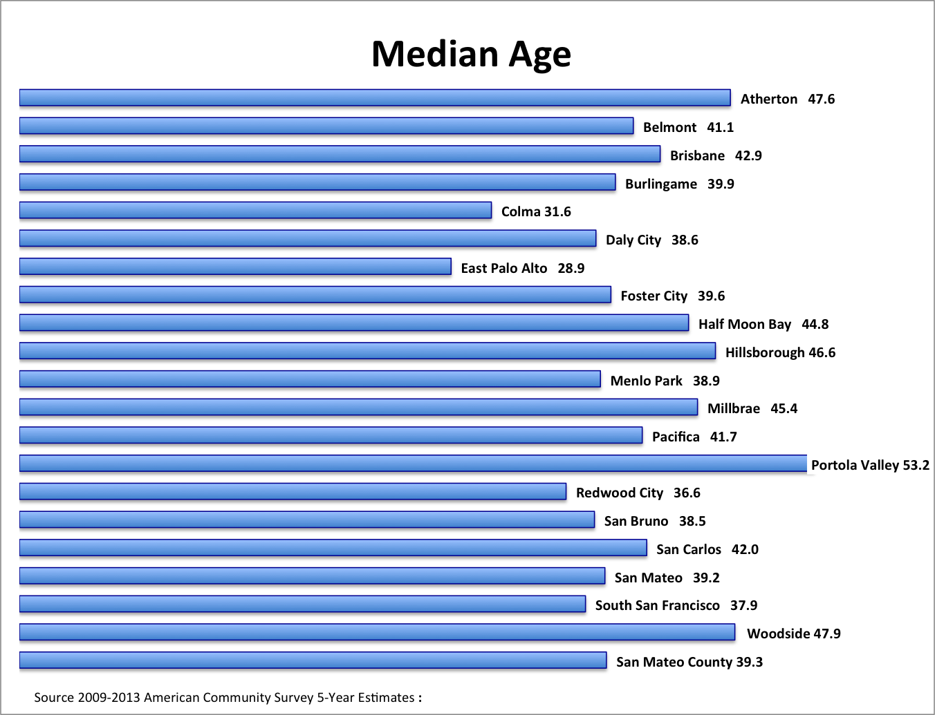

After the planning period, younger adults (age ranges 15 to 34) will increase sharply as will older adults (ages 60 and above). Beyond the planning period, San Mateo and the surrounding counties are expected to experience above average growth in population for people ages 29 and younger, and declines in population for adults ages 30-54. The decline in younger adults during the planning period is a pivotal finding facing the District’s immediate future (Figure 2).

Race and Ethnicity
Shifting race and ethnicity patterns in San Mateo County also shape the District’s strategic planning (Table 1). It is estimated that the overall White population will decline over the planning period while the proportion of San Mateo County’s population that identifies themselves as Asian, Hispanic or Latino, American Indian, or Two or More Races will increase. These changes are more evident at the secondary school level where the proportion of Hispanic graduates now surpasses the White Not- Hispanic proportion (Figure 3).

Figure 2
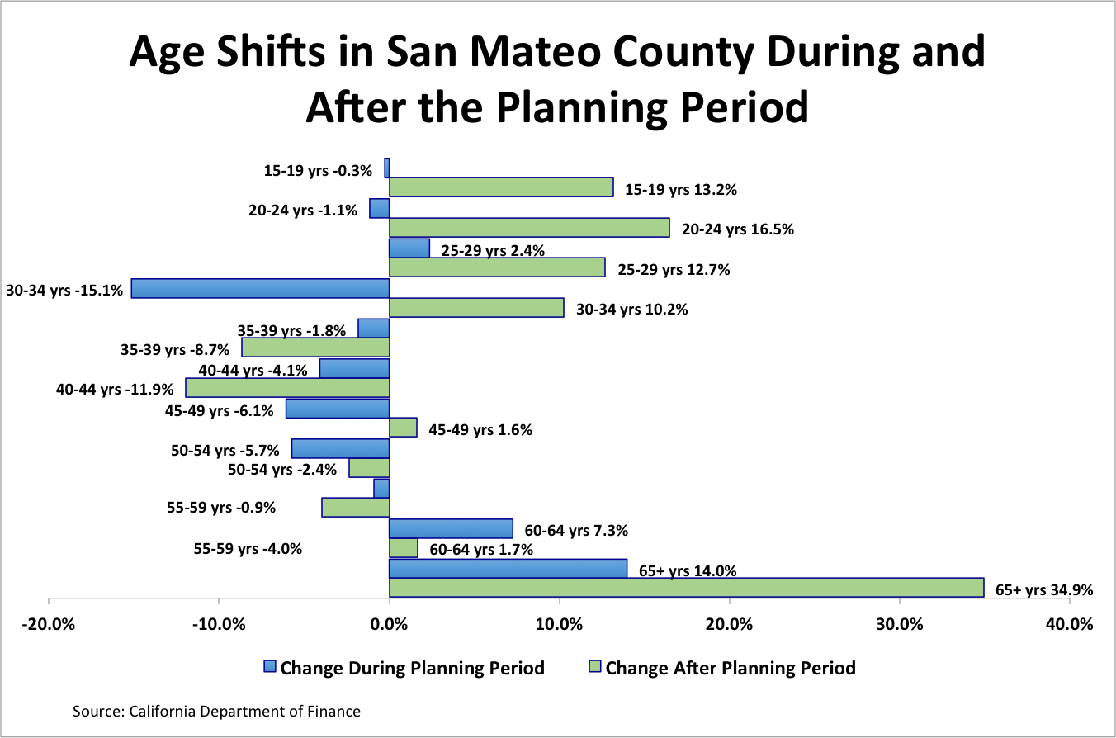

Table 1
Overall Shifts in Race and Ethnicity in San Mateo County
 | 2015 | 2020 | 2030 | % Change During the Planning Period
American Indian and Alaska Native Alone, Not Hispanic or Latino | 1,202 | 1,251 | 1,286 | 4.1%
Asian Alone, Not Hispanic or Latino | 192,367 | 204,567 | 215,893 | 6.3%
Black or African American Alone, Not Hispanic or Latino | 19,038 | 18,877 | 18,689 | -0.8%
Hispanic or Latino of Any Race | 195,499 | 207,976 | 220,579 | 6.4%
Native Hawaiian and Other Pacific Islander Alone, Not Hispanic or Latino | 11,395 | 12,392 | 13,360 | 8.7%
Two or More | 25,725 | 28,328 | 31,404 | 10.1%
White, Not Hispanic or Latino | 307,525 | 303,697 | 299,717 | -1.2%
Source: California Department of Finance

Figure 3
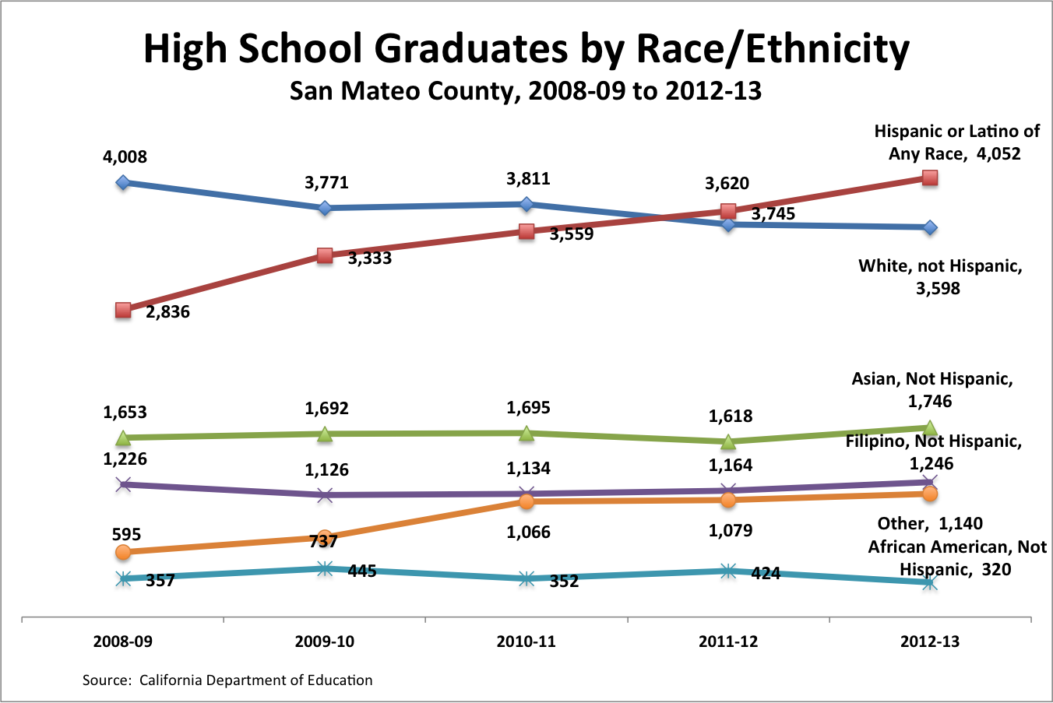

Income and Poverty
The County’s median household income of $87,751 is substantially higher than all but several counties in California. The proportion of all persons living in poverty in San Mateo County (7.6%) is half the California (15.9%) and United States (15.4%) proportions. However, four cities within the county exceed the San Mateo County average: East Palo Alto (18.4%), Redwood City (9.0%), Daly City (8.6%), and Colma (8.0%). Figure 4 depicts Per Capita Income in San Mateo County and shows the wealth gap in the County.

Figure 4
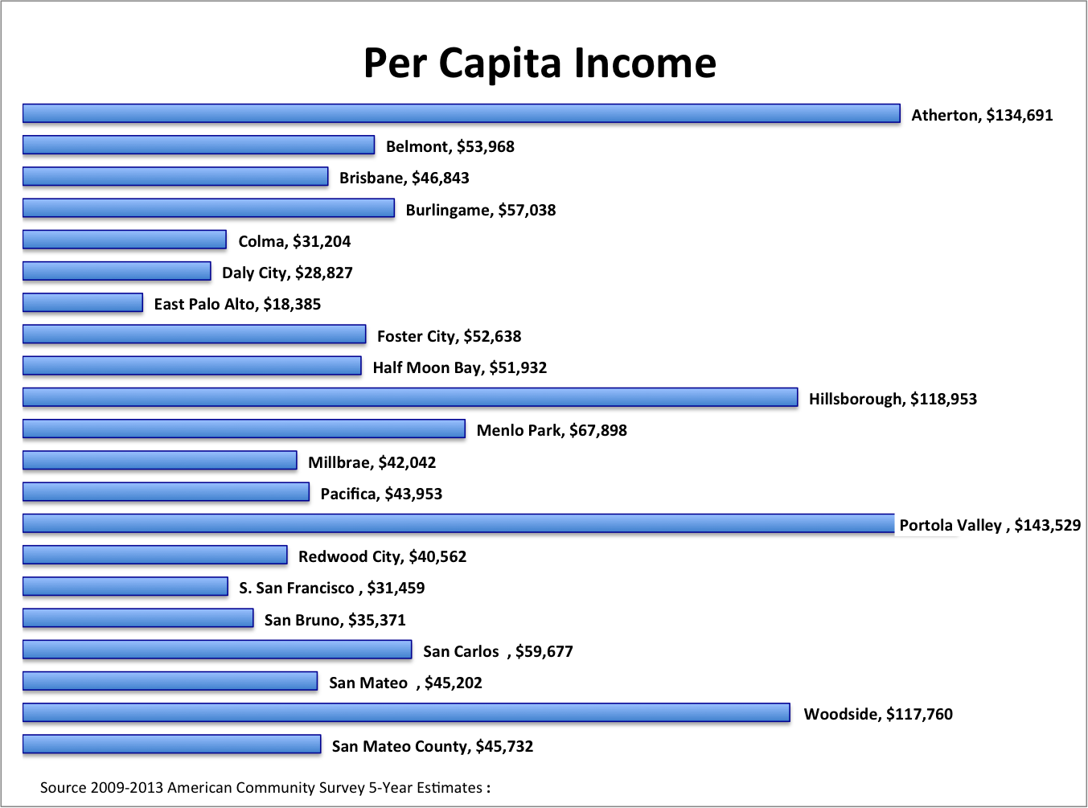

English Language Proficiency
San Mateo County is linguistically complex as illustrated by Table 2. The majority of residents of East Palo Alto speak Spanish at home. Other locations where more than a quarter of homes speak Spanish include Colma, Redwood City, Half Moon Bay, and South San Francisco. Locations where more than a quarter of homes speak Asian and Pacific Islander languages include Daly City, Foster City, and Millbrae.

Table 2
Language Spoken at Home, San Mateo County and Cities
 | English only | Spanish | Other Indo-European languages | Asian and Pacific Islander languages | Other languages
San Mateo County | 54.0% | 20.3% | 6.3% | 18.0% | 1.4%
Atherton | 84.4% | 4.2% | 6.2% | 5.1% | 0.2%
Belmont | 65.6% | 10.2% | 10.5% | 11.8% | 1.9%
Brisbane | 63.9% | 10.7% | 3.4% | 21.9% | 0.2%
Burlingame | 68.1% | 9.6% | 7.0% | 14.5% | 0.8%
Colma | 27.6% | 44.6% | 3.4% | 24.2% | 0.1%
Daly City | 31.4% | 18.2% | 4.2% | 44.4% | 1.8%
East Palo Alto | 29.9% | 57.2% | 2.4% | 8.4% | 2.1%
Foster City | 50.0% | 3.3% | 14.8% | 29.3% | 2.6%
Half Moon Bay | 64.8% | 28.5% | 4.3% | 2.0% | 0.3%
Hillsborough | 72.8% | 3.5% | 6.4% | 16.5% | 0.8%
Menlo Park | 69.6% | 16.5% | 6.3% | 6.5% | 1.1%
Millbrae | 49.5% | 9.5% | 6.8% | 31.8% | 2.4%
Pacifica | 72.1% | 10.3% | 4.2% | 12.4% | 0.9%
Portola Valley | 87.8% | 4.0% | 4.2% | 3.7% | 0.3%
Redwood City | 54.5% | 33.8% | 5.0% | 5.9% | 0.8%
San Bruno | 50.1% | 21.4% | 8.1% | 18.1% | 2.3%
San Carlos | 78.3% | 6.2% | 7.8% | 7.2% | 0.5%
San Mateo | 55.8% | 20.7% | 7.7% | 14.2% | 1.6%
South San Francisco | 40.4% | 26.9% | 6.5% | 24.6% | 1.7%
Woodside | 88.9% | 4.2% | 4.4% | 1.8% | 0.7%
Source: 2009-2013 American Community Survey 5-Year Estimates

Educational Attainment
Educational attainment among adults aged 25 in San Mateo County older exceeds both the California and United States proportions by wide margins (Table 3). The proportion of adults in the County holding Bachelor’s degrees or higher is significantly greater than either California or the nation. Even with a high overall rate of educational attainment, there are cities and other locations in the County where educational attainment are low (Table 4). Through this plan the District will work with school districts, community based organizations, businesses and industry, and other partners to help close these gaps.

Table 3
Comparative Education Attainment by Adults 25 years and Older
Attainment | %  United States | % California | %  San Mateo County
Less Than High School Diploma | 13.6 | 18.5 | 11.2
High School Graduate or GED | 28.0 | 20.6 | 16.9
Some College or Associate’s Degree | 29.2 | 30.0 | 28.1
Bachelor’s Degree | 18.2 | 19.6 | 26.8
Graduate or Professional Degree | 10.9 | 11.3 | 17.6
U.S. Census survey, 2013

Table 4
Education Attainment by City
 | Less than 9th Grade | 9th to 12th Grade, no Diploma | High School graduate or GED | Some college, no degree | Associate's degree | Bachelor's degree | Graduate or Prof. Degree | High School Graduate  + | Bachelors  +
Atherton | 0.4% | 1.7% | 4.1% | 6.0% | 3.7% | 42.6% | 41.5% | 98.0% | 84.1%
Belmont | 2.1% | 2.4% | 12.3% | 20.1% | 7.6% | 30.4% | 25.0% | 95.4% | 55.5%
Brisbane | 4.6% | 2.6% | 14.7% | 21.2% | 4.9% | 36.0% | 16.1% | 92.8% | 52.0%
Burlingame | 2.6% | 1.9% | 13.0% | 16.8% | 7.4% | 32.7% | 25.6% | 95.5% | 58.3%
Colma | 9.6% | 5.8% | 18.5% | 27.6% | 4.8% | 28.1% | 5.7% | 84.6% | 33.7%
Daly City | 7.4% | 6.5% | 21.1% | 22.3% | 9.5% | 27.2% | 6.0% | 86.1% | 33.2%
East Palo Alto | 21.4% | 11.5% | 27.6% | 18.9% | 4.3% | 9.6% | 6.7% | 67.1% | 16.3%
Foster City | 1.6% | 2.1% | 10.7% | 16.6% | 6.7% | 33.7% | 28.6% | 96.3% | 62.3%
Half Moon Bay | 11.6% | 6.1% | 14.4% | 18.2% | 4.5% | 25.5% | 19.8% | 82.4% | 45.3%
Hillsborough | 2.3% | 1.5% | 6.0% | 9.6% | 4.5% | 32.8% | 43.2% | 96.1% | 76.0%
Menlo Park | 4.2% | 3.0% | 7.9% | 10.3% | 4.2% | 30.6% | 39.8% | 92.8% | 70.4%
Millbrae | 4.4% | 4.0% | 19.0% | 23.5% | 7.9% | 26.5% | 14.6% | 91.6% | 41.1%
Pacifica | 2.1% | 3.3% | 18.3% | 25.9% | 10.3% | 26.8% | 13.4% | 94.6% | 40.1%
Portola Valley | 1.1% | 3.3% | 4.1% | 7.0% | 3.9% | 36.1% | 44.5% | 95.6% | 80.5%
Red Wood City | 8.6% | 7.1% | 18.6% | 19.4% | 6.1% | 24.0% | 16.2% | 84.3% | 40.2%
San Bruno | 5.4% | 4.3% | 22.2% | 23.7% | 9.5% | 25.5% | 9.5% | 90.3% | 35.0%
San Carlos | 1.4% | 1.9% | 11.3% | 17.8% | 7.5% | 32.7% | 27.3% | 96.6% | 60.0%
San Mateo | 7.1% | 4.5% | 16.2% | 20.1% | 7.8% | 26.9% | 17.5% | 88.4% | 44.4%
South San Francisco | 7.2% | 8.1% | 24.4% | 20.1% | 10.5% | 21.9% | 7.8% | 84.7% | 29.8%
Woodside | 2.4% | 1.1% | 12.9% | 11.7% | 5.4% | 31.0% | 35.5% | 96.5% | 66.5%
Source: 2009-2013 American Community Survey 5-Year Estimates

Demographic Summary

The demographic pattern in San Mateo County as portrayed above shows income, age, and languages spoken at home to be correlated. In general, cities where these factors are lower also have lower levels of education attainment. The reverse is also true. Since this strategic plan seeks to increase the education attainment level in the County, the communities with these characteristics are the places where accelerated effort should be directed.

Equity

The San Mateo Community College District has a longstanding commitment to closing equity gaps. This commitment has seen recent and accelerated interest statewide. In particular the Student Success Act of 2012 has been a focus for the State Assembly as well as the California Community Colleges. To meet its obligations to students and taxpayers, the District will continue to utilize its own research to identify where all students are succeeding or not succeeding in their educational pursuits. In particular, these disaggregated subgroups will be a focus of Districtwide efforts to close equity gaps: race/ethnicity, age, gender, veteran’s status, economic disadvantage, and foster youth. Closing equity gaps depends on understanding the experiences of students entering one of the three Colleges as well as those prospective students who do not enter. Cohort analysis will continue to be used to determine both overall success rates for all students in the District as well as success rates for the subgroups identified above.

In November 2014 the San Mateo Community College Board of Trustees approved Equity Plans developed by each College to identify gaps in access, course completion, ESL and basic skills completion, degrees, certificates and transfer for all students as measured by success indicators linked to the California Community Colleges Student Success Scorecard, as well as local measures developed at each College. College plans identify quantitative benchmarks and associated targets to close equity gaps. Prior to next academic year, 2015-16, the State Chancellor’s office will set system targets for overall improvement while individual community colleges will set their own targets. These targets will be updated annually.

Economics

Employment
Business building and leasing activity is accelerating in San Mateo County,and the County is a desirable location for tech companies to expand. The acceleration of openings in the tech-based economy recently placed the County as the second most favorable unemployment rate among California’s counties. There are, however, pockets of unemployment within the County that drag the average employment rate downward. As of March 2015, these cities and locations exceeded the County’s 3.4% unemployment rate: Broadmoor CDP (5.6%), East Palo Alto (5.4%), North Fair Oaks CDP (5.1%), Brisbane (4.4%,), Daly City (4.2%), and South San Francisco (3.6%).

Business Expansion
Examples of recent economic expansion include: (a) San Mateo BayCenter Office Campus along the Highway 92 corridor in San Mateo was recently sold for $128.5 million; (b) Storm’s Crossing 900 is on track to be completed by 2015. The 300,425-square-foot high-rise office development is located in Downtown Redwood City and already is 100% leased to Box, a young high tech company and (c) Alibaba, the Chinese internet commerce giant is increasing its leased space in San Mateo.

Housing

Housing prices determine whether young families become established in the County or whether they seek other Counties to raise their children. Housing prices also affect older aged individuals who may wish to downsize their living space by moving into condominiums, townhouses, or managed living environments. Homeownership costs throughout the County are high meaning that young families may be unable to relocate to San Mateo County without sufficiently high levels of income typically brought about by accompanying high levels of education.

As the population ages in the County and as available land increases in cost, an increasing proportion of new construction will be in multi-unit structures. As the housing market—especially in places where rental costs are high—squeezes lower-income families’ disposable income the result is that family resources available for education and tuition may correspondingly decline, making it more difficult for the District to increase its penetration rate from a low-income, rental demographic.

Community Supported Status

The San Mateo County Community College District is a “community-supported or basic aid ” district unlike 66 of the 72 California community college districts that receive state aid through apportionment (general fund monies based on student enrollment). These 66 colleges are allocated state resources based on the Full Time Equivalent Student (FTES) cap number set in the State Chancellor’s Office. Community supported means that when the State sets the District’s revenue limit (determining how many students we are funded to serve) and deducts from that revenue limit the local property taxes and student fees, there is no need for State apportionment to sum to our revenue limit. Property taxes, then, are the chief source of revenue in a community-supported district.

Community-supported funding for the San Mateo Community College District has risen independently of student enrollment, a result of increasing property values. The San Mateo County Community College District is not obligated to increase enrollment annually to increase revenues. The fundamental obligation of the San Mateo Community College District is to serve San Mateo County citizens irrespective of limits set by the state. The District’s financial position provides opportunities to create new approaches to serve San Mateo citizens independent of state revenues and community college funding levels. At the same time, enrollment levels are an important barometer for assessing the vitality of the District’s Colleges and the programs they offer.

Enrollment and Student Demographics

Changes in Enrollment
District enrollments have generally declined over the past five years (Figure 3) in tandem with statewide community college enrollments that saw 2.3 million fewer students enrolled from 2008-09 to 2012-13 due to reduced funding from the State. Statewide economic declines resulted in severe budget cuts to community colleges. Consequently, colleges cut back on courses and sections they offered. As a result of the voter-approved parcel tax, SMCCCD did not cut as severely as other colleges. As the economy recovered, SMCCCD’s enrollment declined, as higher education enrollments traditionally decline as students pursue employment over college attendance. Changes in state policy in 2012 limiting the number of times that students may repeat classes in physical education, performing and visual arts areas also impacted SMCCCD enrollments.
Figure 5
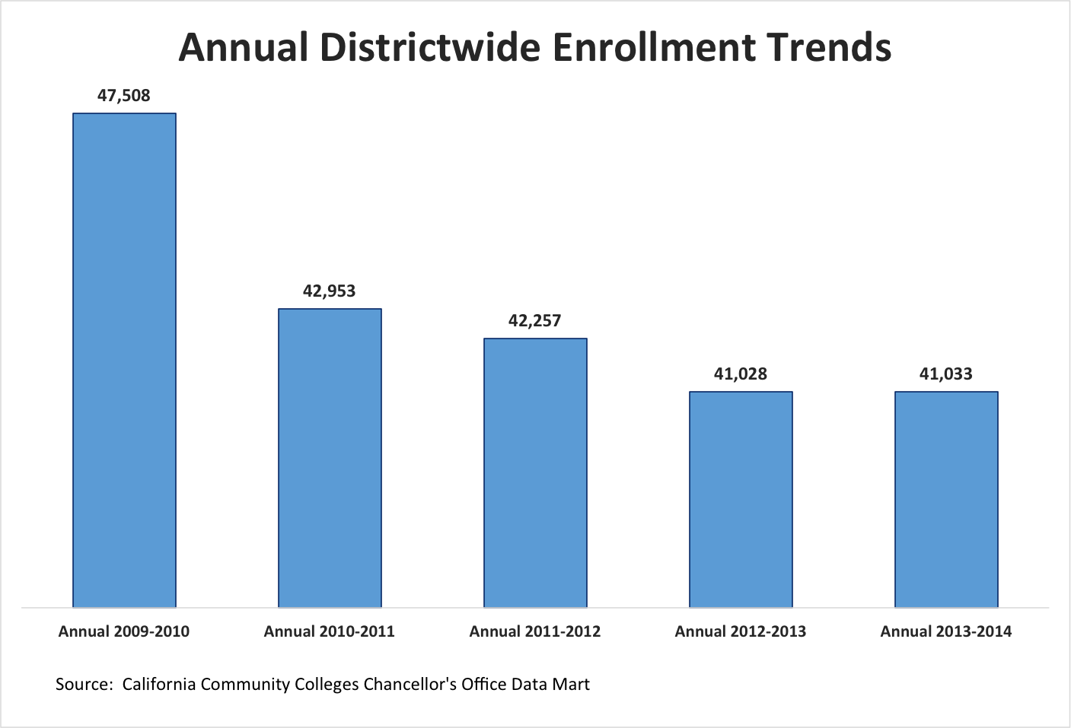

During this same time, enrollment has shifted at Cañada, College of San Mateo, and Skyline (Figure 6). While all three colleges have declining enrollment, Skyline College has had less consistent drops and CSM has seen the most percentage drop.

Figure 5
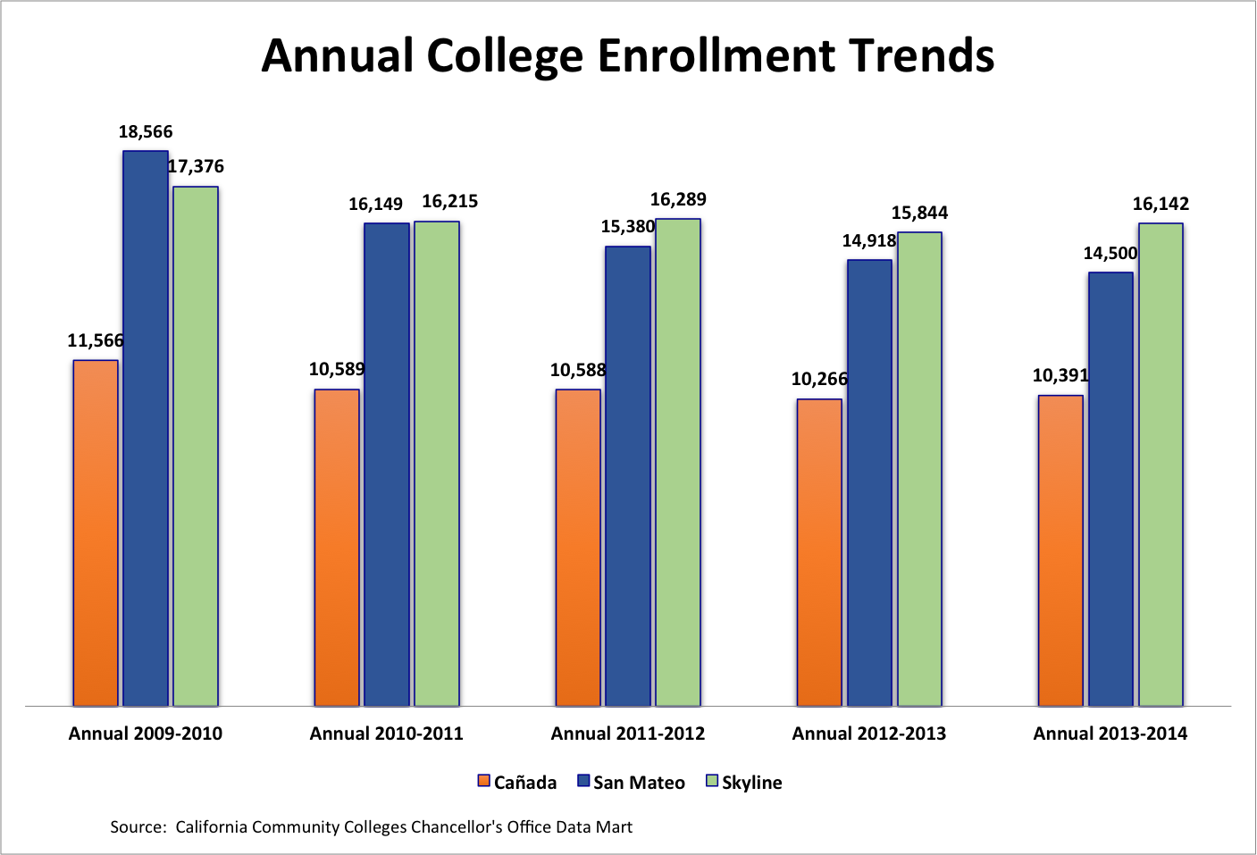

Shifts in Student Demographics

Age Trends
The District has become younger during the past five Fall terms (Table 5 and Figure 7) when the proportion of enrollment in Fall terms is considered. Older student age ranges have declined, perhaps the result of state policy changes noted above as well as an economy, while always healthy in San Mateo County, which has become even more robust. Increasing fees at CSU and UC may have shifted more high school graduates to community college as well.

Table 5
Districtwide Proportionate Age Range Shifts
 | Fall 2010 | Fall 2011 | Fall 2012 | Fall 2013 | Fall 2014 | Change Fall 2010 to 2014
19 or Less Headcount | 6,406 | 6,331 | 6,181 | 6,751 | 6,893 | 487
% of Fall Total | 23.8 | 23.7 | 24.4 | 26.3 | 27.7 | 16.1
20 to 24 Headcount | 8,271 | 8,446 | 8,422 | 8599 | 8,393 | 122
% of Fall Total | 30.8 | 31.7 | 33.3 | 33.5 | 33.7 | 9.5
25 to 29 | 3,702 | 3,697 | 3,518 | 3418 | 3,213 | -489
% of Fall Total | 13.8 | 13.9 | 13.9 | 13.3 | 12.9 | -6.4
30 to 34 | 2,081 | 2,108 | 2,041 | 1967 | 1,897 | -184
% of Fall Total | 7.7 | 7.9 | 8.1 | 7.7 | 7.6 | -1.7
35 to 39 | 1,481 | 1,376 | 1,195 | 1191 | 1,221 | -260
% of Fall Total | 5.5 | 5.2 | 4.7 | 4.6 | 4.9 | -11.1
40 to 49 | 2,377 | 2,318 | 1,899 | 1768 | 1,613 | -764
% of Fall Total | 8.8 | 8.7 | 7.5 | 6.9 | 6.5 | -26.8
50 + | 2,565 | 2,385 | 2,026 | 1952 | 1,697 | -868
% of Fall Total | 9.5 | 8.9 | 8.0 | 7.6 | 6.8 | -28.6

Figure 6
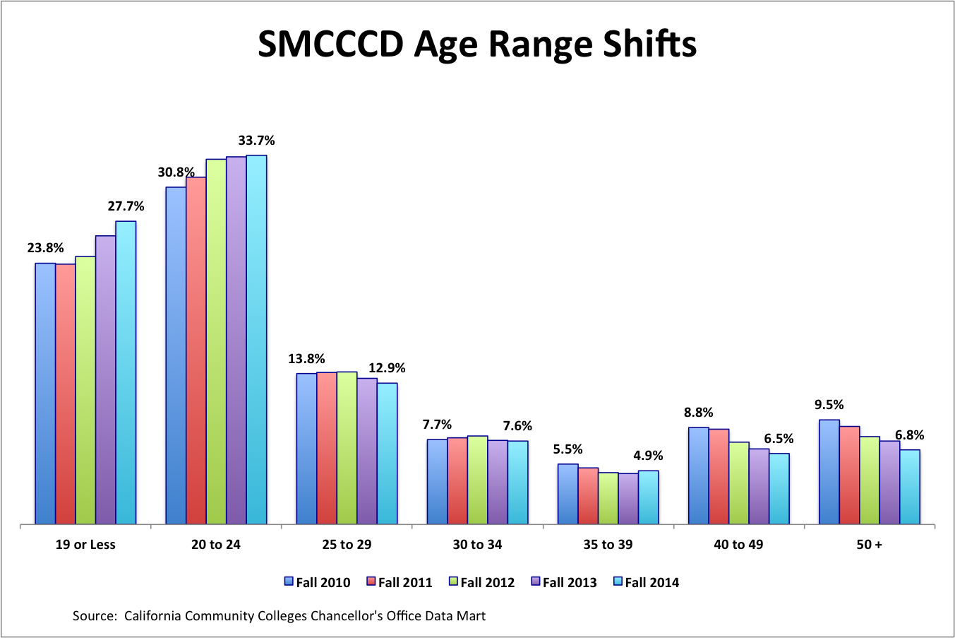

Gender Trends
The District has become slightly but increasingly more male during the past five falls (Figure 8).
Figure 7
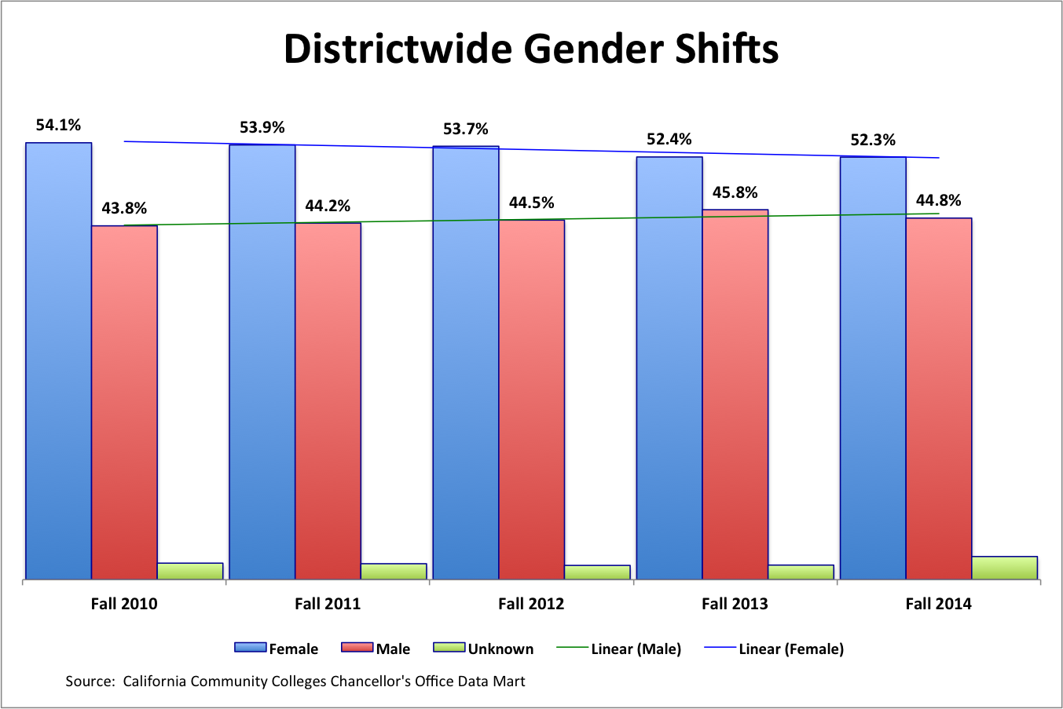

Ethnicity Trends
The District has become more racially and ethnically diverse during the past five Fall terms (Table 6). Hispanics and White Non-Hispanics constituted equal parts of the District’s profile in Fall 2010. Since that time, the proportion of Hispanics has increased while White Non-Hispanics have decreased. Asian, American Indian/Alaskan Native, and Pacific Islander students have remained stable while there is an increase in students who identify themselves as Multi-Ethnic.

Table 6
Districtwide Race and Ethnicity Shifts

 | Fall 2010 (%) | Fall 2011 (%) | Fall 2012 (%) | Fall 2013 (%) | Fall 2014 (%)
African-American | 3.7% | 3.6% | 3.7% | 3.4% | 3.3%
American Indian/Alaskan Native | 0.3% | 0.3% | 0.2% | 0.2% | 0.2%
Asian | 16.7% | 15.9% | 15.9% | 16.1% | 16.8%
Filipino | 9.8% | 9.7% | 9.6% | 10.1% | 10.5%
Hispanic | 28.4% | 30.5% | 31.9% | 34.1% | 35.3%
Multi-Ethnicity | 2.4% | 3.4% | 4.1% | 4.6% | 4.7%
Pacific Islander | 2.0% | 2.0% | 2.0% | 1.7% | 1.7%
White Non-Hispanic | 28.8% | 28.6% | 27.8% | 26.1% | 24.8%
Unknown | 8.0% | 5.9% | 4.8% | 3.6% | 2.9%
Source: California Community Colleges Chancellor’s Office Data Mart

Financial Aid Trends
While District annual enrollments have declined over the past five years, the proportion of students receiving financial aid has increased, indicating an upward shift in low-income students (Figure 9). Table 7 depicts the numbers of financial aid recipients by College over the past five Falls. The number of financial aid recipients increased most at Skyline (n=2,556). CSM and Cañada added 1,343 and 1,264, respectively.

Figure 9
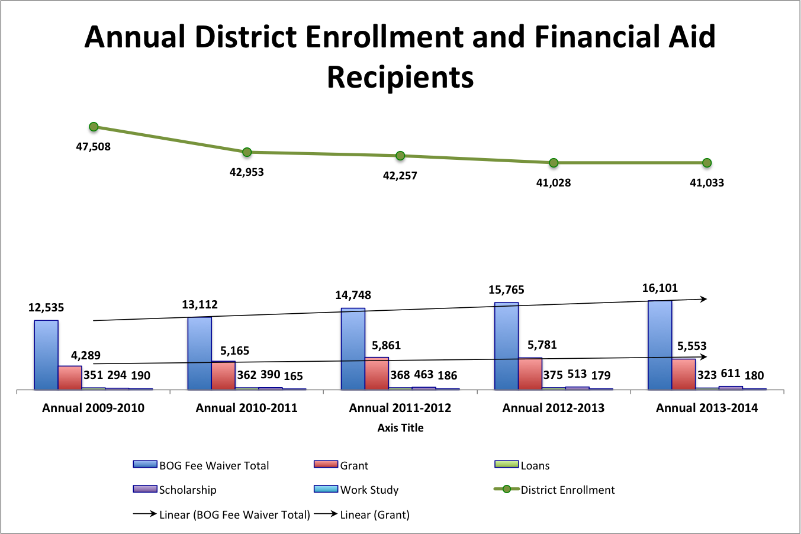

Table 7
Financial Aid Recipients by College
 |  |  | 2009-2010 | 2010-2011 | 2011-2012 | 2012-2013 | 2013-2014
 | Cañada |  | 4,408 | 4,481 | 4,834 | 5,416 | 5,672
 |  | Grants | 1,003 | 1,209 | 1,406 | 1,338 | 1,340
 |  | Loans | 128 | 111 | 147 | 142 | 102
 |  | Scholarship | 94 | 128 | 148 | 158 | 150
 |  | Work Study | 25 | 30 | 35 | 35 | 34
 | San Mateo |  | 5,029 | 5,235 | 6,019 | 6,426 | 6,372
 |  | Grants | 1,520 | 1,708 | 1,764 | 1,806 | 1,635
 |  | Loans | 130 | 142 | 91 | 102 | 91
 |  | Scholarship | 117 | 144 | 166 | 202 | 268
 |  | Work Study | 74 | 64 | 69 | 49 | 67
 | Skyline |  | 5,458 | 6,012 | 7,033 | 7,624 | 8,014
 |  | Grants | 1,768 | 2,248 | 2,693 | 2,638 | 2,578
 |  | Loans | 93 | 109 | 130 | 131 | 130
 |  | Scholarship | 86 | 118 | 153 | 157 | 194
 |  | Work Study | 91 | 71 | 82 | 95 | 79
Source: California Community Colleges Chancellor’s Office Data Mart

Secondary Schools and Penetration Rates
Figure 10 shows the recent upswing in high school graduates in the County through 2013-14 followed by a forecast decline of 249 graduates in 2014-15. Whether the forecasted upward trajectory continues throughout the planning period is in question since state population projections suggest that the 15 to 19 year-old age range will decline slightly from 2015 to 2020.
Figure 10
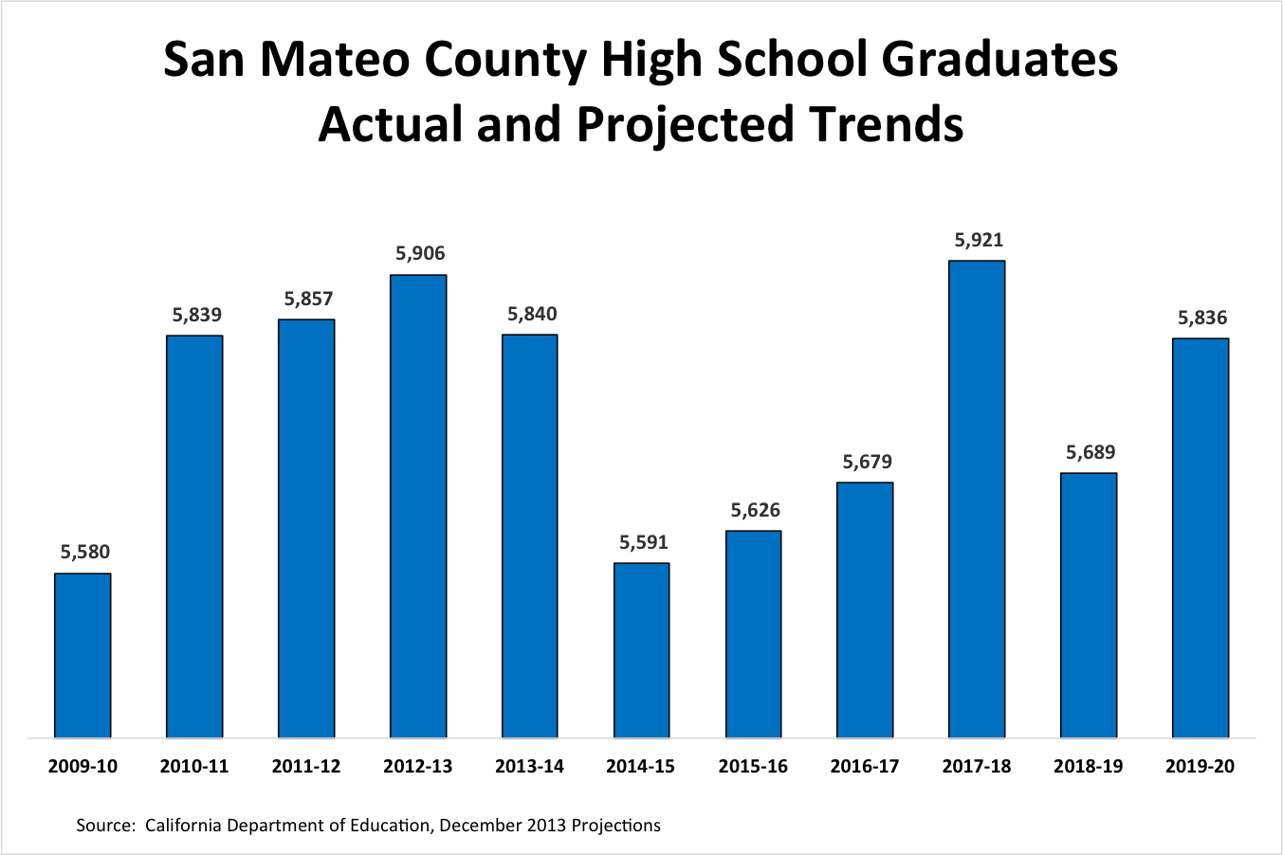

Figure 11 shows that Hispanic or Latino graduates in the County surpassed White Non-Hispanic graduates in 2011-12. Higher birthrates among Hispanic citizens make it likely that this trend will continue.

Figure 11
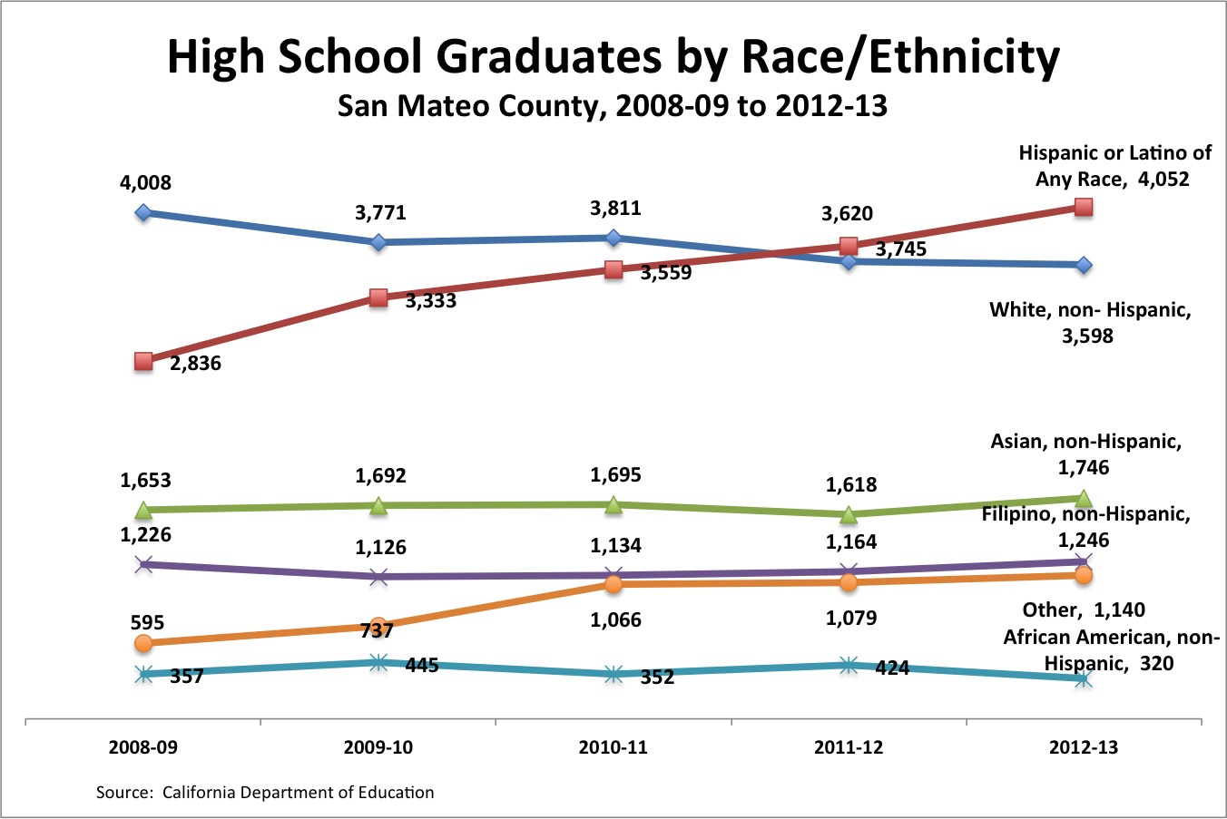
Figure 12
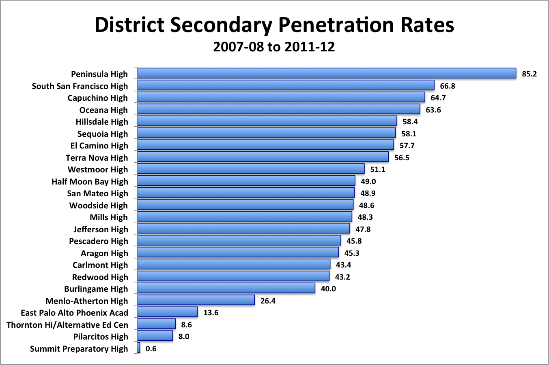

Figure 12 depicts the high school senior take-rate in the District over a five-year span. During this time span, 49.0% of the County’s high school seniors enrolled in one of the District’s Colleges.

High School Student Enrollment
Students enrolled in San Mateo high schools can enroll in District classes at one of the three Colleges, at District-sponsored Middle College High Schools, and through classes delivered at their own high schools (Figure 13).
Figure 13
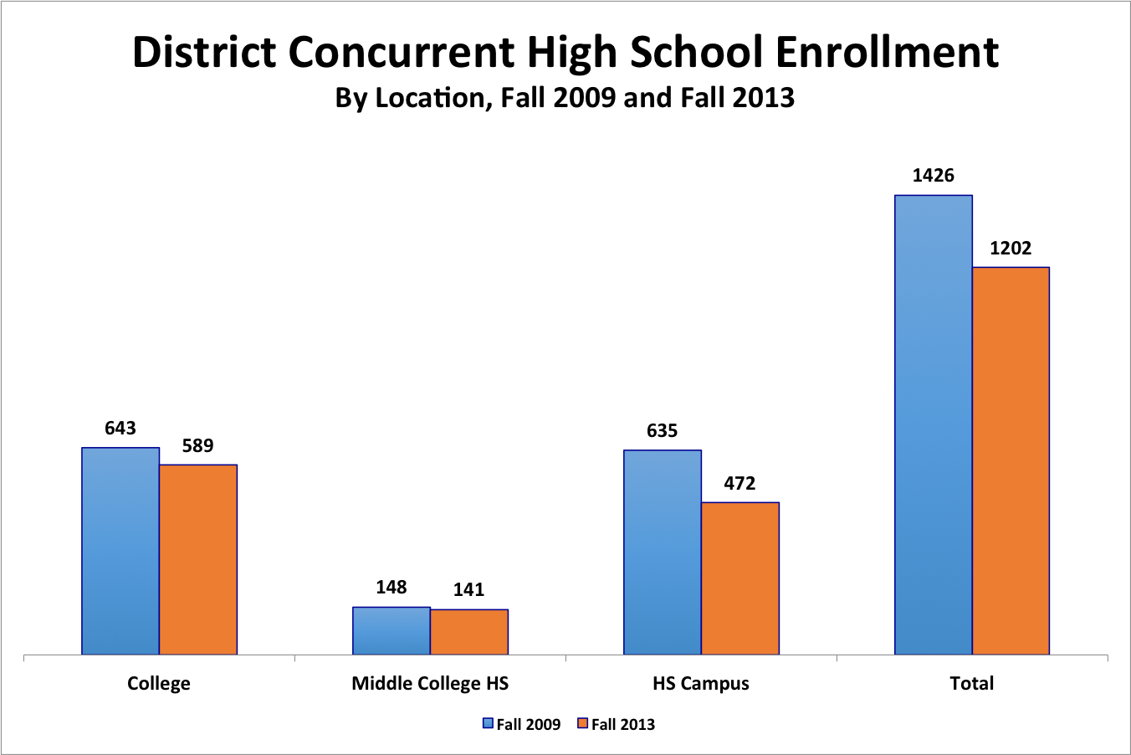

Connections to Labor Markets
San Mateo County lies directly between and is a part of two dynamic employment centers, San Francisco to the north and Santa Clara to the south. Employment in this region grew even during the recent Recession and rapid growth is expected throughout the planning period. Employment growth in San Mateo County has been robust throughout the past several years while unemployment has come down steadily since early 2010. Many of the jobs in the County are in professional, scientific, and information sectors. The boom in information technology, e-commerce, media, and mobile technology has contributed to a healthy employment outlook.

As bright as the future looks for high-end jobs in the County, recent research shows that the Peninsula economy is no longer generating as many mid-range jobs as it once did while low-wage service jobs are multiplying. This gap is widening and the District can play a key role in providing workforce solutions by refining existing certificate and degree programs and creating new programs that lead to jobs not only in technology and related services but also in jobs in support fields. Working with business and industry partners, the District has assessed employer demand in these key areas: (1) accounting, (2) biotechnology, (3) digital arts, graphics and media, (4) health care, and (5) computer information systems. Changes in curriculum to match this research are underway.
A labor market analysis developed for the planning process documents the rise in low-wage service jobs in the region both among jobs with the most openings. In fact, the top four jobs with the most openings are high turnover occupations that require only short-term on-the-job training. Other jobs are also low-wage and high turnover although they require a level of supervision for which the Colleges can prepare managers. Other occupations with the largest number of openings require postsecondary education and sometimes longer-term or intensive on-the-job training. These jobs should be a focus for the District’s academic planning and include: Market Research Analysts and Marketing Specialists, Software Developers, Accountants and Auditors, Registered Nurses, Customer Service Representatives, Office Clerks, General and Operations Managers, and Food Preparation Workers. Of these occupations that are forecast to grow the most, Registered Nursing requires an Associate’s degree for entry.

The fastest growing occupations for this same timeframe are skilled occupations and, to a large degree, are concentrated in the computer and technology sectors. The computer and technology sectors including software application developers and systems software developers will see an annual employment increases between 48 and 57 percent; information security analysts, web developers and computer network architects will grow by 37 percent; computer and information systems managers is estimated to grow by 30 percent; network and computer systems administrators are predicted to grow by 40 percent; and multimedia artist and animators growing by 38 percent. Nearly all of these jobs are linked to a bachelor’s degree for entry, suggesting that a District academic planning focus should be on providing the first two years of applied study in these fields for transfer students as well as short-term classes and training for individuals already employed in these fields.

Instructional Programs

Breadth of Offerings And Trends
The District provides an array of instructional programs across its three Colleges (Figure 14). Larger areas of instruction are in “traditional” college programs and including humanities, mathematics, social sciences, education, psychology interdisciplinary studies, and business and management. The District also offers a range of career and technical programs that are smaller in scope and in engineering and industrial technologies, health, public and protective services, architecture and environmental design, media and communication, and information technology.

Figure 14
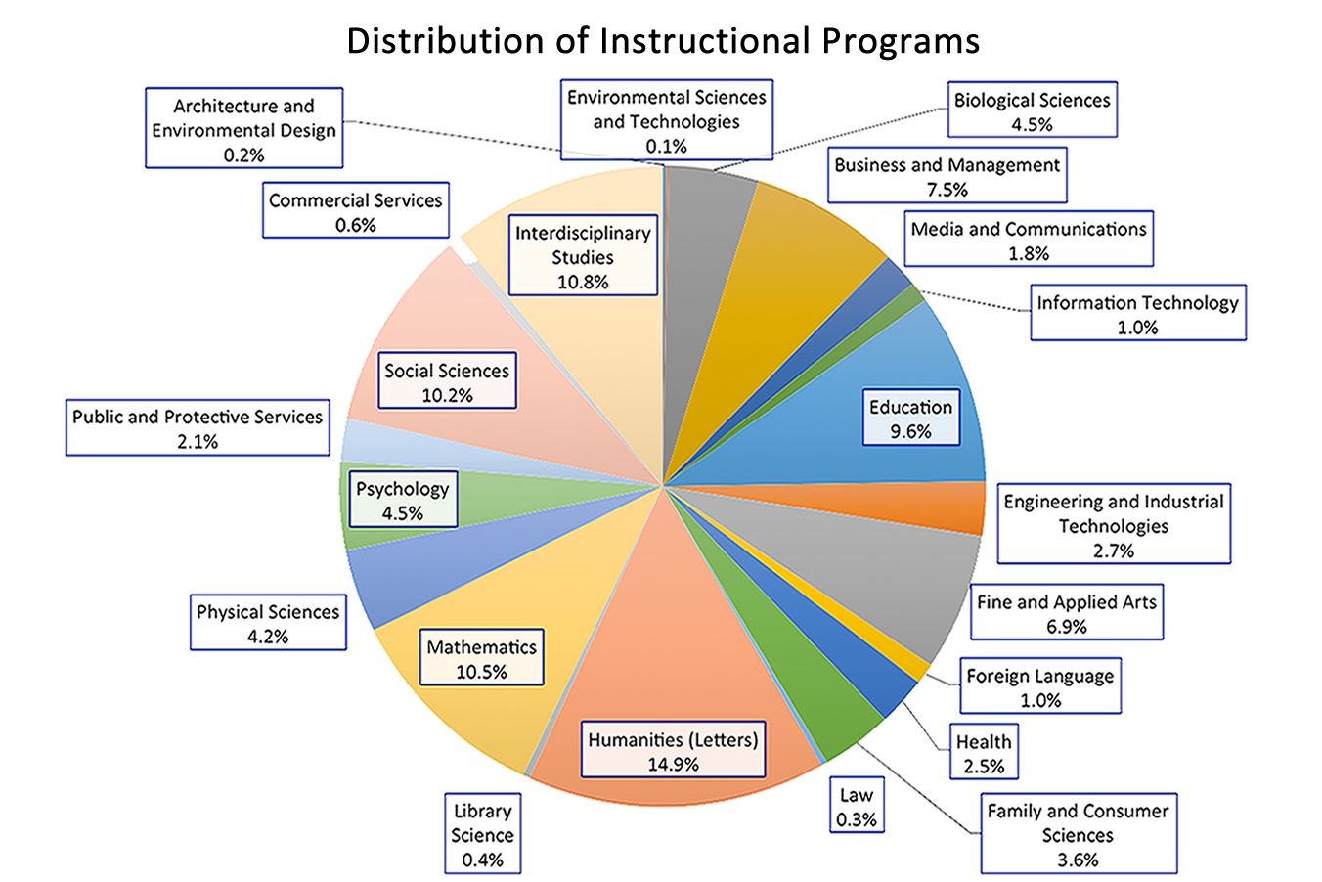

Table 8 is an overview of program trends from Fall 2009 through Fall 2013. This table shows a decline in course enrollments of 6% Districtwide during this span, reflecting, in part, purposeful decisions made the District to reduce course sections and the 2012 state requirement to limit the number of course repeats. Large program areas increasing the most were mathematics (89%) and humanities (31%). The three largest declines among large programs were interdisciplinary studies (-42%), business and management (-14%) and education (-11%). Smaller programs that grew the most were information technologies (39%), environmental sciences and technologies (13%), and health (5%). The steepest declines in smaller programs were in commercial services (-49%), foreign language (-46%), law (-35%), family and consumer sciences (-28%), architecture and environmental design (-21%), fine and applied arts (-19%), and public and protective services (-13%).

Table 8
District Instructional Course Enrollment Trends by Instructional Area
Taxonomy of Program Areas | Fall 2009 | Fall 2010 | Fall 2011 | Fall 2012 | Fall 2013 | Size Fall 2013 | % Change Fall 2009 to Fall 2013
01: Agriculture and Natural Resources | 70 | 39 | 58 |  |  | -- | n/a
02: Architecture and Environmental Design | 146 | 123 | 137 | 109 | 116 | Small | -21%
03: Environmental Sciences and Technologies | 61 | 87 | 118 | 81 | 69 | Small | 13%
04: Biological Sciences | 2,537 | 2,568 | 2,705 | 2,740 | 2,579 | Medium | 2%
05: Business and Management | 5,017 | 4,811 | 4,645 | 4,483 | 4,300 | Large | -14%
06: Media and Communications | 1,135 | 1,244 | 1,104 | 1,037 | 1,041 | Medium | -8%
07: Information Technology | 421 | 424 | 423 | 487 | 586 | Small | 39%
08: Education | 6,196 | 5,555 | 5,672 | 5,716 | 5,532 | Large | -11%
09: Engineering and Industrial Technologies | 1,575 | 1,645 | 1,575 | 1,568 | 1,570 | Small | 0%
10: Fine and Applied Arts | 4,925 | 4,589 | 4,169 | 3,920 | 3,983 | Medium | -19%
11: Foreign Language | 1,113 | 836 | 764 | 707 | 599 | Medium | -46%
12: Health | 1,359 | 1,434 | 1,440 | 1,536 | 1,423 | Medium | 5%
13: Family and Consumer Sciences | 2,839 | 2,625 | 2,634 | 2,196 | 2,056 | Medium | -28%
14: Law | 258 | 259 | 200 | 206 | 167 | Small | -35%
15: Humanities (Letters) | 6,532 | 7,893 | 8,345 | 8,509 | 8,588 | Large | 31%
16: Library Science | 22 | 67 | 124 | 158 | 208 | Small | 845%
17: Mathematics | 3,180 | 5,489 | 5,577 | 5,855 | 6,024 | Large | 89%
19: Physical Sciences | 2,359 | 2,171 | 2,432 | 2,424 | 2,411 | Medium | 2%
20: Psychology | 2,486 | 2,216 | 2,374 | 2,417 | 2,576 | Medium | 4%
21: Public and Protective Services | 1,408 | 1,372 | 1,408 | 1,259 | 1,226 | Medium | -13%
22: Social Sciences | 6,394 | 6,113 | 6,010 | 6,001 | 5,851 | Large | -8%
30: Commercial Services | 698 | 371 | 399 | 412 | 353 | Small | -49%
49: Interdisciplinary Studies | 10,667 | 5,770 | 5,862 | 6,049 | 6,206 | Large | -42%
Grand Total | 61,398 | 57,701 | 58,175 | 57,870 | 57,464 |  | -6%

Scheduled Class Times
Figure 15 is the distribution of start times for Districtwide face-to-face classes showing the more than half of all classes (52%) are scheduled in the morning hours while afternoon (22%) and evenings (26%) account for the remainder. In general, the District facilities have capacity for additional courses scheduled for the afternoon and evening hours.
Figure 15
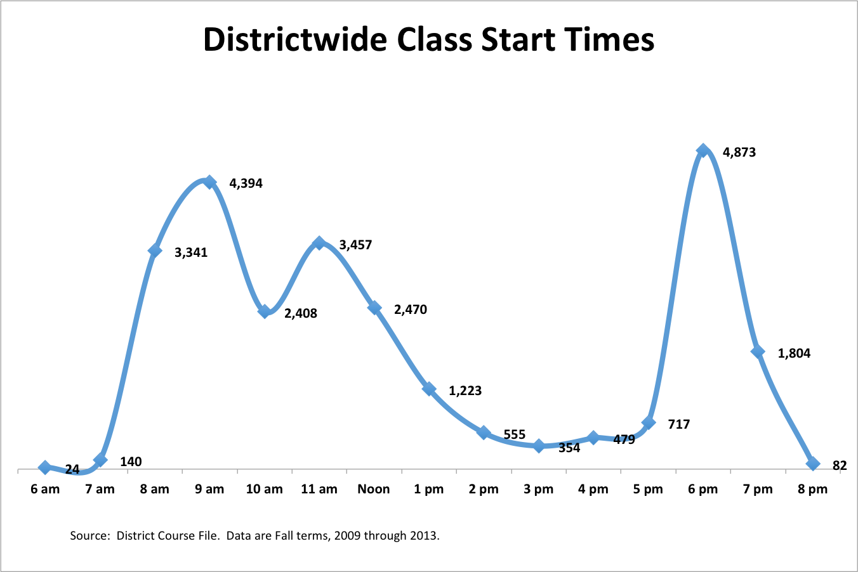

Faculty Age Characteristics and Projections
There are 281 full-time teaching faculty and 41 other faculty (student services and librarians) in Fall 2014. Their average age is 51.4 years while average years of service is 12.0. The College of San Mateo is the oldest of the colleges while Cañada is the youngest in teaching faculty (Figure 16). Analyses of faculty age ranges and program assignment shows more specifically where future hiring needs are likely to emerge (Figure 17). Nearly 40% (112/281) of all teaching faculty are in the retirement zone. For example, all current Information Technology faculty are older than 56. Other programs with relatively high age distributions include: Business and Management, Engineering and Industrial Technologies, and Public and Protective Services. Future demand for instruction in a particular program area may not be static over time, a factor that could influence future resource allocations.
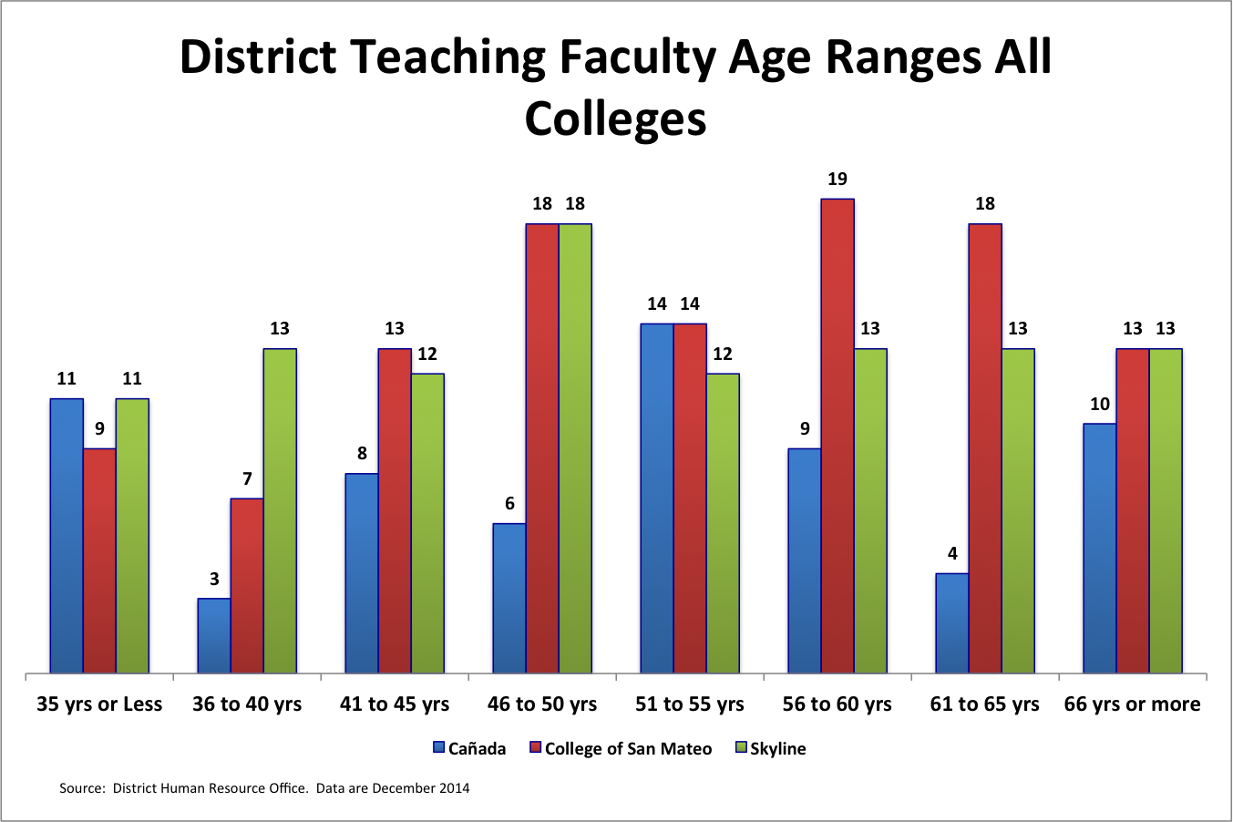
Figure 16

Figure 17
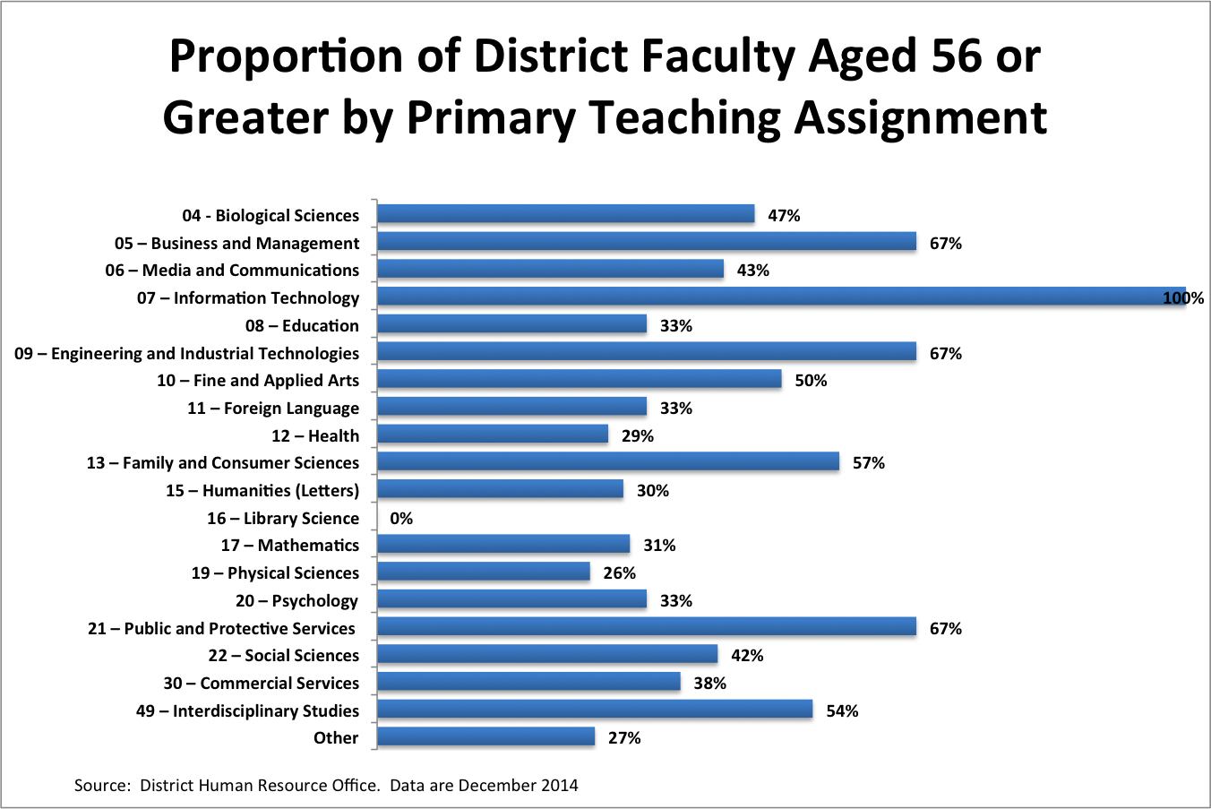

Online Instruction

Ninety-three percent of all District courses are delivered in a traditional face-to-face instruction format. These courses may or may not have some online component. The remainder of District courses are available online (6%) or through hybrid delivery (1%), in which classes meet face-to-face and online (Figure 18). Statewide, more than 12% of all community college courses are offered through distance education, and it is estimated that nearly half of all courses have some online component. Twenty-one percent of all District students enroll for at least one online course. The District is now working to create XLOnline courses that will expand the District’s capacity for providing online learning by enrolling up to 100 students.

Statewide activity in online instruction is increasing. The Online Education Initiative (OEI) is near conclusion of its pilot phase. It is planned that all California Community Colleges will have access to online learning readiness modules and tutoring solutions for free or at reduced cost. There is also a professional development and collaboration component for faculty and staff.
Figure 18
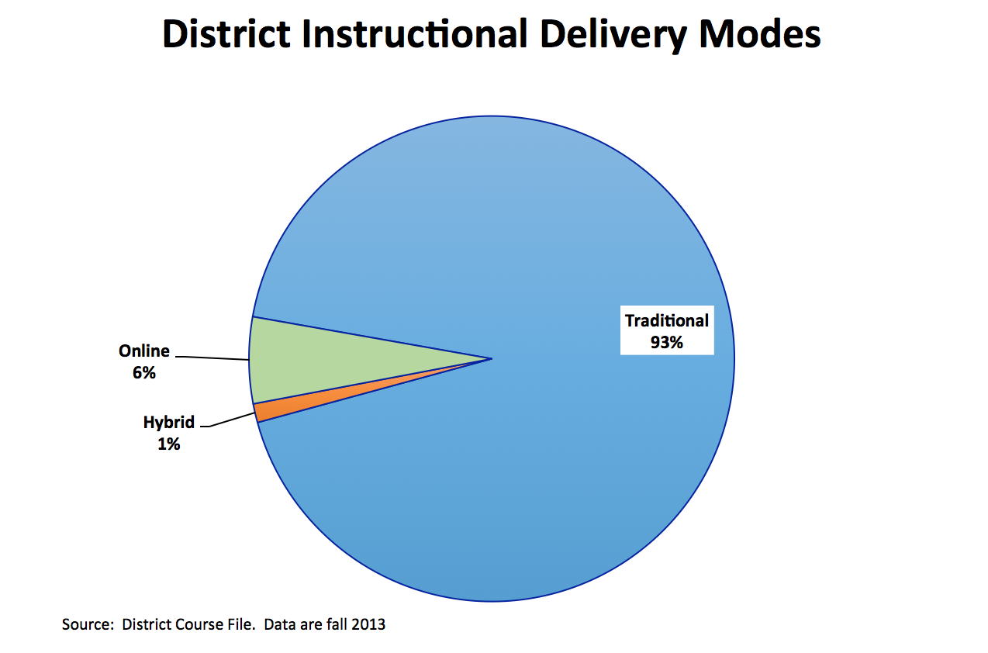

Competitor Analysis
The San Mateo County Community College District enrolls sixteen percent of all students attending public and private two-year colleges in a 25-mile radius of the County (Figure 19). Private-for-profit institutions in this radius enroll a much smaller share of total enrollment (5%). A report documenting competing programs reveals potential niches for new program development as well as places where the District’s programs appear to be saturated.

Figure 19
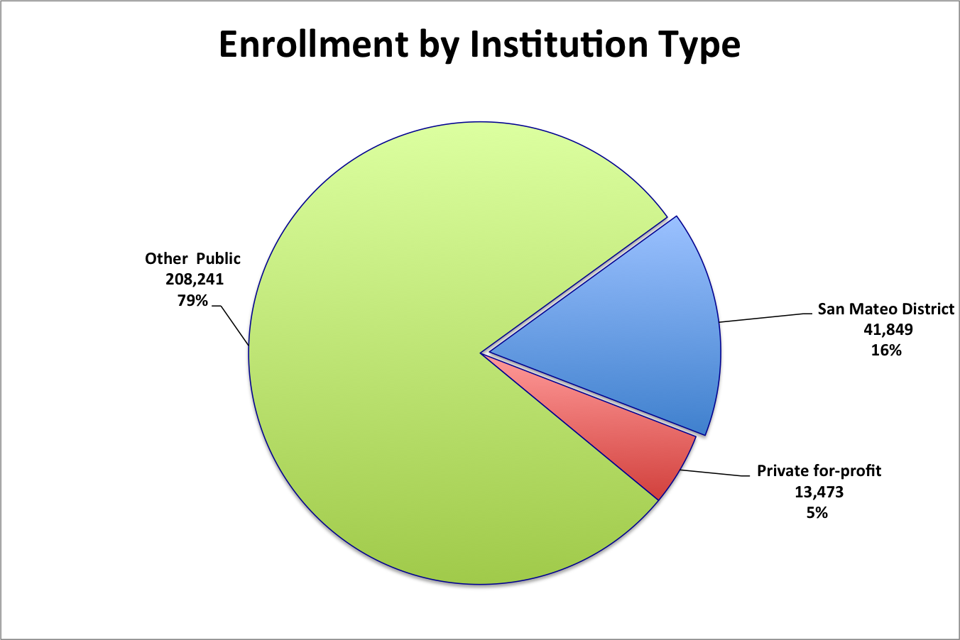

For example, programs with no competition include:

- Astronomy (CSM)
- Bilingualism and Biliteracy in English/Spanish (Cañada)
- Family and Consumer Studies (Skyline)
- Fashion Production (Cañada)
- Police Academy (CSM)

District programs with one to three competitors in the 25-mile radius include:

- Administrative Medical Assisting (Cañada, Skyline)
- Alcohol and Controlled Substances (CSM)
- Computer Graphics and Digital Imagery (Cañada, CSM)
- Cosmetology and Barbering (CSM, Skyline).
- Dance (Cañada, Skyline)
- Earth Science (Cañada)
- Fashion Merchandising (Cañada, Skyline)
- Fire Technology (CSM)
- Fitness Trainer (Cañada, CSM)
- Geology (CSM, Skyline)
- Health Professions, Transfer Core Curriculum (Cañada, Skyline)
- Human Services (Cañada)
- Humanities and Social Sciences (Skyline)
- Interior Design and Merchandising (Cañada)
- Physical Sciences, General (CSM)
- Retail Store Operations and Management (Cañada, CSM, Skyline)
- Website Design and Development (Cañada, CSM, Skyline)

Workforce Alignment

Alignment with workforce needs is central to the District’s planning strategy. Research to support this planning process includes forecasts for the top 20 jobs predicted to grow the most as well as those predicted to grow the fastest in the District’s geographical area. This research compares the availability of degree and certificate programs offered by two-year colleges or less throughout District’s 25-mile radius with current District programming, labor force needs, and the number of completers. This analysis shows the San Mateo County Community College District’s current alignment with labor market needs as well as opportunities to develop new certificate and degree programs in related areas.

The District also recognizes that not all students who enroll in its career and technical programs intend to complete a degree or certificate. Students who complete one or several courses or clusters of courses to advance their skills are a critical contribution to workforce alignment. As key component of this plan’s strategic goals (below), the District will create new research to document these successful outcomes for students and for its Colleges. Future employment demand requires at least some postsecondary education but may not automatically mean completion of a certificate or degree. Recent research on California’s “skill builders.” community college students who attend college to improve skills and not necessarily to earn a credential, shows increases in median wages for students who complete specific coursework, but do not complete a community college degree or certificate, nor transfer to a four‐year institution. Statewide, skills builder students in 2011-12 enjoyed an earnings gain of $5,100 or 15%.

Alignment in high skill areas also is a statewide concern at the baccalaureate degree level. Earlier in 2015, Skyline College’s respiratory therapy program was one of twelve California community colleges selected to pilot a baccalaureate degree program by Fall 2016.

District Program Alignment with Labor Markets
The programs below offered by District Colleges are aligned with the top 20 jobs predicted to grow either the most of the fastest through the planning period.
- Audio and Video Equipment Technicians (CSM)
- Broadcast Technicians (CSM)
- Dental Assistants (CSM)
- Emergency Medical Technicians and Paramedics (Skyline)
- Firefighters (CSM)
- Hairdressers, Hairstylists, and Cosmetologists (CSM, Skyline)
- Health Technologists and Technicians, All Other (Skyline [Surgical Technology])
- Massage Therapists (Skyline)
- Paralegals and Legal Assistants (Cañada, Skyline)
- Radiologic Technologists and Technicians (Cañada)
- Registered Nurses (CSM)
- Respiratory Therapists (Skyline)
- Skincare Specialists (Skyline)
- Sound Engineering Technicians (CSM)
- Telecommunications Equipment Installers and Repairers, Except Line Installers (Skyline)

Program Opportunities
The programs below represent the Top 20 jobs predicted to grow either the most or the fastest but for which the District currently does not offer programs.

- Aircraft Mechanics and Service Technicians
- Construction Managers
- Dental Hygienists
- First-Line Supervisors of Production and Operating Workers
- General and Operations Managers
- Heating, Air Conditioning, and Refrigeration Mechanics and Installers
- Licensed Practical and Licensed Vocational Nurses
- Life, Physical, and Social Science Technicians
- Manicurists and Pedicurists
- Nursing Aides, Orderlies, and Attendants
- Preschool Teachers, Except Special Education
- Veterinary Technologists and Technicians

Student Achievement and Success

Understanding student success and equity requires use of cohort analysis to gauge where students are progressing within institutions and where they are not progressing. Identifying bottlenecks in that progression is an important ingredient in strategic planning. As part of the current strategic planning process, a cohort of all entering students (n=3,807) in the Fall of 2009 was created and tracked through Spring 2014, a five-year timeframe.

Success Rates for Students in Coursework
In this entering cohort, 1,163 entered remedial math, 401 entered remedial English, and 468 entered ESL/EOSL courses. Their success rate (passing with a grade of C or better) was 54%, 60%, and 59% respectively. Students who do not meet with success in developmental coursework most frequently do not return.

Gatekeeper Classes
Success rates in the first college-level course in English and math are 66% and 55%, respectively. These gatekeeper courses are required in all degree programs and many certificate programs and determine who progresses toward a degree, certificate, or successful transfer. Lack of success in developmental and gatekeeper courses carries negative consequences for students and for enrollment in the District’s other courses at the 100 and 200 levels.

Retention Rates
The Fall 2009 to Spring 2010 retention rate was 75% while Fall 2009 to Fall 2010 retention rates were 61%.

Degree and Certificate Completion
Last, the cohort’s degree completion rate during the four-year span was 12% and certificate completion was 8%. An upward spike in these rates would also be favorable for the District and for students.
Success rates can serve as a benchmark for the District’s effort to increase student progression.

Developmental Skills and Student Success

More than 2,000 course enrollments occur in three developmental areas Districtwide (Figure 20). A key to community college student success nationwide and in California is the progress students placed in basic skills make toward completing their basic skills courses, entering gatekeeper courses, and earning certificates, degrees, or successfully transferring. Short-term retention (Fall term to Spring term) and longer-term retention (Fall term to next Fall term) are also key measures of success for basic skills students. Figure 21 shows that throughout the District 54% of students complete developmental Math courses with a grade of “C” or better while success rates for developmental English and ESL are 60% and 59%, respectively.

Changes in basic skills placement testing procedures are afoot in the San Mateo County Community College District. Recognizing that a single, “high stakes” test does not serve students or Colleges well, the District will investigate and implement multiple measures for placing students in basic skills classes when required. This imperative is not only experienced by the District, it is also a statewide concern.

Figure 20
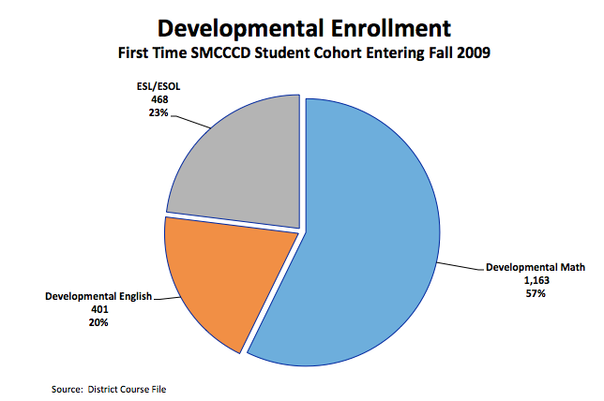
Figure 21
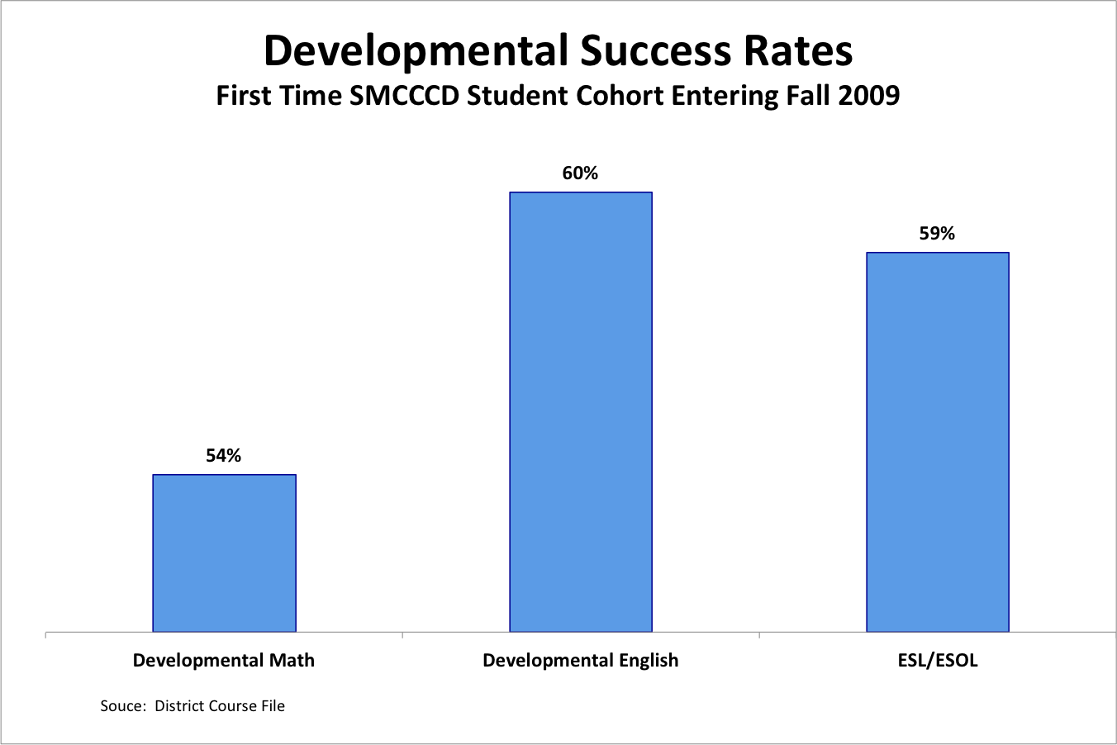

Figure 22
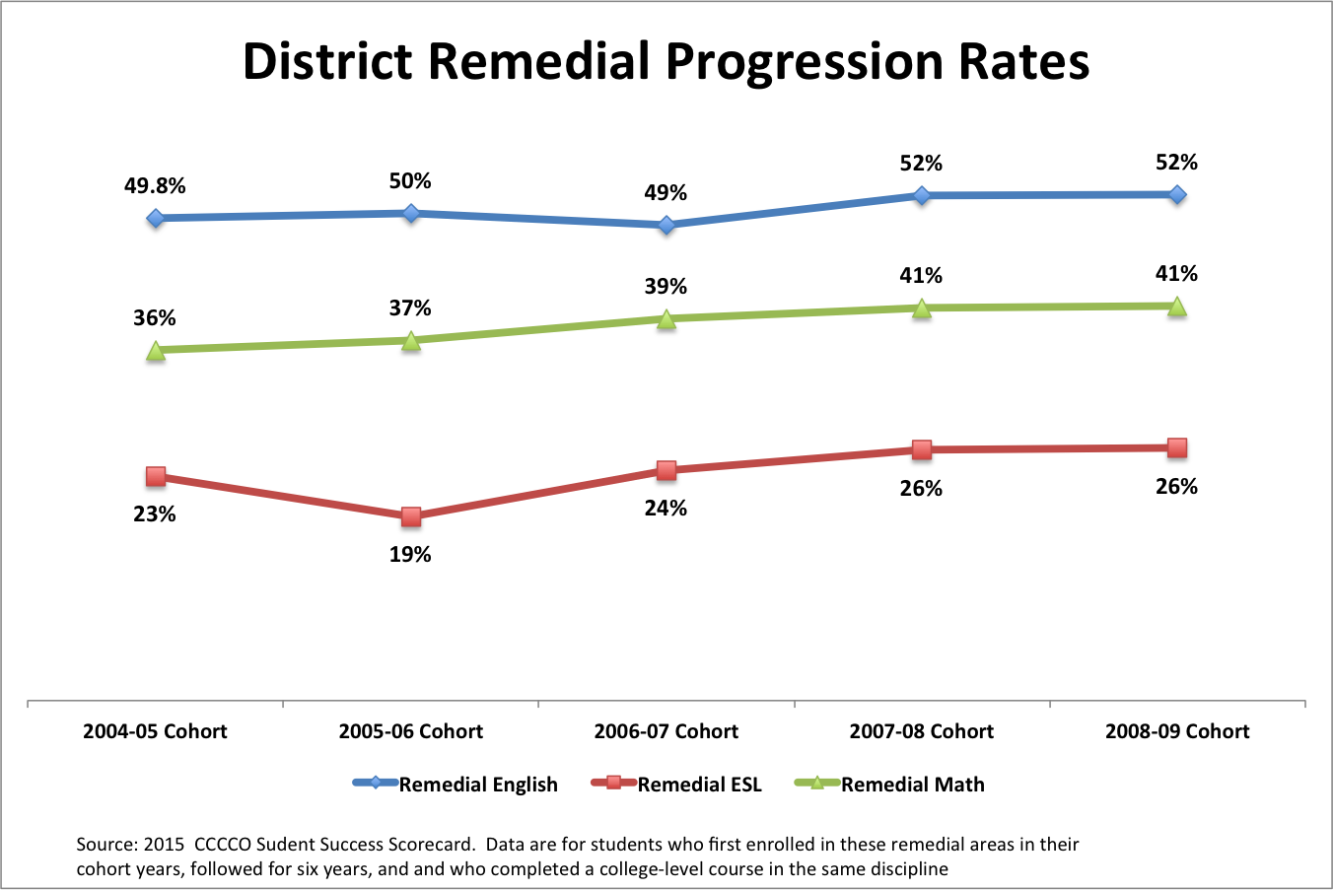

Figure 22 displays the proportion of entering students moving from basic skills to the next level college credit class for five cohort years of entering students. Figure 23 shows pass rates in District gatekeeper classes for the entering Fall 2009 cohort.

Figure 23
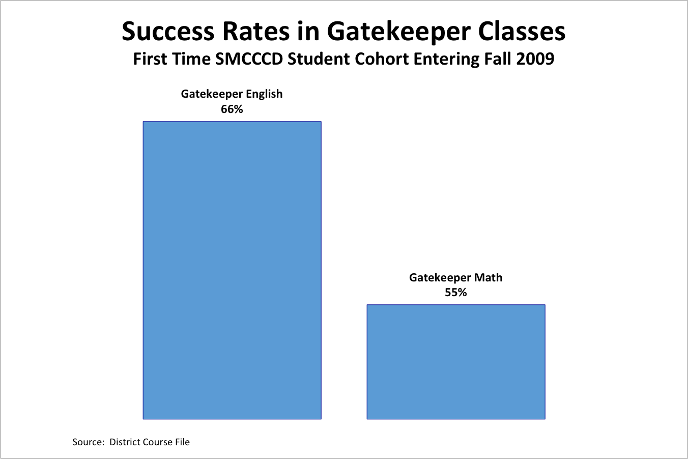
Figure 24
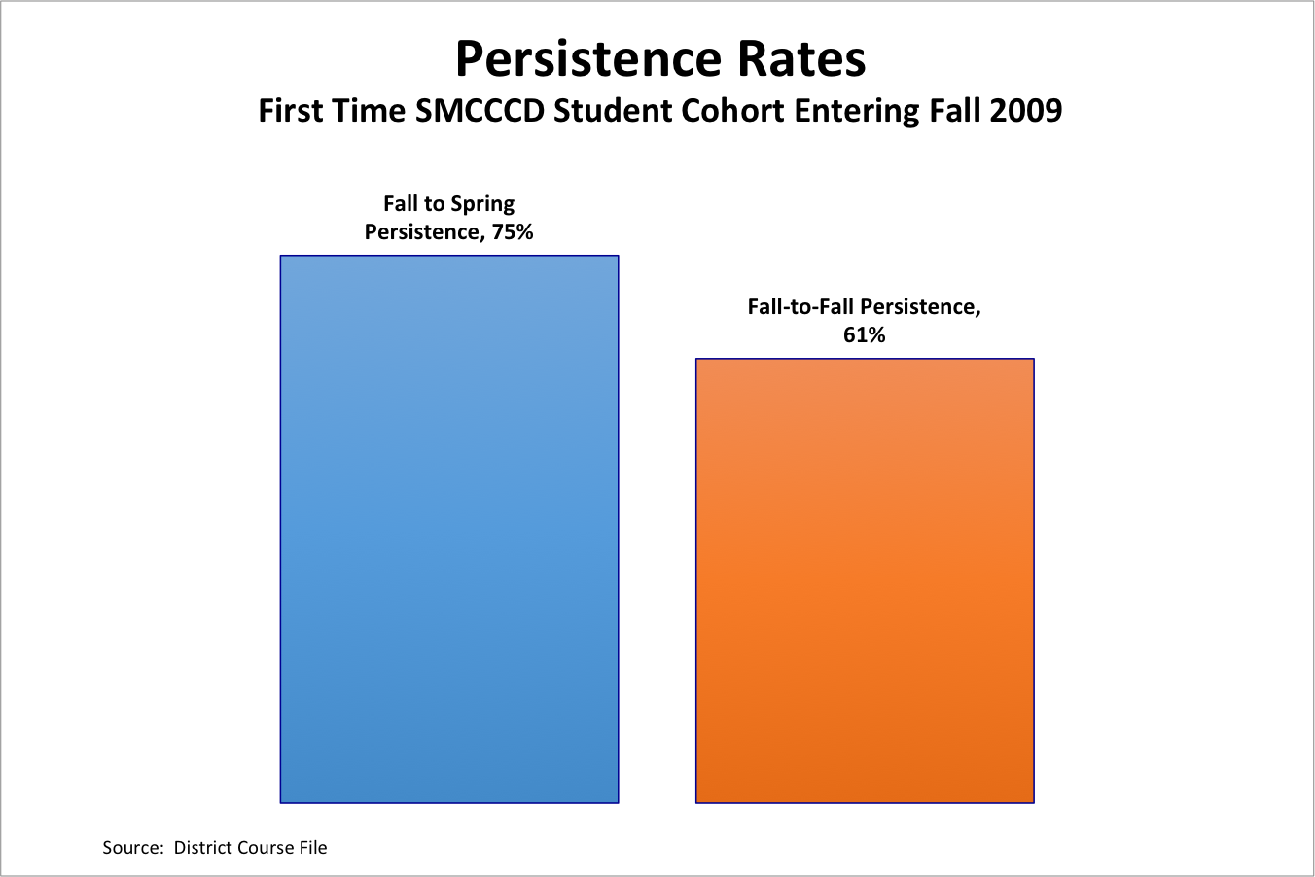

Figure 24 shows the persistence rate of the entering Fall 2009 cohort for Spring 2010 and Fall 2010. Figure 24 shows that 20% of the entering Fall 2009 cohort earned degrees (12%) or certificates (8%) by Spring 2014.

Figure 25
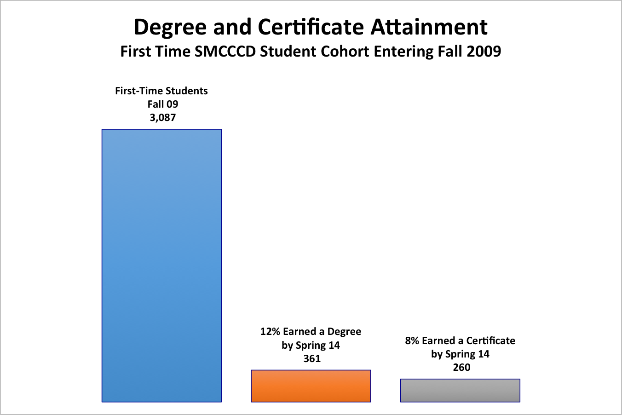

Degrees, Certificates, and Noncredit Awards

Figure 26 is an overview of degrees and certificates awarded by District Colleges. Appendix C provides a detailed list of degrees and certificates awarded by title.
Figure 26
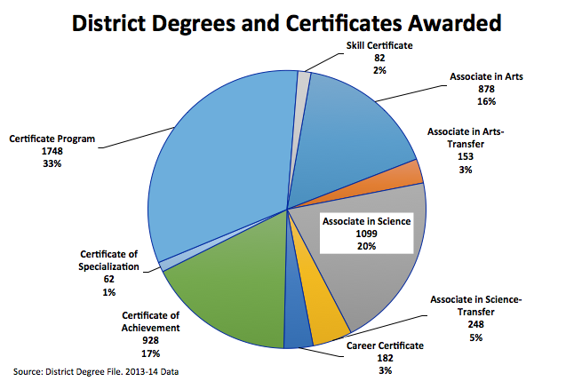

Transfer to the UC and CSU Systems

The District transfers more than a thousand students annually to the University of California and California State University Systems (Table 9). Within the CSU system, the largest transfer destination is San Francisco State followed by San Jose State and East Bay. In the UC System, Davis is the largest transfer destination followed by Berkeley. Figure 27 shows transfer numbers from the District’s three colleges.

Table 9
SMCCCD Transfers to CSU and UC Systems
2008-09 to 2012-13
System | Campus | 2008-09 | 2009-10 | 2010-11 | 2011-12 | 2012-13
CSU
 | Bakersfield | 3 | 1 | 0 | 0 | 0
 | Channel Islands | 0 | 0 | 0 | 1 | 1
 | Chico | 11 | 8 | 11 | 14 | 10
 | Dominguez Hills | 2 | 3 | 3 | 1 | 1
 | East Bay | 104 | 80 | 80 | 101 | 91
 | Fresno | 5 | 2 | 4 | 3 | 5
 | Fullerton | 2 | 3 | 0 | 1 | 3
 | Humboldt | 7 | 5 | 11 | 7 | 9
 | Long Beach | 11 | 4 | 3 | 10 | 13
 | Los Angeles | 7 | 6 | 7 | 6 | 2
 | Maritime Academy | 1 | 1 | 5 | 1 | 0
 | Monterey Bay | 3 | 4 | 3 | 9 | 8
 | Northridge | 5 | 4 | 7 | 7 | 9
 | Pomona | 5 | 1 | 2 | 2 | 5
 | Sacramento | 25 | 20 | 42 | 26 | 27
 | San Bernardino | 3 | 1 | 1 | 2 | 0
 | San Diego | 11 | 2 | 13 | 4 | 22
 | San Francisco | 471 | 311 | 615 | 502 | 418
 | San José | 162 | 71 | 87 | 100 | 103
 | San Luis Obispo | 7 | 6 | 3 | 13 | 8
 | San Marcos | 1 | 0 | 0 | 0 | 0
 | Sonoma | 8 | 5 | 8 | 10 | 11
 | Stanislaus | 6 | 0 | 6 | 6 | 7
CSU Total |  | 860 | 538 | 911 | 826 | 753
UC
 | Berkeley | 55 | 70 | 73 | 53 | 76
 | Davis | 91 | 78 | 95 | 80 | 124
 | Irvine | 8 | 9 | 8 | 6 | 13
 | Los Angeles | 22 | 22 | 19 | 19 | 17
 | Merced | 4 | 1 | 2 | 3 | 3
 | Riverside | 7 | 7 | 4 | 8 | 6
 | San Diego | 17 | 24 | 28 | 40 | 18
 | Santa Barbara | 20 | 17 | 13 | 7 | 11
 | Santa Cruz | 26 | 23 | 34 | 25 | 36
UC Total |  | 250 | 251 | 276 | 241 | 304
Grand Total |  | 1,110 | 789 | 1,187 | 1,067 | 1,057
Source: District Transfer Files

Figure 27
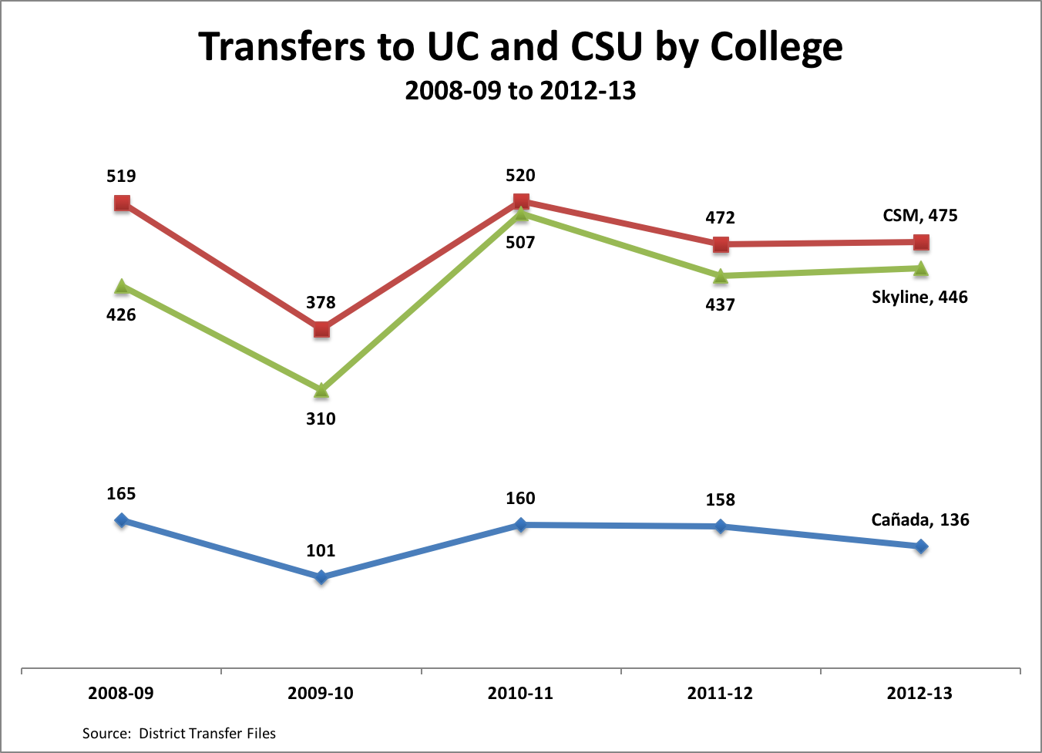

Appendix d: District Degrees and Certificates Awarded
Title | # |  | Title | #
University Transfer: CSUGE | 222 |  | Computer Info Specialist | 7
Early Childhood Education | 165 |  | ECE/Child Development: CSU | 7
Accounting | 149 |  | Entry Level Bookkeeper | 7
Social Science | 148 |  | Health Sciences | 7
Administration of Justice | 142 |  | Mathematics for Transfer | 7
Business Administration | 123 |  | Medical Office Assistant | 7
Interdisciplinary Studies | 99 |  | Multimedia: Web Design | 7
Computer & Information Science | 97 |  | Re-Design & Home Staging | 7
University Transfer: IGETC/UC | 93 |  | Sociology: UC | 7
IS-Letters & Science (Opt. I) | 88 |  | Tax Preparer II | 7
Allied Health | 85 |  | DGME: Graphic Design | 6
IS-Social & Behavioral Sci (Opt I) | 66 |  | International Trade | 6
Auto Electricity/Electronics CB | 62 |  | KINE Pilates Mat Instructor | 6
Emergency Medical Technician I | 61 |  | Kinesiology: CSU | 6
Communication Studies | 58 |  | Multimedia Technology | 6
IS-Social/ Nat Sciences-Opt. I | 57 |  | Music | 6
IS-Arts & Humanities (Opt. I) | 55 |  | Solar Energy Technology | 6
University Transfer: CSU GE | 55 |  | 3D Animation & Videogame Art | 5
Auto Engines Technology CB | 50 |  | Architecture | 5
University Transfer: IGETC/CSU | 50 |  | ECE: Special Education | 5
Nursing | 49 |  | Engineering | 5
Fire Technology | 44 |  | IS-Social & Behavioral Science | 5
Psychology | 42 |  | KINE Group Fitness Instructor | 5
Electrical Power Systems | 41 |  | Multimedia Art and Technology | 5
Business Administration AS-T | 39 |  | Physical Education | 5
Auto Drive Train Technology CB | 36 |  | Physics | 5
Paralegal | 35 |  | Political Science | 5
Admin Medical Assistant | 34 |  | Spanish | 5
Cosmetology | 34 |  | Art: Fine Arts | 4
Medical Assistant | 34 |  | Business, Business Info Processing | 4
Auto Chassis Technology CB | 33 |  | Fitness Professional | 4
Network Engineering | 33 |  | General Office | 4
Accounting Assistant | 32 |  | Graphics | 4
Interior Design | 31 |  | IS-Letters & Science | 4
Promoter Ed & Employ Proj | 31 |  | Journalism | 4
Sub-total by Certificate of Specialization | 31 |  | Medical Transcriber | 4
Dental Assisting | 30 |  | Multimedia: Graphic Design | 4
Human Services | 30 |  | Office Assistant | 4
Psychology for Transfer | 30 |  | Real Estate | 4
University Transfer: IGETC UC | 30 |  | Administrative Support Assistant | 3
Preparation for Academic | 28 |  | Art: Studio Art | 3
Auto Engine Performance Tech CB | 27 |  | Communication Studies: UC | 3
Auto Adv. Engine Perf. Tech CB | 26 |  | Early Childhood Education AS-T | 3
Asian Engine Perf. Tech CB | 23 |  | Electrical Technology | 3
KINE Yoga Instructor | 23 |  | Int'l Logistics-Customs Broker | 3
Natural Science | 23 |  | IS-Arts & Humanities | 3
English | 22 |  | KINE Pilate Mat & Reform Instructor | 3
Family Development | 22 |  | KINE Pilates Instructor | 3
PC Config. & Repair Endorse. | 22 |  | Management: Marketing Management | 3
Medical Coding & Billing | 21 |  | Music: Electronic Music | 3
Respiratory Therapy | 21 |  | Business Administration: CSU | 2
Basic Networking Skill Endorsement | 20 |  | Business: Office Assistant I | 2
Liberal Arts | 20 |  | CPA Exam Preparation | 2
Sociology: CSU | 19 |  | Dance | 2
Solar Installation Career Cert | 19 |  | Film | 2
Alcohol & Other Drug Studies | 18 |  | International Business | 2
Community Health Worker | 18 |  | International Logistics | 2
Esthetician CB | 18 |  | IS-Social & Natural Sciences | 2
Massage Therapy | 18 |  | Life Sciences - Biological | 2
Radiologic Technology | 18 |  | Life Sciences: Medical | 2
Biology: Pre Nursing | 17 |  | Multimedia: Digital Video | 2
Human Resources Management | 17 |  | Office Management CB | 2
Liberal Studies | 17 |  | Project Management | 2
Paralegal/Legal Assistant | 17 |  | Sustainable Design | 2
Tax Preparer I | 17 |  | Wiring & Install. Skill Endorsement | 2
Mathematics | 16 |  | Anthropology | 1
Economics | 15 |  | Asian Business Practices | 1
Psychology: CSU | 15 |  | Automotive Technician | 1
Biology | 14 |  | Biology - General | 1
Kinesiology | 14 |  | Biology: Medical | 1
AOD: Co-Occurring Disorders | 13 |  | Broadcast & Electronic Media | 1
Automotive Technology | 12 |  | Business Management AS | 1
Basic Police Academy | 12 |  | Business, Merchandising Management | 1
Biology: Biotechnology | 12 |  | Business: Office Assistant II | 1
Fashion Merchandising | 11 |  | Central Service Technology | 1
History | 11 |  | Computer Information Systems: | 1
IS-Org. Structures (Opt. I) | 11 |  | DGME: Digital Video Production | 1
Surgical Technology | 11 |  | DGME: TV Producing | 1
Art | 10 |  | DGME: Web Design | 1
Fashion Design | 10 |  | Drafting Technology | 1
Found. in Early Childhood Education | 10 |  | ECE. Entrepreneurship CA | 1
Kinesiology AA-T | 10 |  | Entrepreneurship & | 1
IS-Health/Physical Ed (Opt. I) | 9 |  | Fashion Design Merchandising | 1
Management: Business Management | 9 |  | Global Studies | 1
Medical Coding Specialist | 9 |  | Horticulture: Floristry | 1
Sociology | 9 |  | Image Consulting | 1
Accounting Computer Specialist | 8 |  | Int'l Logistics-Air Freight | 1
Building Inspection | 8 |  | Int'l Logistics-Ocean Freight | 1
Central Serv. Tech. w/Clinical | 8 |  | KINE Comp Pilates Instructor | 1
Digital Media | 8 |  | KINE Spl Pilates Instructor | 1
Fashion Design: | 8 |  | Life Sciences: Pre Nursing | 1
Medical Billing Specialist | 8 |  | Management: Retail Management | 1
Physics AS-T | 8 |  | Mathematics: UC | 1
Administrative Assistant | 7 |  | Multimedia | 1
Art - Photography | 7 |  | Philosophy | 1
Art: Art History | 7 |  | Political Science | 1
Biological Sciences | 7 |  | Speech | 1
Chemistry | 7 |  | Theater Arts | 1
Communication Studies: CSU | 7 |  | University Studies | 1
 |  |  | Web Developer | 1
Source: District Degree File. In addition to the degrees and certificates reported to the California Community Colleges Chancellor’s Office, these data contain “certificates of specialization” thereby reflecting the District’s total contribution to degrees and certificates. Data are 2013-14

Appendix e: Other Data Developed for the Strategic Plan
The following links lead to data components developed specifically to inform the District’s new strategic plan. Much of the information is also included in summary or in its entirety in this report.
- External Trends and Implications for Strategic Planning
- District Enrollment Projections and Scenarios
- College Specific Enrollment Projections and Scenarios
- Competitor Analysis
- Labor Market Forecasts
- Connections: Labor Markets, Programs, Competitors and Jobs Forecast
- Course Enrollments by TOP Code Area by College
- Instructional Program Course Enrollment Trends by 2-Digit Top Code
- Summary of Local K through 12 Enrollment Projections
Other supporting data and key information used to create this strategic plan can be found in the Strategy Session Presentations which were held at each College throughout this process and are available on the District’s strategic planning website.

Sources for Environmental Trends

Source: U.S. Census Bureau. 2009-2013 American Community Survey 5-Year Estimates, DP03 File.
California Employment Development Department . Labor Force and Unemployment Rates for Cities and Census Designated Places. Retrieved April 30, 2015 at http://www.labormarketinfo.edd.ca.gov/CES/Labor_Force_Unemployment_Data_for_Cities_and_Census_Areas.html#CCD
Interdisciplinary studies includes remedial courses that were moved to other program areas during this time, accounting for most of the decline in this area. Remedial classes mathematics, for example, was moved out of interdisciplinary studies to the mathematics area accounting, in part, for the growth in mathematics
This program analysis does not include individual courses or clusters of courses. For public institutions, only those programs officially registered with the California Community Colleges Chancellor’s Office were employed in the analysis.
See the District’s strategic planning website for the full report
The District also addresses workforce needs by offering courses corresponding to those needs. This strategic plan specifically recognizes that not all learners are interested in completing degrees or certificate but may be interested in one or more classes to advance their skills. Official labor market projections, however, are developed on the basis of minimum levels of education (e.g., certificates and degrees) required for entry into specific jobs and are a solid basis for designing and improving pathways to employment.
The Student Success Scorecard published by California Community Colleges Chancellor’s Office provides an overview of the progress of defined student cohorts for the District but does not provide the District with a picture of all entering students.
Levy, S. (2014, May). Trends Affecting Workforce Development in San Mateo County and the San Francisco Peninsula. Silicon Institute for Regional Studies Retrieved at http://samceda.org/san-mateo-county-information-resources/economy2/
County of San Mateo. 2012-2013 Profile. Retrieved at http://www.co.sanmateo.ca.us/bos.dir/Budget/recommend2012/county/A-19.pdf
California Department of Finance (n.d.). E-6. Population Estimates and Components of Change by County July 1, 2010–2013. Retrieved at http://www.dof.ca.gov/research/demographic/reports/estimates/e-6/view.php
US Census, American FactFinder. DP03 File. Retrieved at factfinder2.census.gov
US Census, American FactFinder. Retrieved at factfinder2.census.gov
US Census, American FactFinder. Retrieved at factfinder2.census.gov
US Census, American FactFinder. Retrieved at factfinder2.census.gov
US Census, American FactFinder. Retrieved at factfinder2.census.gov
US Census, American FactFinder. Retrieved at factfinder2.census.gov
One Bay Area (2013, July). Bay Area Plan: Strategy for a Sustainable Region. Retrieved at www.onebayarea.org/plan-bay-area/final-plan-bay-area.html
The United States Conference of Mayors (2012). Figure 1: Most and Least Congested Areas. Congestion Cost Per Commuter, 2010, page 9. Retrieved at usmayors.org/metroeconomies/0712/FullReport.pdf
The Registry. Bay Area Real Estate. http://news.theregistrysf.com/construction-around-bay-area-surges/
One Bay Area (2013, July). Bay Area Plan: Strategy for a Sustainable Region. Retrieved at www.onebayarea.org/plan-bay-area/final-plan-bay-area.html
One Bay Area (2013, July). Bay Area Plan: Strategy for a Sustainable Region. Retrieved at www.onebayarea.org/plan-bay-area/final-plan-bay-area.html
California Department of Finance (2013, December). E-6. Population Estimates and Components of Change by County — July 1, 2010–2013. Retrieved at www.dof.ca.gov/research/demographic/reports/estimates/e-6/view.php
U.S. Census Bureau (n.d.). State and County Quickfacts. Retrieved at html Data compares April 2010 to July 2012 statistics.
Johnson, H., and Mejia, M. C. (2013, May). Immigrants in California. Public Policy Institute of California. Retrieved at www.ppic.org/main/publication_show.asp?i=258
Public Policy Institute of California. Retrieved at www.ppic.org/content/pubs/jtf/JTF_ImmigrantsJTF.pdf
One Bay Area (2013, July). Bay Area Plan: Strategy for a Sustainable Region. Retrieved at www.onebayarea.org/plan-bay-area/final-plan-bay-area.html
U.S. Census Bureau (n.d.). State and County Quickfacts
U.S. Census Bureau (n.d.). State and County Quickfacts.
The Campaign for College Opportunity, (2013, May). Working Hard, Left Behind: Education as a pathway from poverty to prosperity for working Californians. Retrieved at www.collegecampaign.org/resource-library/our-publications/
The Campaign for College Opportunity, (2013, May). Working Hard, Left Behind: Education as a pathway from poverty to prosperity for working Californians. Retrieved at www.collegecampaign.org/resource-library/our-publications/
U.S. Census Bureau (n.d.). State and County Quickfacts.
U.S. Census Bureau (2011). Cited in The State of Latinos in Higher Education in California. Retrieved at www.collegecampaign.org/files/6013/8361/4629/State_of_Higher_Education_Latino_FINAL.pdf
U.S. Census Bureau (2011). Cited in The State of Latinos in Higher Education in California. Retrieved at www.collegecampaign.org/files/6013/8361/4629/State_of_Higher_Education_Latino_FINAL.pdf
Public Policy Institute of California (2012 and 2010). Cited in The State of Latinos in Higher Education in California. Retrieved at www.collegecampaign.org/files/6013/8361/4629/State_of_Higher_Education_Latino_FINAL.pdf
The Campaign for College Opportunity (2013, December). The State of Blacks in Higher Education in California. Retrieved at http://collegecampaign.org/wp-content/uploads/2014/06/State_of_Higher_Education_Black.pdf
Institute for the Future. Future Work Skills 2020 n.d. Retrieved at www.iftf.org/futureworkskills/
US Census, American Factfinder. Retrieved at factfinder2.census.gov
Migration Policy Institute, 2011. Up for Grabs: The Gains and Prospects of First- and Second-Generation Young Adults. Retrieved at www.migrationpolicy.org/pubs/youngadults-upforgrabs.pdf
New York Times (2014, July). Census Considers How to Measure a More Diverse America. Retrieved at http://www.nytimes.com/2014/07/02/us/census-bureau-arabs-hispanics-diversity.html?_r=0
SMEDA (August 2014). San Mateo County Economic $ Industry Overview. Retrieved at http://samceda.org/wp-content/uploads/SMC_EconomicAndIndustry_Overview_August_2014.pdf
California Employment Development Department (n.d.). San Mateo County Profile. Retrieved at http://www.labormarketinfo.edd.ca.gov/cgi/databrowsing/localAreaProfileQSResults.asp
The Registry-Bay Area Real Estate (2014, August). San Mateo County Poised for Surging Office Market. Retrieved at http://news.theregistrysf.com/san-mateo-county-poised-surging-office-market/
The Registry-Bay Area Real Estate (2014, September). Retrieved at http://news.theregistrysf.com/box-inc-leases-100-kilroy-realtys-new-redwood-city-office-development-project/
California Employment Development Department (n.d.). San Mateo County Profile. Retrieved at http://www.labormarketinfo.edd.ca.gov/cgi/databrowsing/localAreaProfileQSResults.asp
California Employment Development Department (n.d.). San Mateo County Profile. Retrieved at http://www.labormarketinfo.edd.ca.gov/cgi/databrowsing/localAreaProfileQSResults.asp
Haveman Economic Consulting for the San Mateo County Economic Development Association (2011, October). Deconstructing and Understanding the Employment Dynamics of the San Mateo County Economy. Retrieved at http://samceda.org/wp-content/uploads/HEC_Report_100511A.pdf
Levy, S. (2014, May). Trends Affecting Workforce Development in San Mateo County and the San Francisco Peninsula. Silicon Institute for Regional Studies Retrieved at http://samceda.org/san-mateo-county-information-resources/economy2
Levy, S. (2012, April). Presentation to ABAG Regional Planning Committee. Retrieved at www.abag.ca.gov/presentations/Levy1204.pdf
Levy, S. (2012, April). Presentation to ABAG Regional Planning Committee. Retrieved at www.abag.ca.gov/presentations/Levy1204.pdf
Levy, S. (2012, April). Presentation to ABAG Regional Planning Committee. Retrieved at www.abag.ca.gov/presentations/Levy1204.pdf
Florida, R. (2013, August). Why San Francisco May Be the New Silicon Valley. Retrieved at www.theatlanticcities.com/jobs-and-economy/2013/08/why-san-francisco-may-be-new-silicon-valley/6295/
Bay Area Council Economic Institute Report (2012, October). A Regional Economic Assessment of the San Francisco Bay Area. Retrieved at www.abag.ca.gov/abag/events/agendas/J111612a-Item%2008,%20Regional%20Economic%20Assessment.pdf
Levy, S. (2014, May). Trends Affecting Workforce Development in San Mateo County and the San Francisco Peninsula. Silicon Institute for Regional Studies Retrieved at http://samceda.org/san-mateo-county-information-resources/economy2/
Levy, S. (2014, May). Trends Affecting Workforce Development in San Mateo County and the San Francisco Peninsula. Silicon Institute for Regional Studies Retrieved at http://samceda.org/san-mateo-county-information-resources/economy2/
San Mateo County Economic Development Association (2013, November). San Mateo County Economic & Industry Overview. Retrieved at http://samceda.org/wp-content/uploads/SMCEconomicIndustryOverviewNovember2013.pdf
Levy, S. (2014, May). Trends Affecting Workforce Development in San Mateo County and the San Francisco Peninsula. Silicon Institute for Regional Studies Retrieved at http://samceda.org/san-mateo-county-information-resources/economy2/
Levy, S. (2014, May). Trends Affecting Workforce Development in San Mateo County and the San Francisco Peninsula. Silicon Institute for Regional Studies Retrieved at http://samceda.org/san-mateo-county-information-resources/economy2/
Levy, S. (2014, May). Trends Affecting Workforce Development in San Mateo County and the San Francisco Peninsula. Silicon Institute for Regional Studies Retrieved at http://samceda.org/san-mateo-county-information-resources/economy2
US Bureau of Labor Statistics (n.d.). Retrieved at www.bls.gov/ro9/qcewca.htm
The Campaign for College Opportunity, (2013, May). Working Hard, Left Behind: Education as a pathway from poverty to prosperity for working Californians. Retrieved at www.collegecampaign.org/resource-library/our-publications/
Georgetown University (2013, July). California 2020. Retrieved at www9.georgetown.edu/grad/gppi/hpi/cew/pdfs/california2020.pdf
Georgetown University (2013, July). California 2020. Retrieved at www9.georgetown.edu/grad/gppi/hpi/cew/pdfs/california2020.pdf
AASCU State Outlook. Retrieved at www.aascu.org/policy/publications/aascu-special-reports/stateoutlookjuly2014.pdf
CNBC America’s Top States for Business 2014. Retrieved at http://www.cnbc.com/id/101758236
CBS News, California’s drought could last for years. Retrieved at www.cbsnews.com/news/californias-drought-could-last-for-years/
Jeff Selingo (April 2013). College (Un)Bound. Retrieved at cpe.ky.gov/NR/rdonlyres/513A6A46-BCA2-4A59-9B46-85F8AF7DDAB5/0/CollegeUnbound.pdf
Klor de Alva, J. and Schneider, M. (2013, September). What’s The Value Of An Associate’s Degree? Retrieved at www.air.org/resource/what%E2%80%99s-value-associate%E2%80%99s-degree-return-investment-graduates-and-taxpayers
California Community Colleges Chancellor’s Office (2013, September). Key Facts. Retrieved at californiacommunitycolleges.cccco.edu/PolicyInAction/KeyFacts.aspx
California Community Colleges Chancellor’s Office (2013, August). Distance Education Fact Sheet. Retrieved at californiacommunitycolleges.cccco.edu/PolicyInAction/KeyFacts.aspx
Wilen-Daugenti, T., 2012. Society 3.0: How Technology Is Reshaping Education, Work, and Society. New York: Peter Lang Publishing
Organisation for Economic Co-operation and Development (2012). Education at a Glance: OECD Indicators 2012. Retrieved at www.oecd.org/education/CN%20-%20United%20States.pdf
Leonhardt, D. 2013, May 5. The Idled Young Americans. New York Times. Retrieved at www.nytimes.com/2013/05/05/sunday-review/the-idled-young-americans.html
US Census. State and County Quick Facts. Retrieved at http://quickfacts.census.gov/qfd/states/06/06081.html
Levy, S. (2014, May). Trends Affecting Workforce Development in San Mateo County and the San Francisco Peninsula. Silicon Institute for Regional Studies Retrieved at http://samceda.org/san-mateo-county-information-resources/economy2
Levy, S. (2014, May). Trends Affecting Workforce Development in San Mateo County and the San Francisco Peninsula. Silicon Institute for Regional Studies Retrieved at http://samceda.org/san-mateo-county-information-resources/economy2/
US Census, American FactFinder. Retrieved at factfinder2.census.gov
National Center for Education Statistics (n.d.). College Navigator. Data retrieved at nces.ed.gov/collegenavigator/
National Center for Education Statistics (n.d.). College Navigator. Data retrieved at nces.ed.gov/collegenavigator/
State of California (2012, September). Department of Finance, California Public Postsecondary Enrollment History, Sacramento, California. Retrieved at www.dof.ca.gov/research/demographic/reports/projections/postsecondary/
California Community Colleges Student Success Task Force. (2012). Advancing student success in the California community colleges. Sacramento, CA: California Community Colleges Chancellor’s Office, p. 4. Retrieved at http://www.californiacommunitycolleges.cccco.edu/Portals/0/StudentSuccessTaskForce/SSTF_FinalReport_Web_010312.pdf.
Western Interstate Commission for Higher Education (2012, December). Knocking at the College Door: Projections of High School Graduates. Retrieved at http://www.wiche.edu/knocking-8th.
Flores, Adolfo (2013, January). UC Freshman Applicants for 2013 a Record High, Los Angeles Times. Retrieved at http://articles.latimes.com/2013/jan/18/local/la-me-uc-applicants-20130119
Inside Higher Ed (2014, January). Higher Bar for Fee Waiver in California. Retrieved at www.insidehighered.com/quicktakes/2014/01/14/higher-bar-fee-waiver-california#ixzz2qQKEM7A1
Bidwell, A. (2013, April). California Community Colleges Release Statewide 'Student Success Scorecard.' Retrieved at chronicle.com/article/California-Community-Colleges/138441/
California State University System (2013, October). Transfer Program Between California Community Colleges and California State University Hits Milestone of 1,000 Associate Degrees for Transfer Developed. Retrieved at blogs.calstate.edu/pa/news/?p=3238
California Community College Chancellor’s Office (n.d.). Retrieved at californiacommunitycolleges.cccco.edu/PolicyInAction.aspx
California Community College Chancellor’s Office (n.d.). Students First: Restoring Access and Increasing Success in California Community Colleges. Retrieved at californiacommunitycolleges.cccco.edu/Portals/0/DocDownloads/ChancellorPresentations/2013-01_ccLeague_presentation_web.pdf
Inside Higher Ed (2014, August). California Legislature Approves Bachelor's Degrees at Community Colleges. Retrieved at https://www.insidehighered.com/quicktakes/2014/08/22/california-legislature-approves-bachelors-degrees-community-colleges
California Community Colleges (n.d.) scorecard.cccco.edu/scorecard.aspx. Cited in The State of Latinos in Higher Education in California. Retrieved at www.collegecampaign.org/files/6013/8361/4629/State_of_Higher_Education_Latino_FINAL.pdf
Mangan, K. (2014, January). Full-Time, Structured Program at CUNY Yields More Community-College Grads. Chronicle of Higher Education. Retrieved at chronicle.com/article/How-CUNY-Is-Producing-More/143755/
National Student Clearinghouse (2013, December). Current Term Enrollment Estimates. Retrieved at nscresearchcenter.org/currenttermenrollmentestimate-Fall2013
U.S. Census Bureau (2013, September). After a Recent Upswing, College Enrollment Declines, Census Bureau Reports. Retrieved at http://www.census.gov/newsroom/releases/archives/education/cb13-153.html
Western Interstate Commission for Higher Education (2012, December). Knocking at the College Door: Projections of High School Graduates. Retrieved at http://www.wiche.edu/knocking-8th.
DeSilver, D. (2014, January). College Enrollment Among Low-income Students Still Trails Richer Groups. Pew Research Center. Retrieved at http://www.pewresearch.org/fact-tank/2014/01/15/college-enrollment-among-low-income-students-still-trails-richer-groups/
Organization for Economic Cooperation and Development, Education at a Glance 2009: OECD Indicators; Table A-3.5. Retrieved at www.oecd.org/education/skills-beyond-school/43636332.pdf
FACT SHEET on the President’s Plan to Make College More Affordable: A Better Bargain for the Middle Class. Retrieved at www.whitehouse.gov/the-press-office/2013/08/22/fact-sheet-president-s-plan-make-college-more-affordable-better-bargain-
FACT SHEET on the President’s Plan to Make College More Affordable: A Better Bargain for the Middle Class. Retrieved at www.whitehouse.gov/the-press-office/2013/08/22/fact-sheet-president-s-plan-make-college-more-affordable-better-bargain-
U.S. Department of Education (n.d.). Basic Eligibility Criteria. Retrieved at studentaid.ed.gov/types/grants-scholarships/pell/calculate-eligibility
U.S. Department of Education (n.d.). Calculating Pell Grant Lifetime Eligibility Used. Retrieved at studentaid.ed.gov/types/grants-scholarships/pell/calculate-eligibility
USA Today (2014, July) , Census: 74% of STEM grads don't get STEM jobs Retrieved July 28, 2014 at http://www.usatoday.com/story/money/business/2014/07/10/census-stem-graduates/12492079/)
The Chronicle of Higher Education, July 3, 2014. chronicle.com/article/As-Stricter-Default-Standard/147485/?cid=at&utm_source=at&utm_medium=en 7/3/14, 7:43:20 AM
California Community Colleges Chancellor’s Office (2013, April). Advancing Student Success in the California Community Colleges. Retrieved at californiacommunitycolleges.cccco.edu/PolicyInAction/StudentSuccessInitiative/SummaryDocuments.aspx .
Education Policy Center (2013, September). Performance-Based Funding: The National Landscape. Retrieved at www.uaedpolicy.ua.edu/uploads/2/1/3/2/21326282/pbf_9-19_web.pdf
California Department of Finance (2013, December). California Public K–12 Graded Enrollment and High School Graduate Projections by County — 2013 Series. Retrieved at http://www.dof.ca.gov/research/demographic/reports/projections/k-12/
County of San Mateo (n.d.). Open Data Portal. Retrieved at https://data.smcgov.org/Education/Elementary-Student-Demographics-by-District-San-Ma/pfu7-udfn
California Department of Education (n.d.). Dropouts by Race & Gender. Retrieved September 16, 2014 at http://www.cde.ca.gov/ds/sd/sd/filesdropouts.asp
Cal-PASS Plus (n.d.). Education-to-Workforce Pipeline. Retrieved from https://www.calpassplus.org/
County of San Mateo (n.d.). Open Data Portal. Retrieved at https://data.smcgov.org/Education/Free-and-Reduced-Price-Meals-2013-2014/g8bq-nqg7
Western Interstate Commission for Higher Education (2012, December). Knocking at the College Door: Projections of High School Graduates. Retrieved at http://www.wiche.edu/knocking-8th.
California Department of Education (n.d.). Common Core State Standards. Retrieved at www.cde.ca.gov/re/cc/
NCES, NASP results. Retrieved at nces.ed.gov/nationsreportcard/subject/publications/stt2013/pdf/2014464CA8.pdf
Rising Above the Gathering Storm, Revisited: Rapidly Approaching Category 5 By Members of the 2005 "Rising Above the Gathering Storm" Committee; Prepared for the Presidents of the National Academy of Sciences, National Academy of Engineering and Institute of Medicine, 2010. Retrieved at www.nap.edu/catalog/12999.html
National Center for Public Policy and Higher Education (2005, July). The Need for State Policy Leadership. Retrieved at www.highereducation.org/crosstalk/ct0305/news0305-insert.pdf
L.A. Times (December, 2013). San Jose State will scale back online collaboration. Retrieved at www.latimes.com/local/lanow/la-me-ln-college-online-20131217,0,7650543.story#ixzz2nqAj3CoY
eCampus News, the Best and Worst State for on=line Learning. Retrieved at www.ecampusnews.com/top-news/learning-online-288/2/
California Community Colleges Chancellor’s Office (2013, August). Distance Education Fact Sheet. Retrieved at californiacommunitycolleges.cccco.edu/Portals/0/KeyFacts/FACT_SHEET_DistanceEducation_FINAL_080213.pdf
California Community Colleges Chancellor’s Office (2013, August). Distance Education Fact Sheet. Retrieved at californiacommunitycolleges.cccco.edu/Portals/0/KeyFacts/FACT_SHEET_DistanceEducation_FINAL_080213.pdf
California Community Colleges Chancellor’s Office (2013, August). Distance Education Fact Sheet. Retrieved at californiacommunitycolleges.cccco.edu/Portals/0/KeyFacts/FACT_SHEET_DistanceEducation_FINAL_080213.pdf
Blair, B. S. (2014, January). Babson study: Over 7.1 Million Higher Ed Students Learning Online. Babson College. Retrieved at http://www.babson.edu/news-events/babson-news/pages/140115-babson-survey-study-of-online-learning.aspx
Papas, C. Top 10 e-Learning Statistics for 2014. Retrieved at elearningindustry.com/top-10-e-learning-statistics-for-2014-you-need-to-know
The Sloan Consortium (2013, January). New Study: Over 6.7 million Students Learning Online. Retrieved at sloanconsortium.org/news_press/january2013_new-study-over-67-million-students-learning-online
Pew Internet and American Life Project (2013, August). Broadband and smartphone adoption demographics. Retrieved at www.pewinternet.org/Infographics/2013/Broadband-and-smartphone-adoption.aspx
Chronicle of Higher Education (2013, March). Open-Education Company Helps Develop Textbook-Free Associate Degree. Retrieved at chronicle.com/blogs/wiredcampus/open-education-company-helps-develop-textbook-free-associate-degree/42847
Fain. P. (2013, November). Adding Competency to Community. Inside HIgherEd. Retrieved at www.insidehighered.com/news/2013/11/19/group-two-year-colleges-work-western-governors-university-try-competency-based
Fain, P. (2014, May). Competency and Affordability. Retrieved at https://www.insidehighered.com/news/2014/05/06/college-america-hits-10000-mark-new-competency-based-bachelors-degrees
Fast Company (n.d.). Most innovative companies 2012. Retrieved at http://www.fastcompany.com/3017340/most-innovative-companies-2012/12southern-new-hampshire-university
See, for example, Educause (2012). Things You Should Know About Flipped Classrooms. Retrieved at net.educause.edu/ir/library/pdf/eli7081.pdf
Lumina Foundation (n.d.). America’s Call for Higher Education Redesign. The 2012 Lumina Foundation Study of the American Public’s Opinion on Higher Education. Retrieved at www.luminafoundation.org/publications/Americas_Call_for_Higher_Education_Redesign.pdf
Lumina Foundation (n.d.). America’s Call for Higher Education Redesign. The 2012 Lumina Foundation Study of the American Public’s Opinion on Higher Education. Retrieved at www.luminafoundation.org/publications/Americas_Call_for_Higher_Education_Redesign.pdf
The Economist (2014, June). Closing the Skills Gap: Companies and Colleges Collaborating for Change. Retrieved at http://www.economistinsights.com/sites/default/files/Closing%20the%20skills%20gap%20-%20June%202014.pdf
See, for example, 2012 ECAR Study of Analytics in Higher Education. Retrieved at www.educause.edu/library/resources/2012-ecar-study-analytics-higher-education

