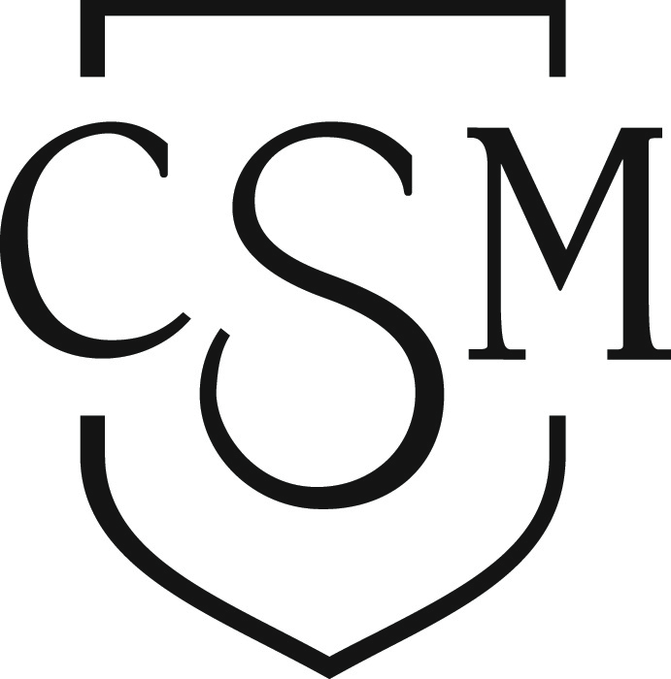
Basic Skills Initiative Committee

REQUEST FOR PROPOSALS

Purpose
The Basic Skills Initiative (BSI) Committee seeks to fund innovative, collaborative projects that improve the retention and success of CSM’s basic skills students across campus.

Application Requirements
Each applicant must …
- be a CSM counseling or instructional faculty member, administrator or staff member, either part- or full-time.
- complete a BSI Project Application Form, including a division dean signature.
- provide a Project Proposal and other supporting documents as requested demonstrating how the proposed project or program specifically assists CSM’s basic skills students.

Funds Available
A total of $15,000 for 2014-15 is available to fund approved new projects and programs.

Applications are reviewed on an ongoing basis until funding is depleted.

Types of Projects and Programs Funded

Internal, On-Campus Projects (Open to Adjunct and Full-Time Faculty)

- Divisional collaborative projects which explore and/or enhance the pedagogy and methodology of instructing students in basic skills classes or in disciplines serving numerous concurrently enrolled basic skills students

- Interdisciplinary/divisional projects which integrate instruction and student services in support of students in basic skills courses

- Projects which focus on departmental training of faculty, staff and/or administrators in support of basic skills students

- Individual or small group, short-term projects in support of basic skills or other underprepared students

External, Off-Campus Projects (Open to Adjunct and Full-Time Faculty)

- Off-campus conferences, workshops, and trainings that focus on the delivery of instruction or support services to basic skills/developmental (pre-transfer level) students

Application Procedure
- Review BSI and CSM institutional documents and data (see “Resources” below).
- Draft a 1-3 page Project Proposal that answers the questions on the Application Form.
- Complete and e-mail the BSI Project Application Form and supporting documentation, including the Project Proposal, to the BSI Coordinator and Dean of Academic Support and Learning Technologies (see “Contacts” below).
- If you have any questions during the application process, contact the BSI Coordinator.

Deadlines
Deadlines are rolling; proposals may be submitted at any time. For projects or programs that require reassigned time for Spring 2015, applications meeting the following deadline will receive priority:

Priority Deadline for Spring 2015: Fri., Dec. 12, 2014

Review Process
All applications will be reviewed and applicants notified within two weeks of receipt of all materials. Proposals will be reviewed and funded according to CSM's planned objectives and student need. Projects and programs that directly address basic skills students will be given priority. Projects which promote student-centered teaching methodology and promote the interdisciplinary exchange of expertise or integrate Instruction and Student Services will be given special consideration.

Follow-up
Upon completion of the project, applicants will submit a Project Summary Report with related project materials to the BSI Committee for archiving. Applicants may be invited to share their report with colleagues or the campus community at campus events. Applicants may re-apply the following year for additional funding in an effort to continue a project or program.

Resources
Please review the 2014-2015 BSI Goals and Action Plan, Educational Master Plan: Informational Update, 2012, Institutional Priorities, and 5 in 5 College Strategies, student outcomes data prior to drafting a proposal. Visit the BSI and/or PRIE websites to review reference documents, including:
http://collegeofsanmateo.edu/bsi/goals.asp
http://collegeofsanmateo.edu/prie/planningdocs.asp
http://collegeofsanmateo.edu/institutionalresearch/studentoutcomes.asp

Contacts
Kristi Ridgway, Basic Skills Coordinator ridgwayk@smccd.edu 574-6686
Jennifer Taylor-Mendoza, mendozaj@smccd.edu 574-6572
Dean of Academic Support & Learning Technologies
Basic Skills Initiative Committee

PROJECT APPLICATION FORM

CONTACT INFORMATION

Applicant Name: Division/Department:

Phone: E-mail:

If an adjunct faculty member, include the name and contact information of your sponsoring full-time faculty member:

Co-Applicant/Sponsor Name: Division/Department:

Phone: E-mail:

PROPOSAL HIGHLIGHTS

Title of Proposal:

Proposed Start Date:

Proposed End Date:

Student Target (Check all that apply):

________ Basic Skills course(s)
________ English
________ ESL
________ Math
________ Reading

________ Basic Skills program(s)
Name of program(s):

________ Basic Skills students in non-Basic Skills programs/courses
Name of program(s)/course(s):

Funding request: $ __________________

PROJECT PROPOSAL

Generally, the Project Proposal should be in narrative form (paragraphs), but you may include bulleted lists and charts as appropriate. Attach a 1-3 page Project Proposal to address each of the following areas:

Rationale
Identify and explain department, division, and/or college-wide need for the proposed basic skills/developmental education project.

Note: Projects promoting student-centered teaching methodology and promote the interdisciplinary exchange of expertise or integrate Instruction and Student Services will be given special consideration.

Project Description
Briefly describe the project's objectives, timeline, number of participants, or other pertinent, logistical information. Demonstrate how the project objectives support department, division, and/or college SLO's or planning as well as the CSM Strategic and Educational Master Plans, Institutional Priorities, 5 in 5 Strategies, or relevant college initiatives.

Assessment
Explain how the effectiveness of the project will be assessed. These results should be included in the culminating Project Summary Report.

Requested Funds
Funds may be requested as stipends or reassigned time, or for the purchase of project related materials. Assistance for conference travel and lodging expenses will be considered.

Dissemination
Explain how the results of the project will be shared with departments, divisions, and/or the campus community. This may include a variety of methods—department or division meetings, department or college websites, flex day activities.

Signatures:

Primary Applicant Signature Date

Co-Applicant/Sponsor Signature Date

Division Dean Signature Date

